Contents
Login Screen: 2
ADMIN DASHBOARD 4
COURSE 5
SEARCH COURSES 5
WEIGHATAGE 5
ASSIGN WEIGHTAGE 5
VIEW ASSIGNED WEIGHTAGE 7
MY PROGRAM STUDENTS 8
SEARCH 9
ADD QUESTION PAPERS 9
ADD FACULTY DETAILS : 10
SEARCH ALL ASSIGNMENT/TESTS 11
GENERIC SEARCH 14
PREVIEW QUERIES LIST 15
ADD FAQ 16
ANNOUNCEMENT 17
Create Announcement For Institute 17
Create Announcement For Program 18
SEARCH ANNOUNCEMENT 20
CALENDAR 21
VIEW EVENT 21
FEEDBACK 22
Create Feedback 22
Uploading Questions for Feedback 23
Allocation Of Feedback (Program level) : 24
VIEW FEEDBACK : 26
NOTIFICATION 27
LIBRARY (Non Course Content) 28
Adding Folder 29
Adding Sub Folder 30
CONTENT (Course Based Content) 31
Addition of Folder: 31

Login Screen:
The ADMIN has to enter his user-id and password.

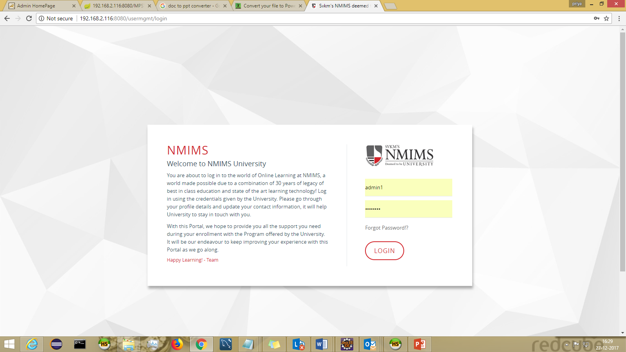

Select a Program from the dropdown
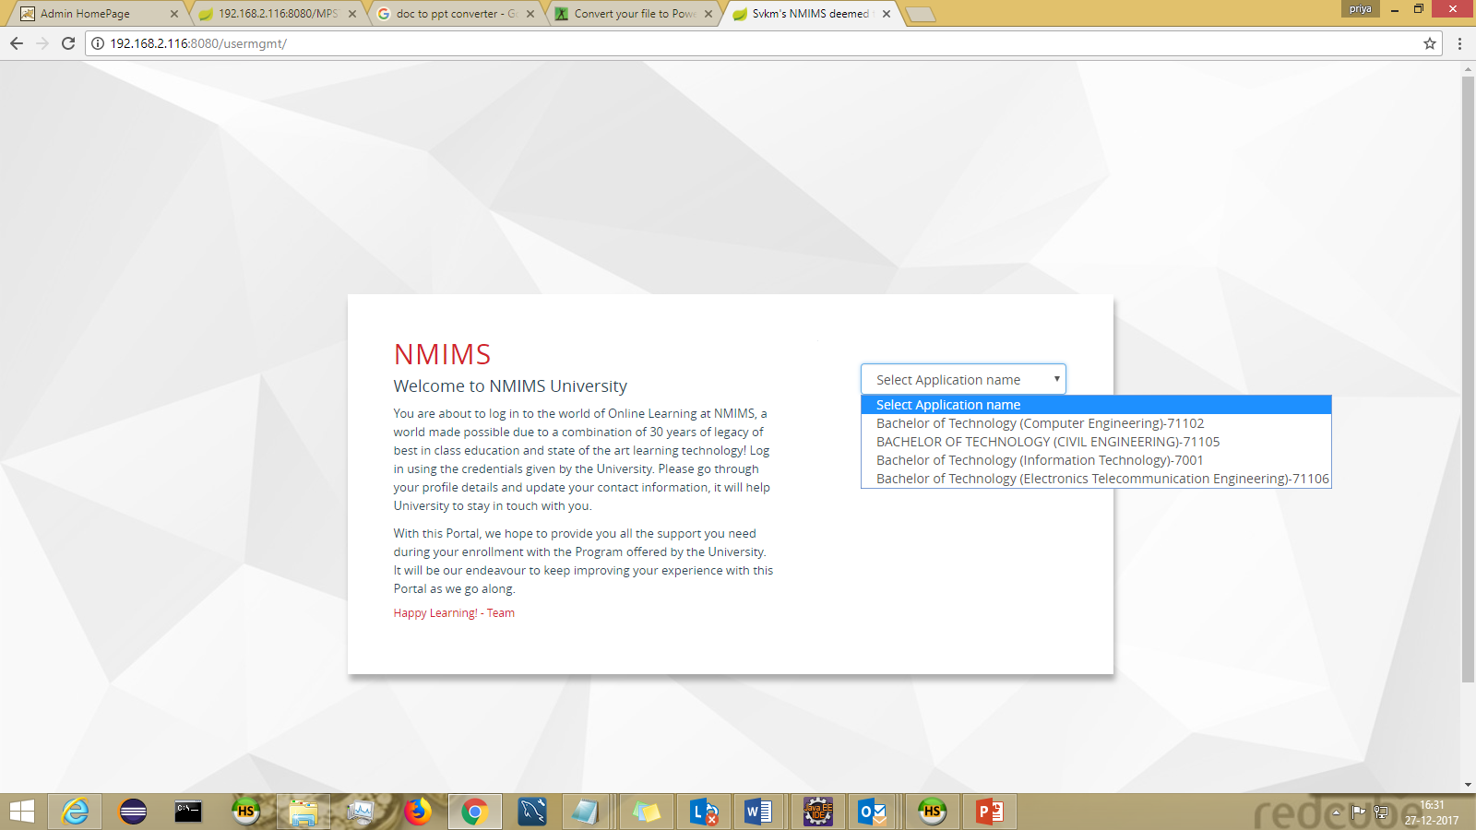

ADMIN DASHBOARD
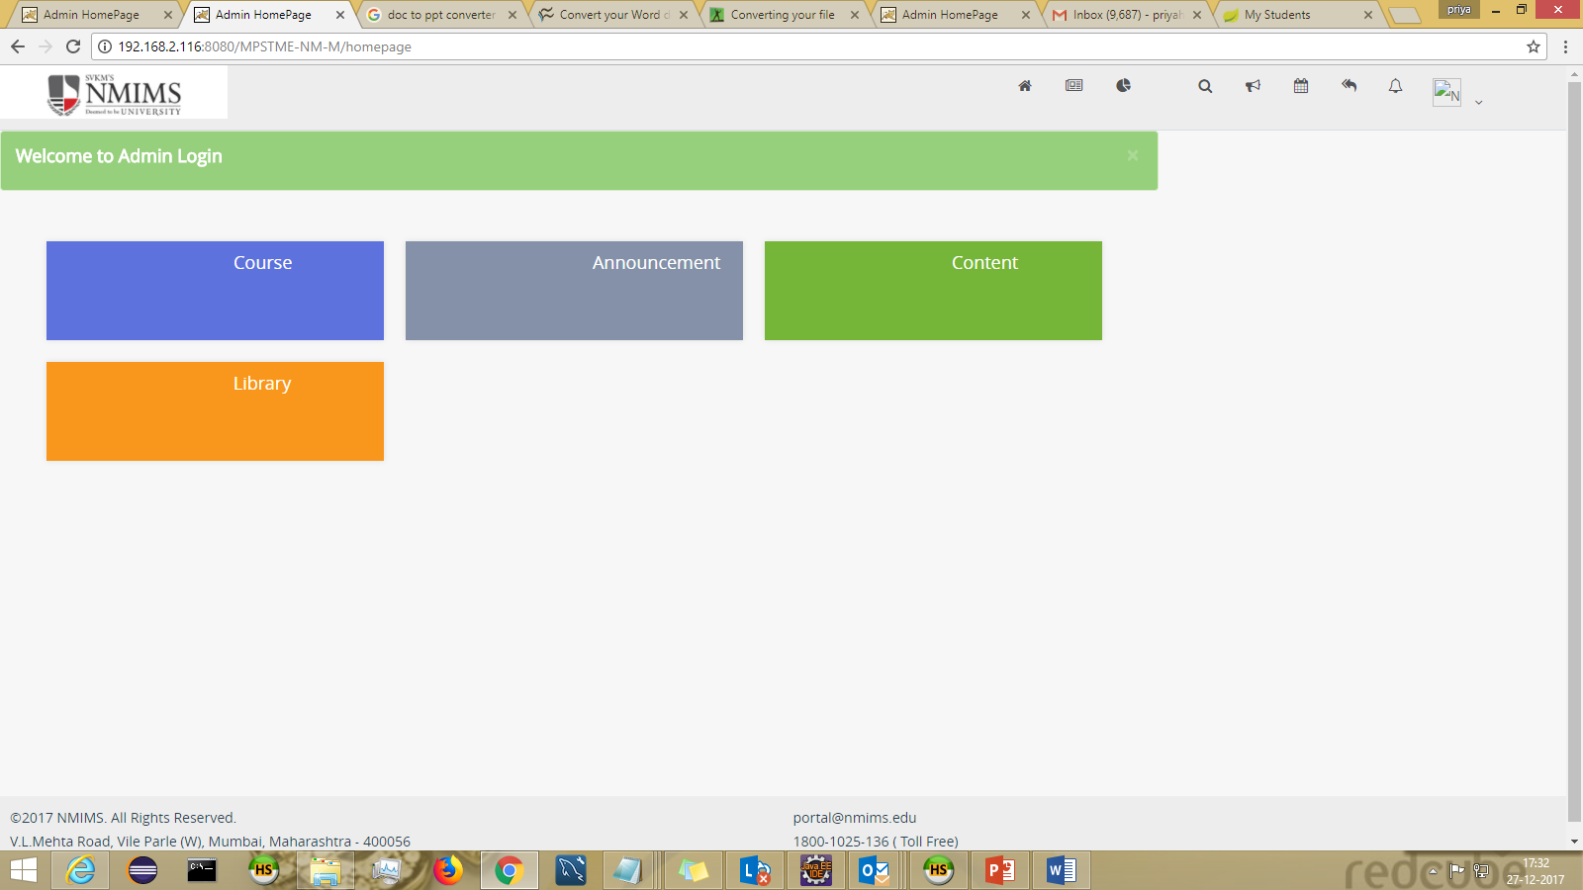

Following are the functionalities:

COURSE
SEARCH COURSES
-can be landed via header : Course > Search Courses

The course details can be searched using the course name.
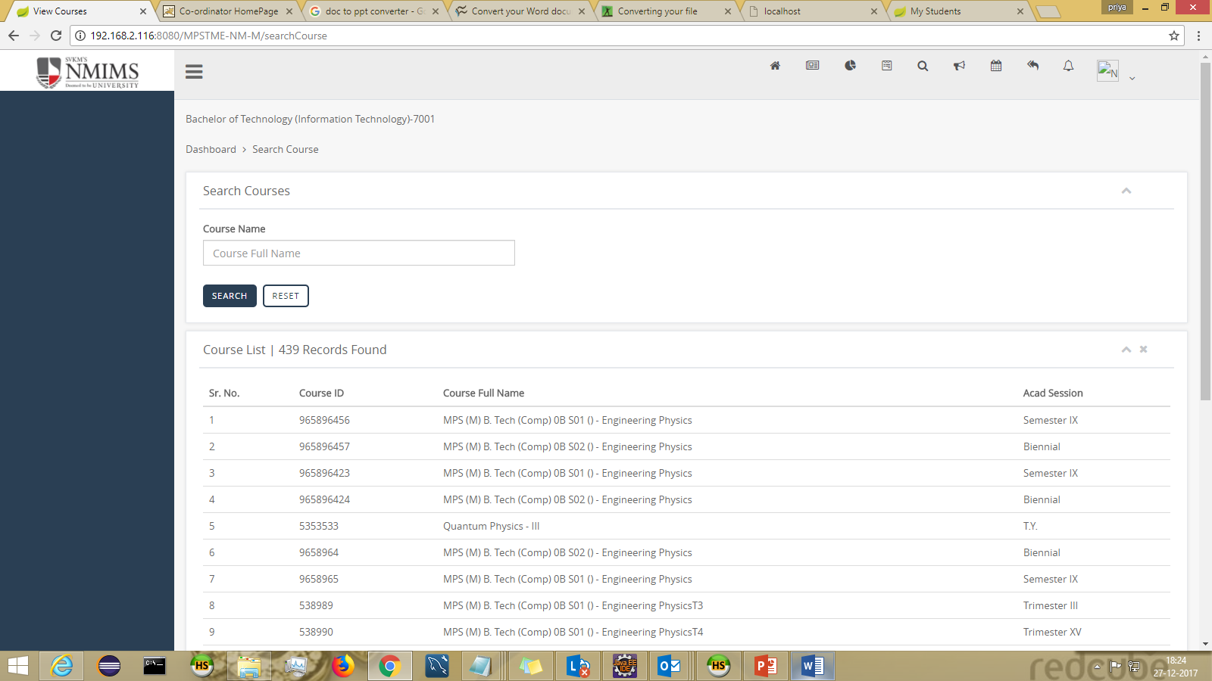

WEIGHATAGE

ASSIGN WEIGHTAGE :
-can be landed via header : Weightage > Assign Weight

Weightage can be assigned to Assignment/Test/Class Participation
- Weigtage can be assigned in 2 ways
a)Individual Component Weightage Allocation
b)Upload from Weightage Bank
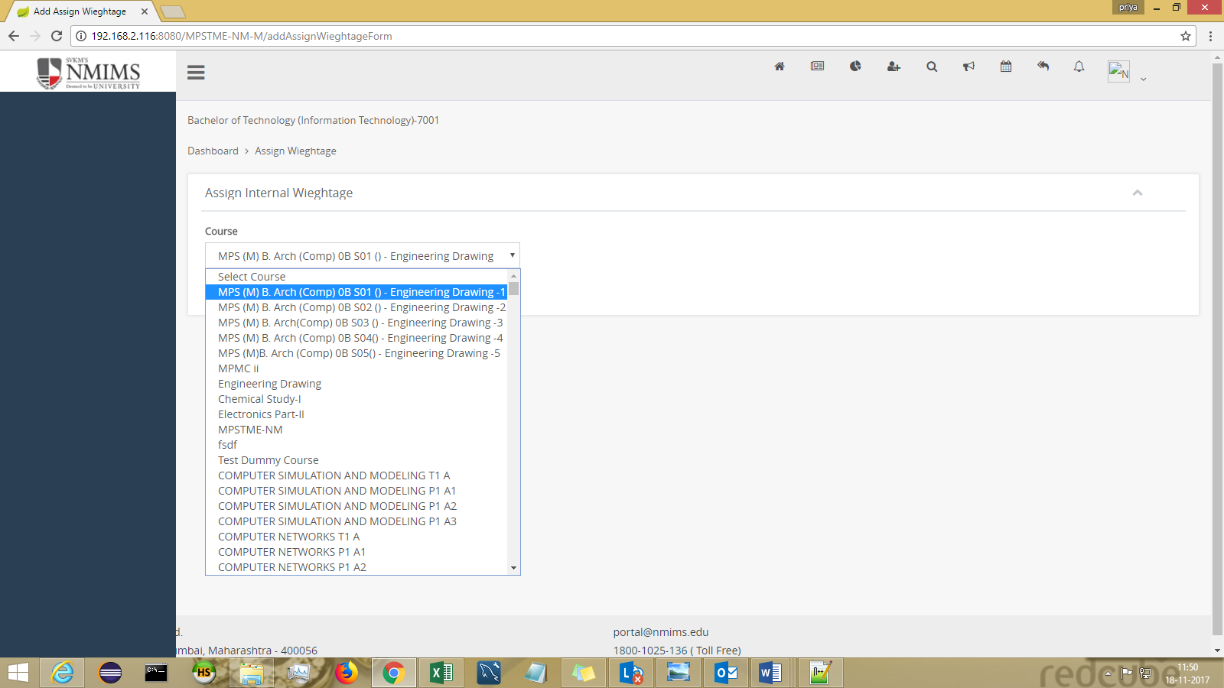

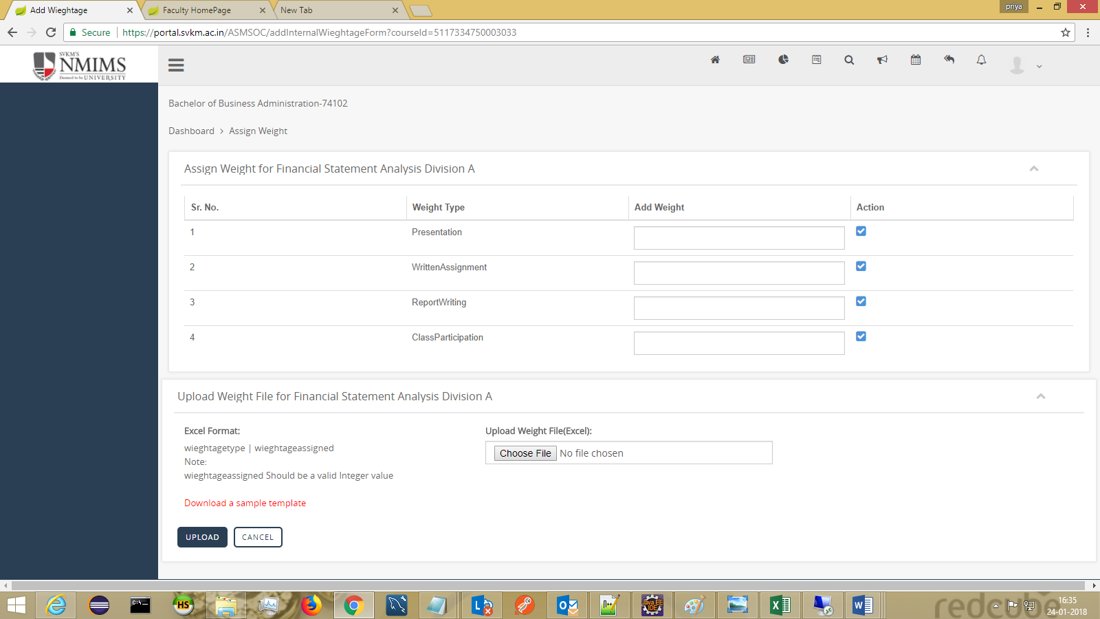

VIEW ASSIGNED WEIGHTAGE-
-can be landed via header : Weightage > View Assigned Weight

The assigned weightage can be seen course wise.
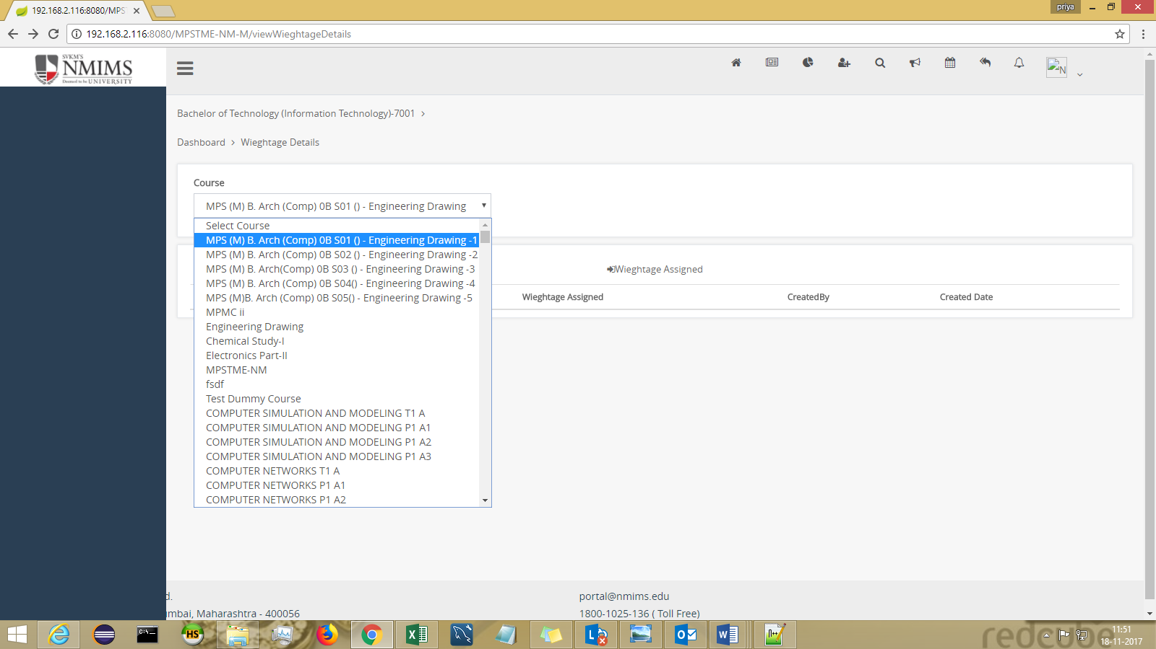

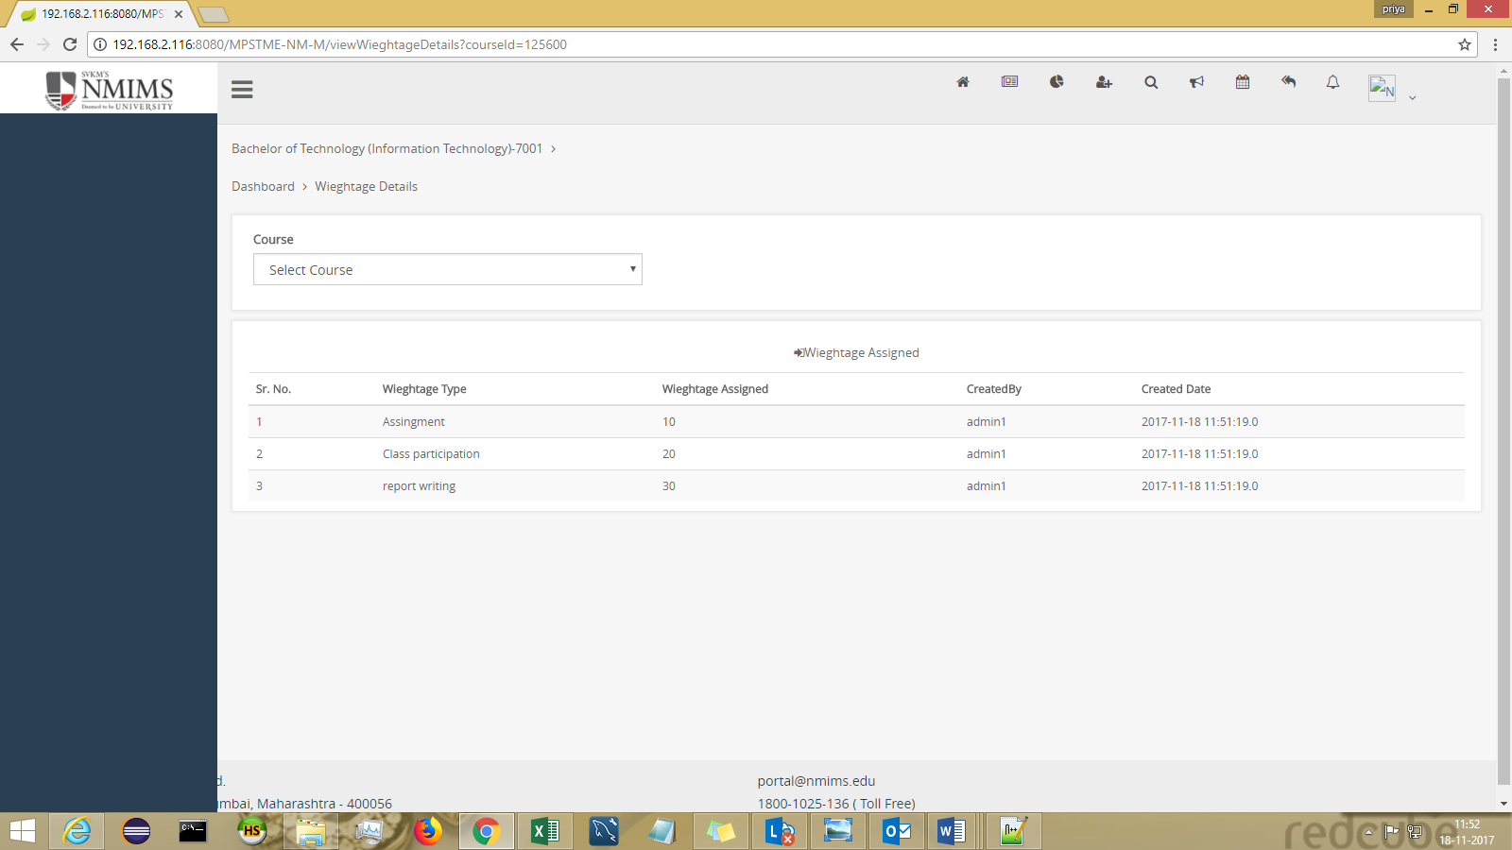

MY PROGRAM STUDENTS
-can be landed via header : My Program(icon)

Course wise Students searching is also possible. Select the course from dropdown. Also, an excel report can be generated by clicking on “Export To Excel” at end of page.
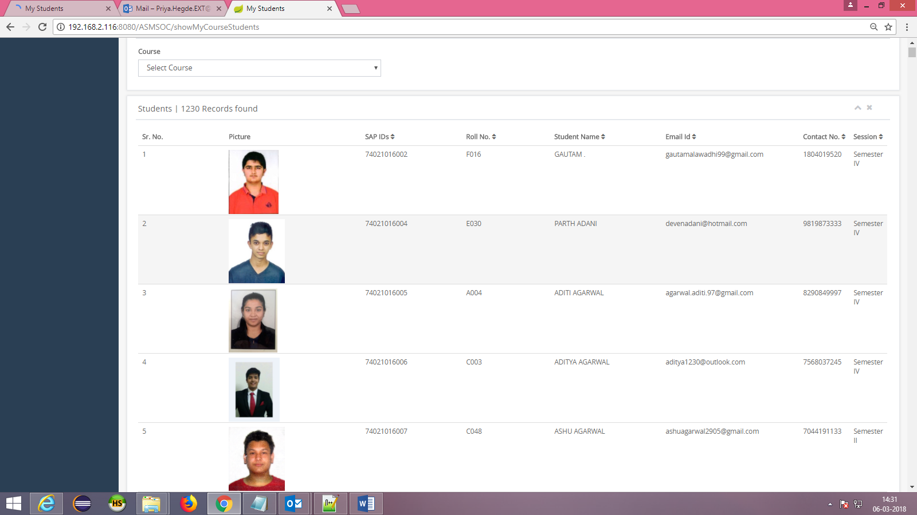

SEARCH

ADD QUESTION PAPERS
-can be landed via header : Search > Add Question Papers

Bulk upload of Question papers can be done course wise.

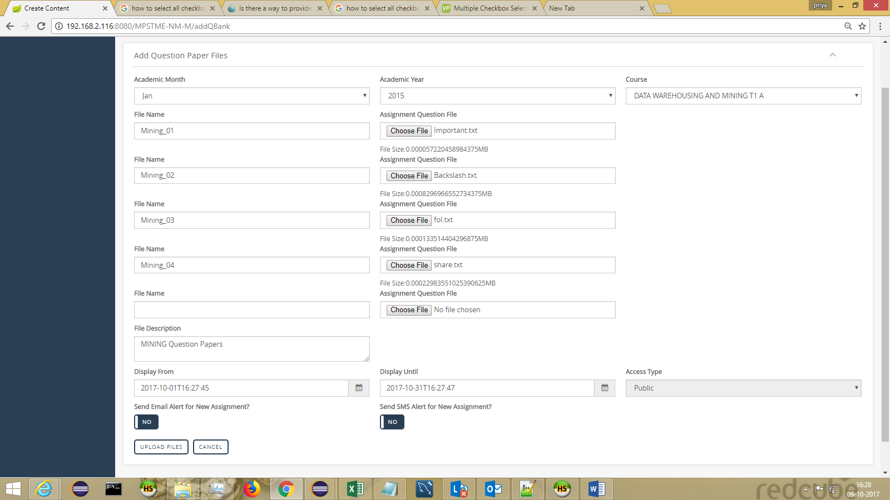

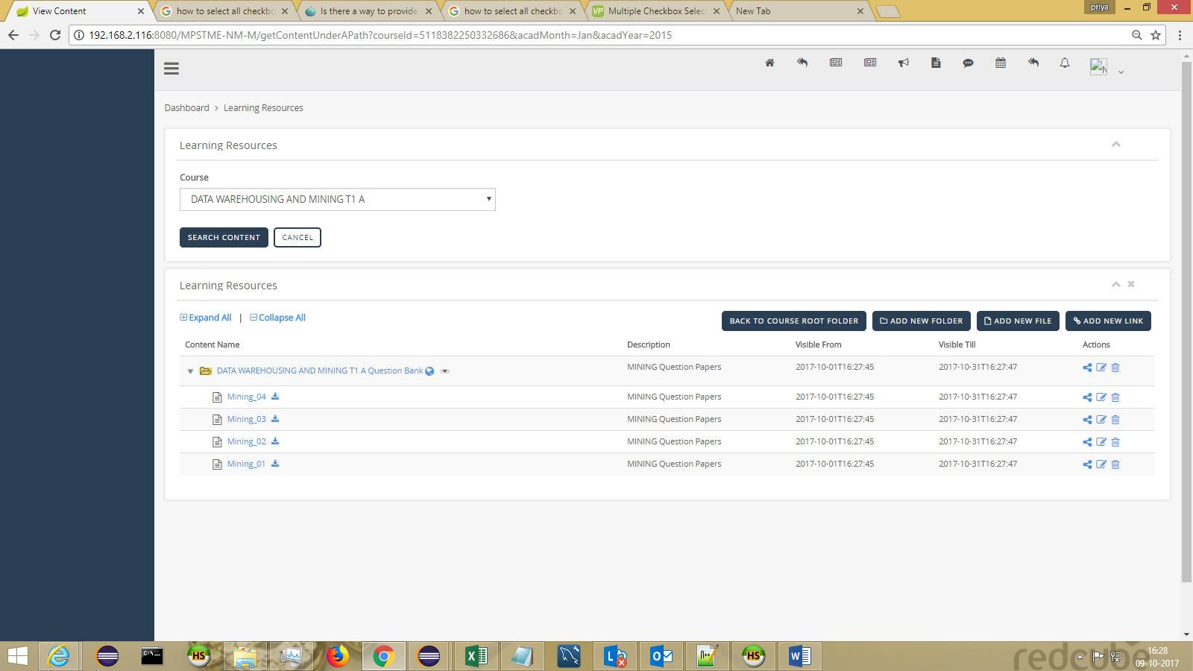

ADD FACULTY DETAILS :
-can be landed via header : Search > Faculty Details

Additional details of faculty like experience, email-id etc can be added on

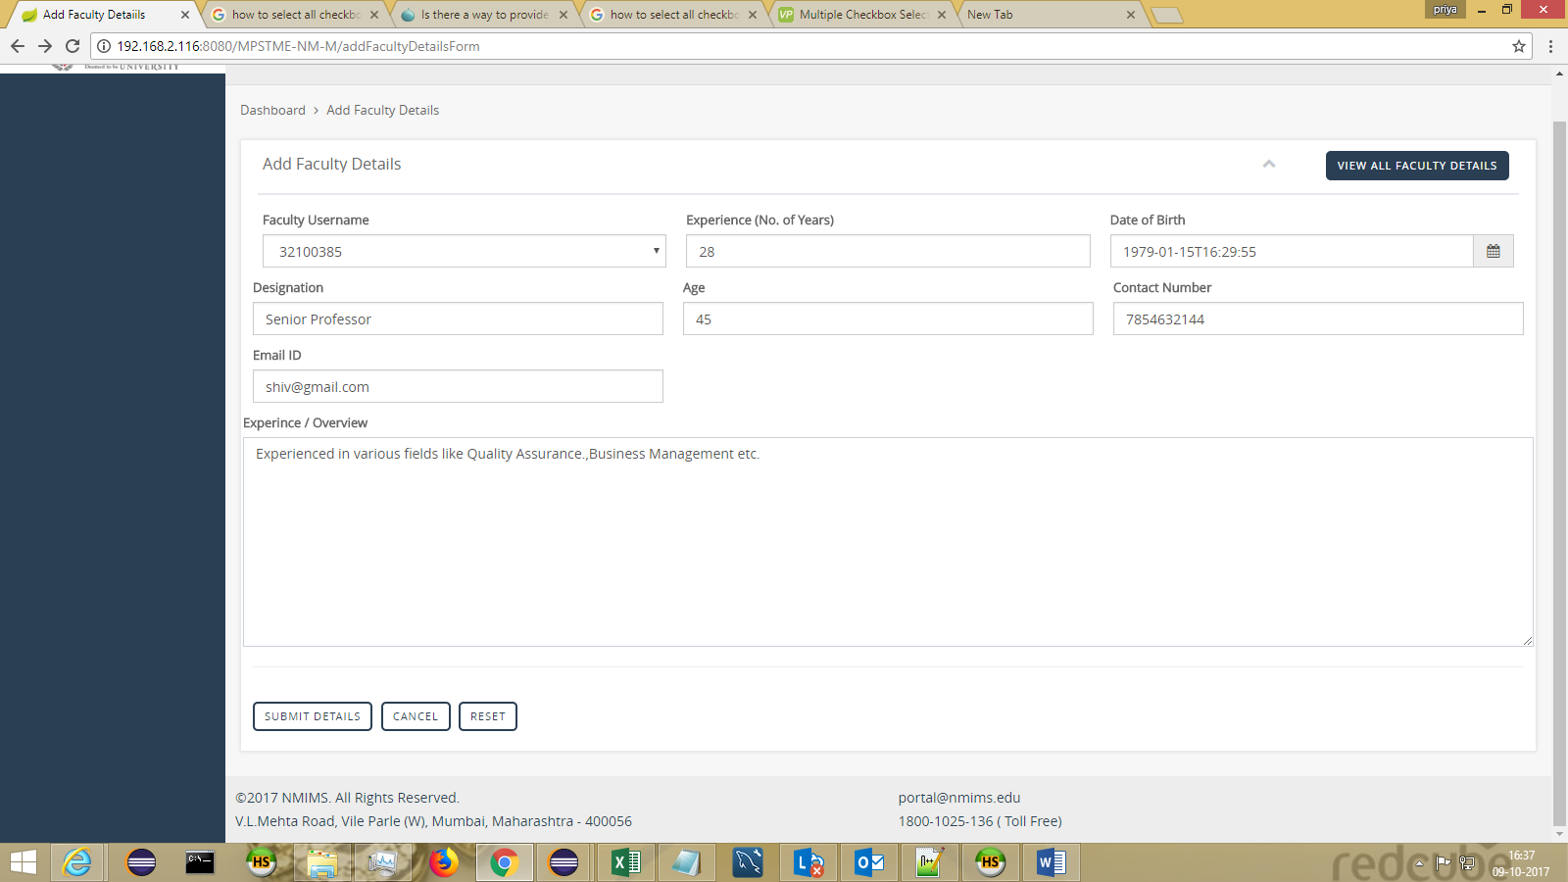
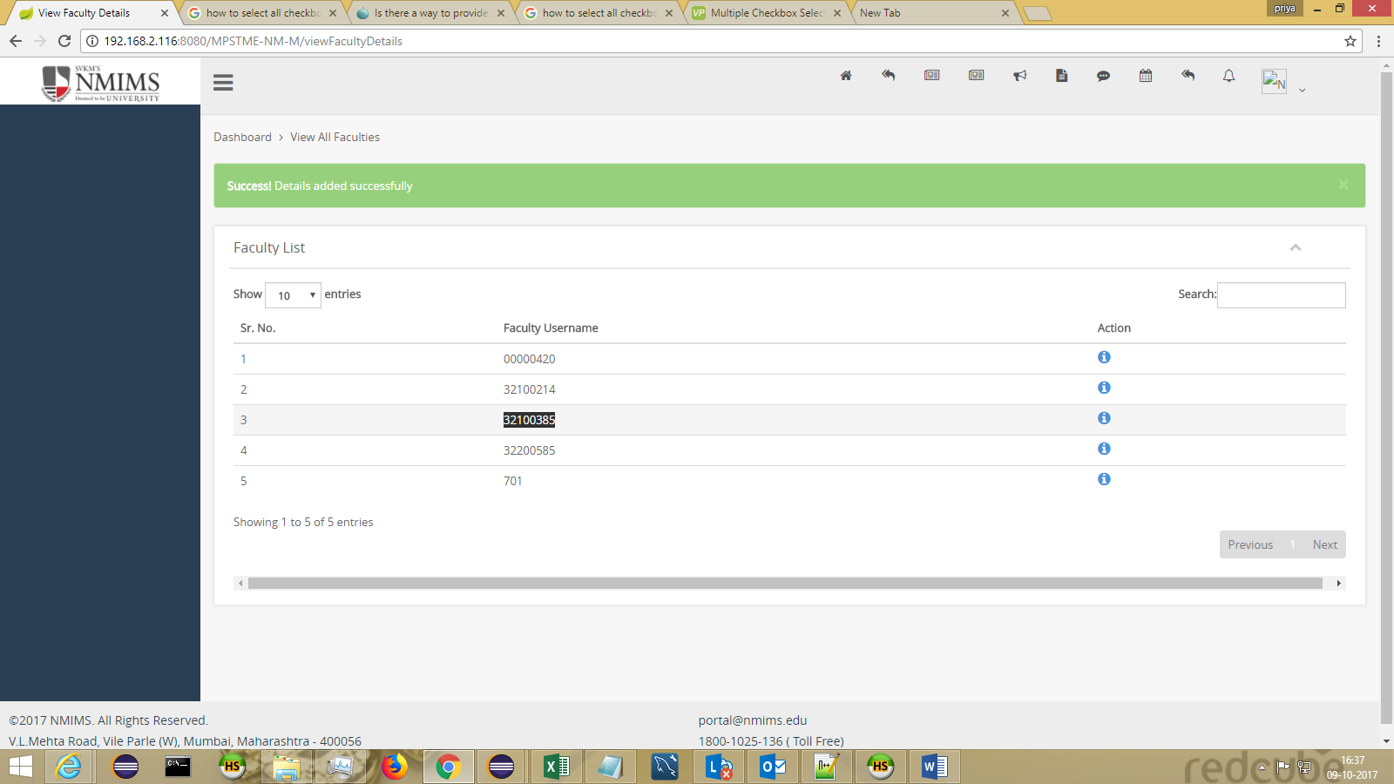

SEARCH ALL ASSIGNMENT/TESTS :
-can be landed via header : Search > Search All Assignment/Test

The assignments and tests can be searched acad year and acad month wise.
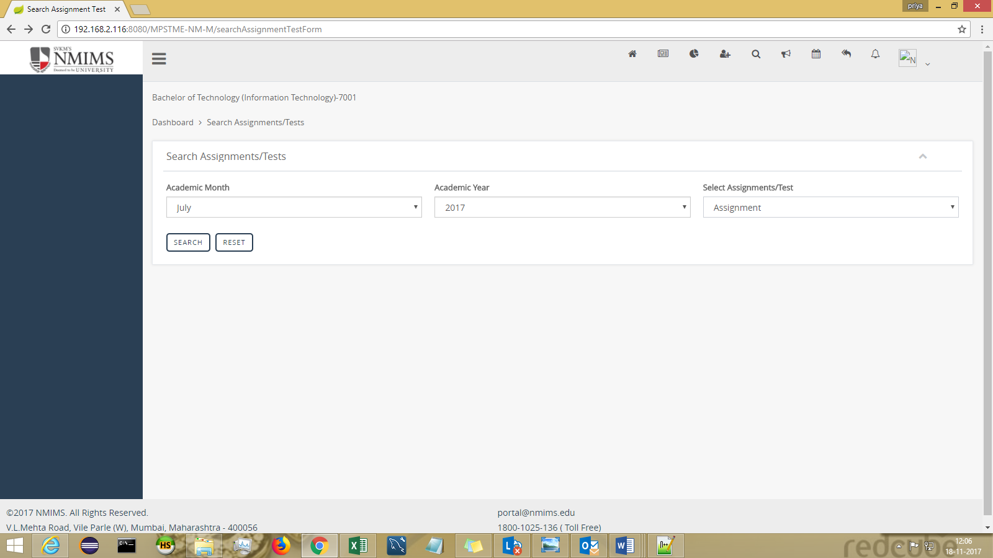

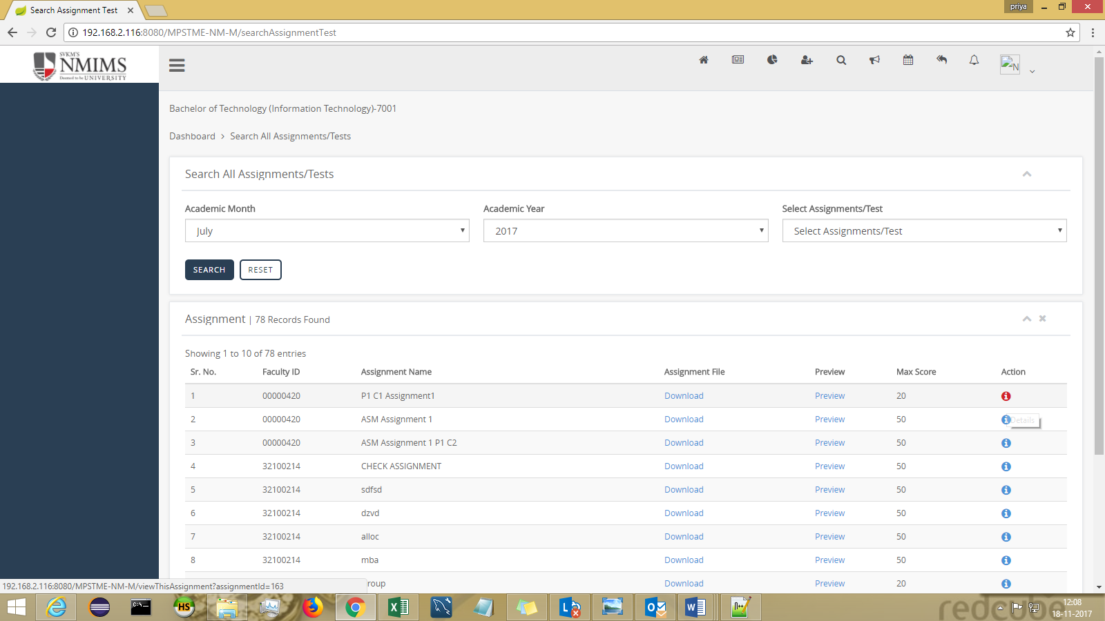

On click of info icon :
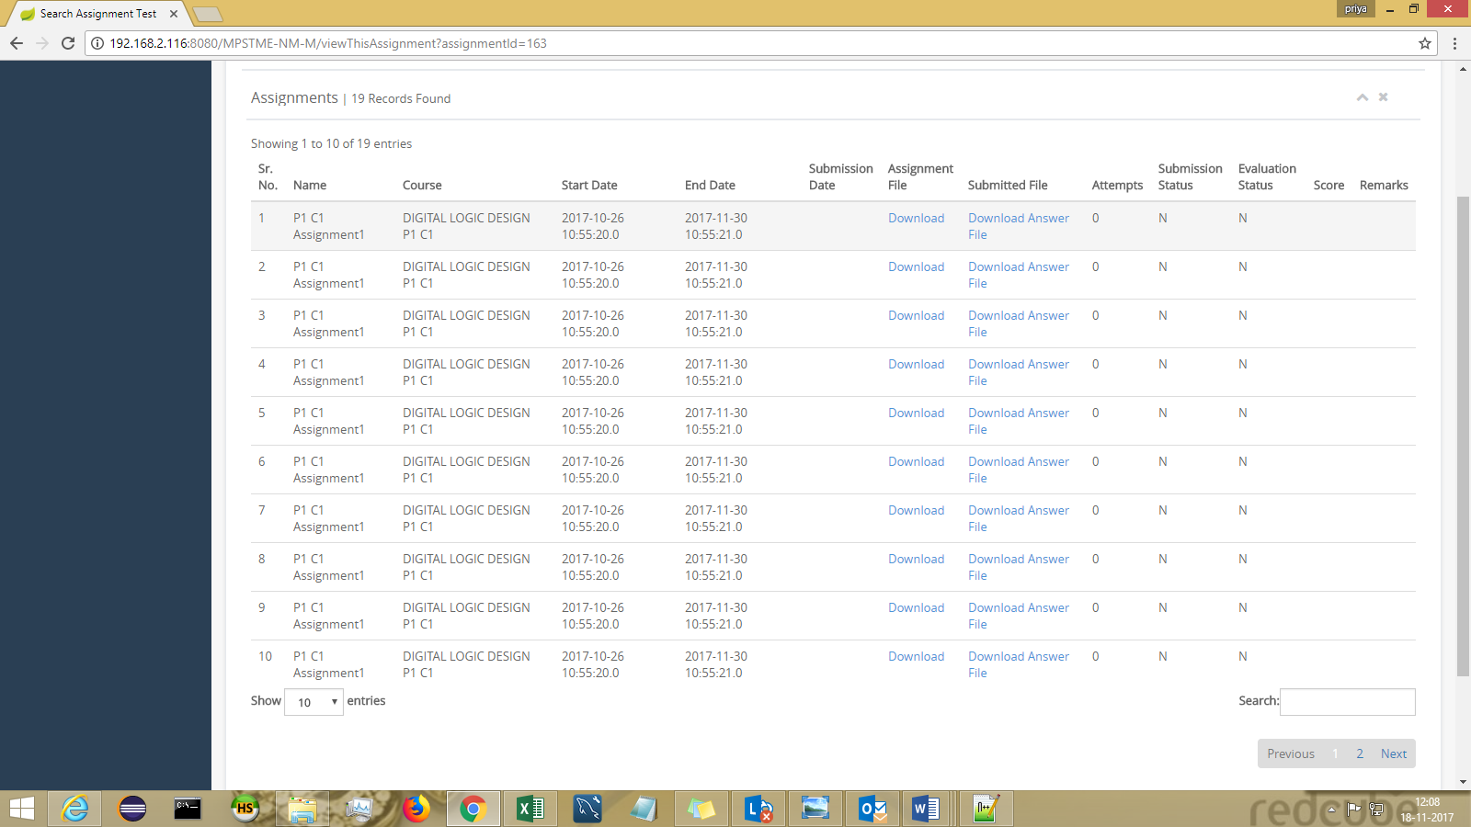

GENERIC SEARCH
-can be landed via header : Search > Generic search

Generic Search can be used for searching Assignment/Test/Feedback/Resource

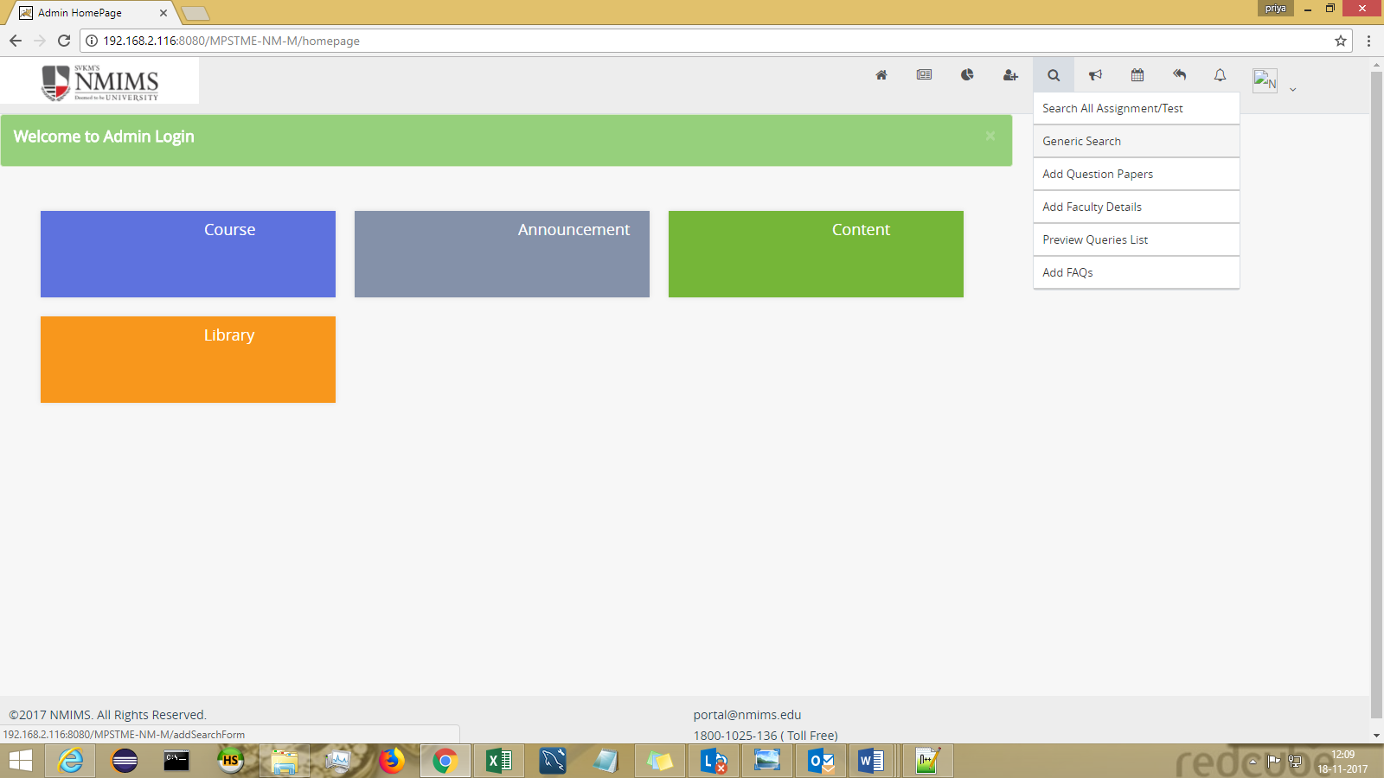

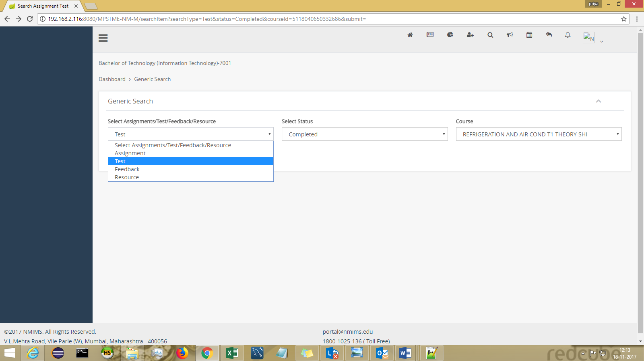

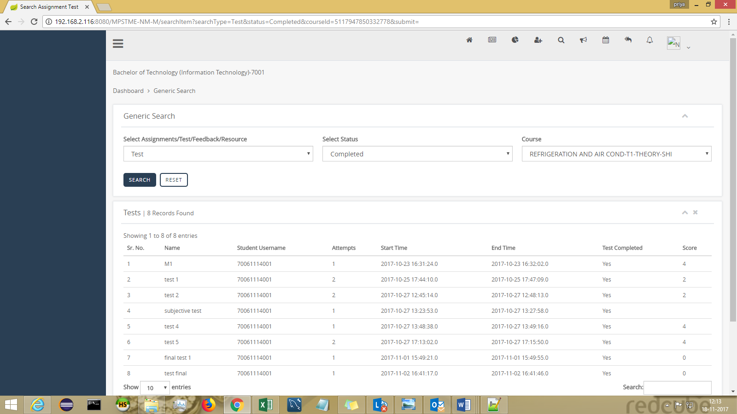

PREVIEW QUERIES LIST :
-can be landed via header : Search > Preview Queries List

The queries raised by students can be viewed here.
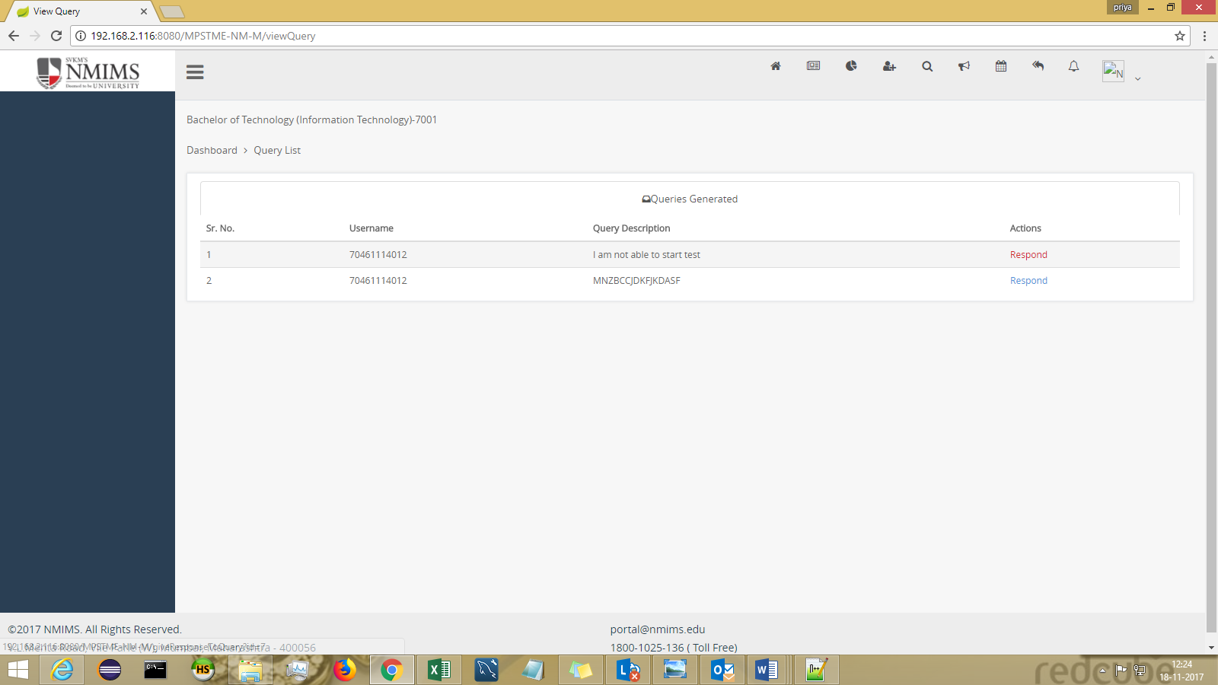

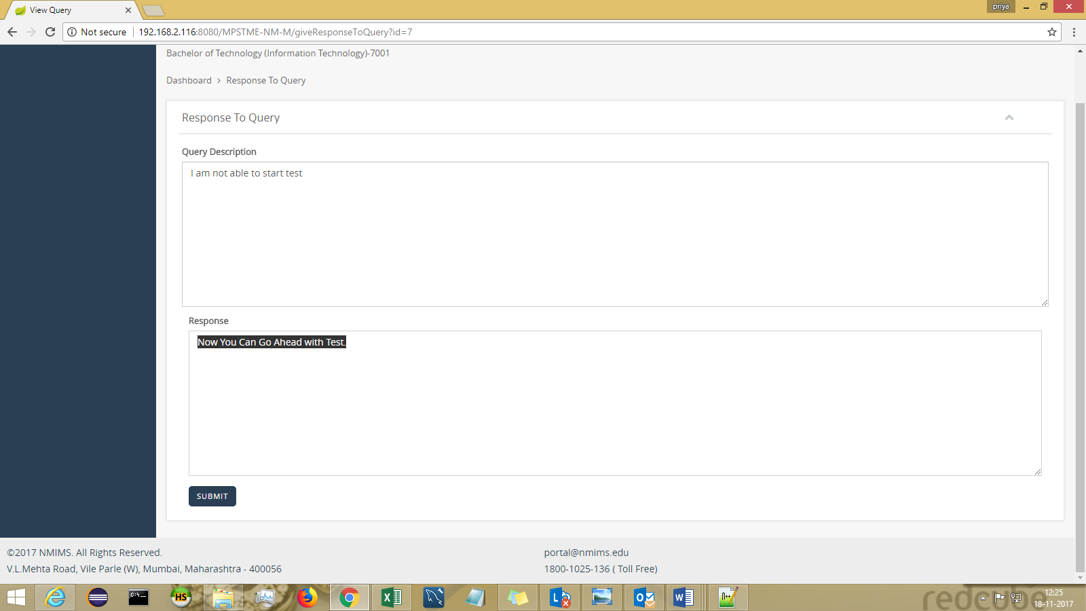

ADD FAQ
-can be landed via header : Search > Add FAQs

Frequently asked Questions can be uploaded in Excel format.

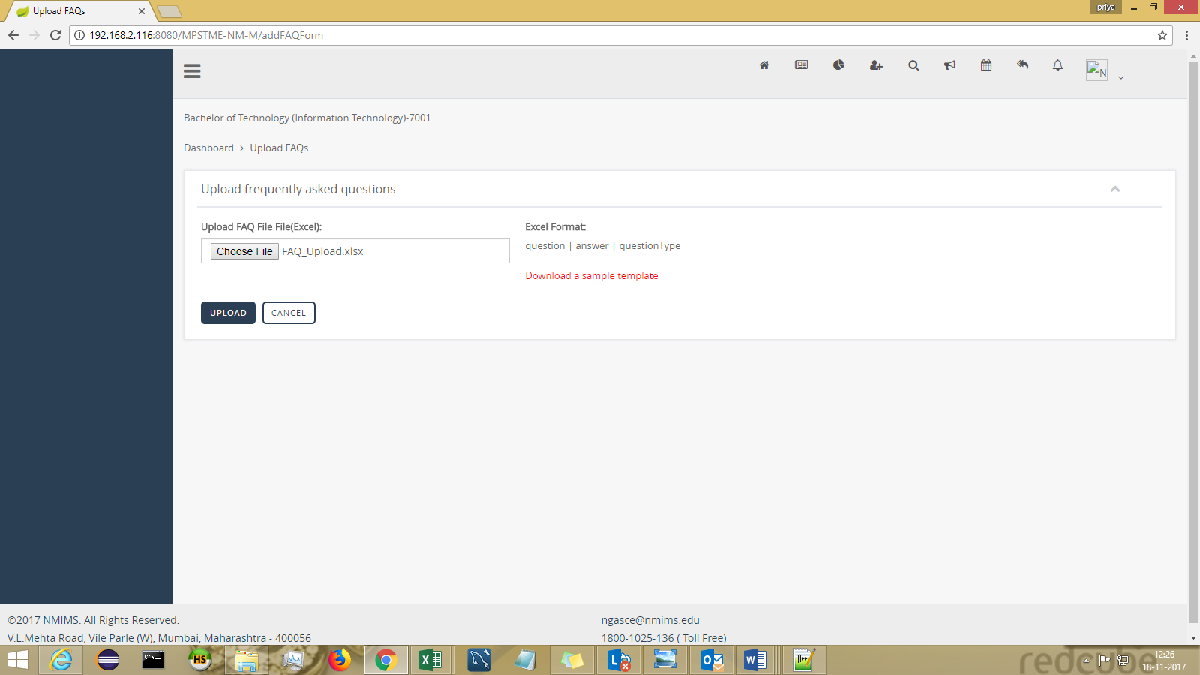

Content of Excel :

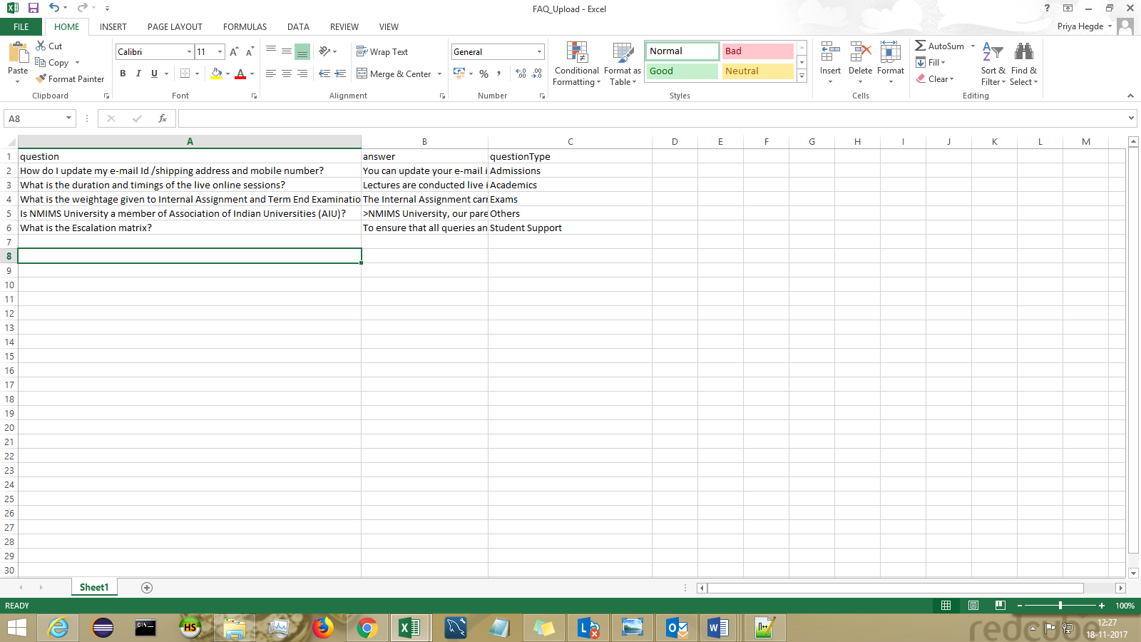

ANNOUNCEMENT

ADMIN can create Institute Level Announcements and Program Level Announcements

Create Announcement For Institute
-can be landed via header : Announcement > Create Announcement For Institute
Fill in the required parameters and click on Create Announcement
Notification can sent to students (Email | SMS) by keeping the toggle “ON”.

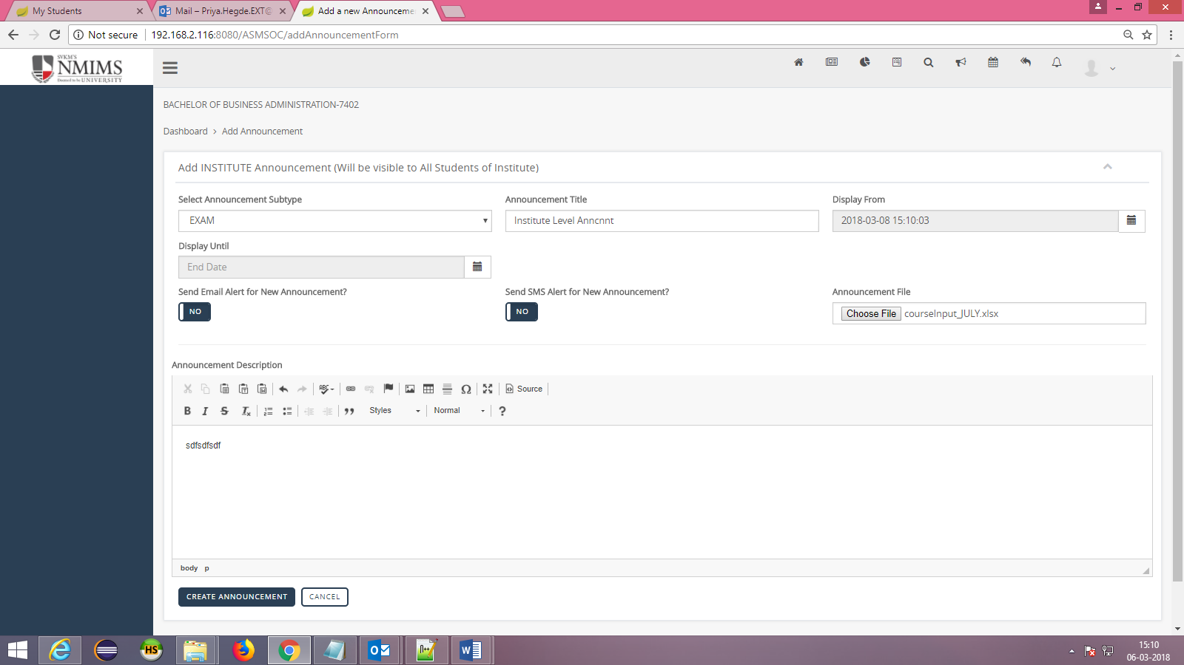

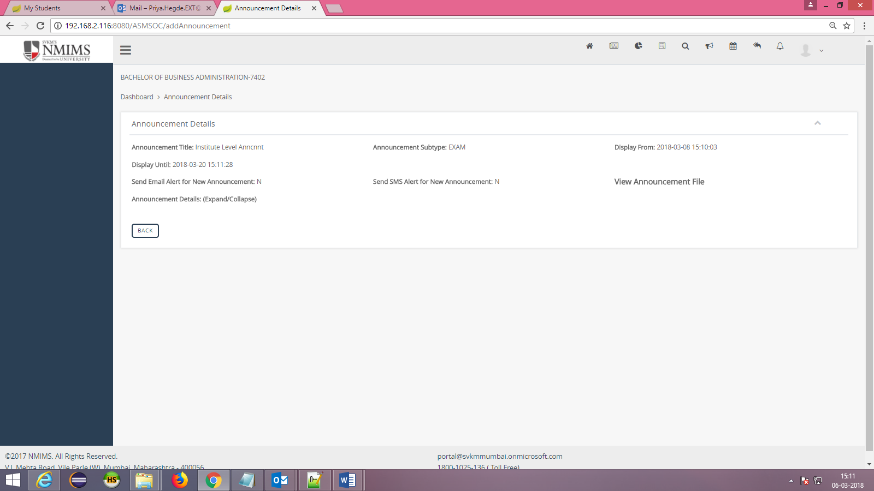

Create Announcement For Program
-can be landed via header : Announcement > Create Announcement For Program

Fill in the required parameters and click on Create Announcement.
Select the appropriate acad year and semester from dropdown.
Notification can sent to students (Email | SMS) by keeping the toggle “ON”.

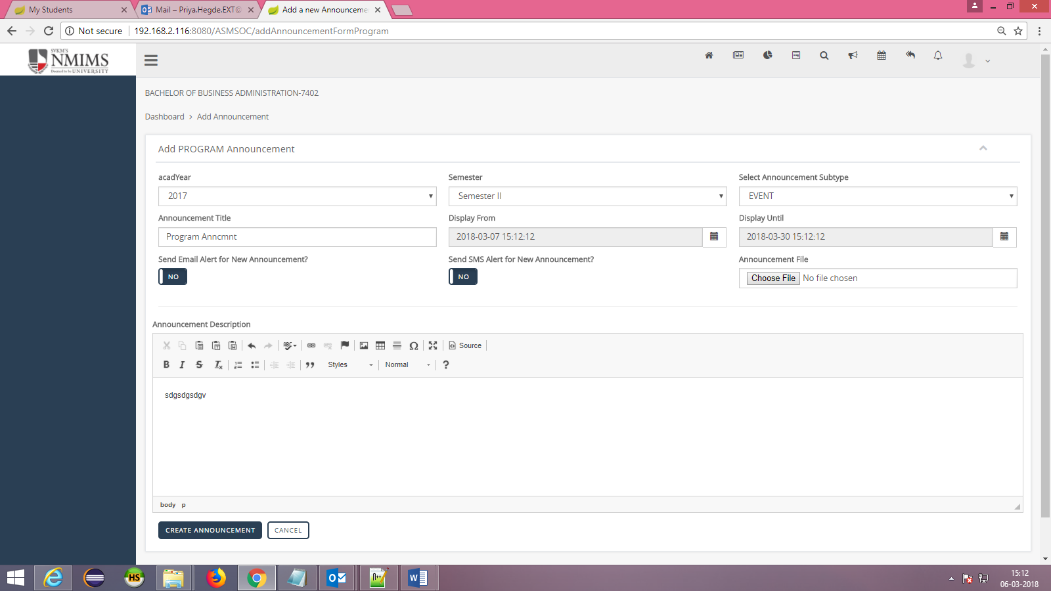

SEARCH ANNOUNCEMENT :
-can be landed via header : Announcement > Search Announcement

Announcements can be serached based on announcement sub type and announcement type
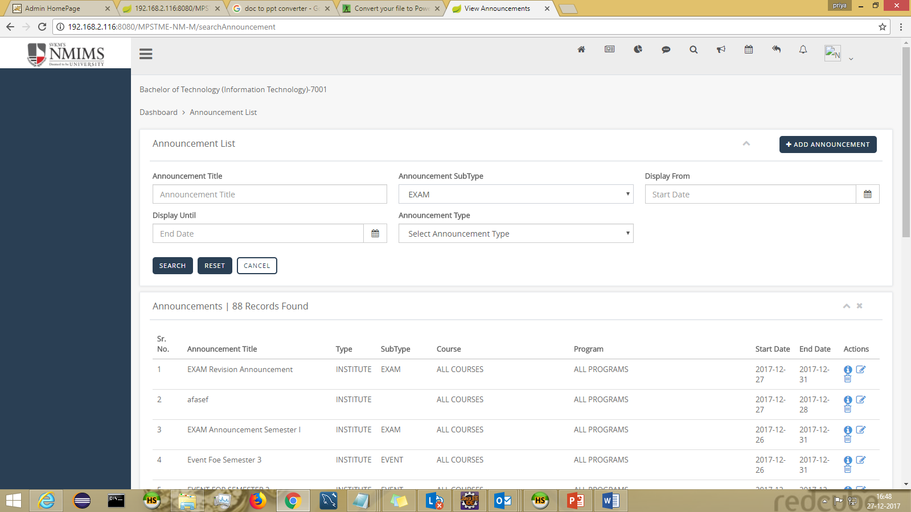

CALENDAR
-can be landed via header : Calendar > View Event

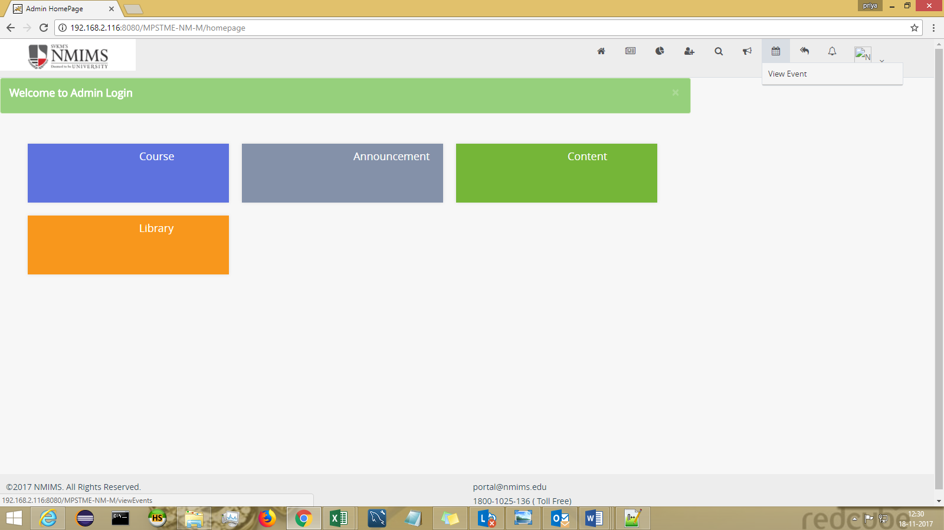

VIEW EVENT
Events can be created using CALENDAR.

Fill in all the required details on the event form and click on ADD EVENT button.
There are 2 access types provided –Only Me and VIEWED BY ALL.

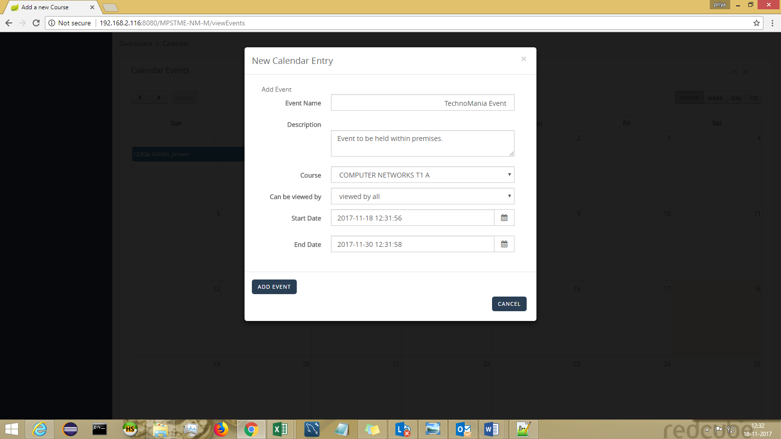

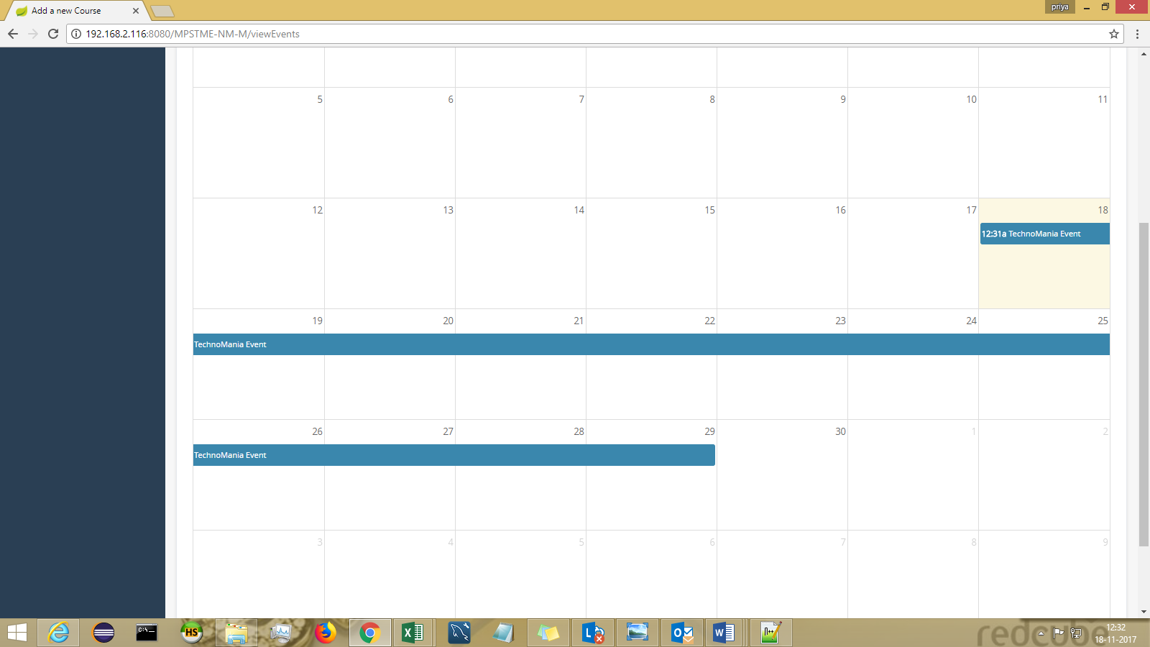

FEEDBACK

Create Feedback
-can be landed via header : Feedback > Add Feedback

Feedback can be added through this screen.
Eg: Feedback-Subject name(Feedback-Marketing)
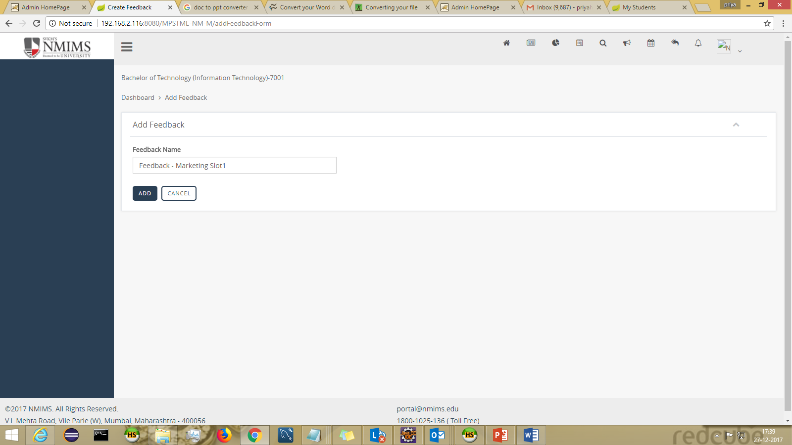

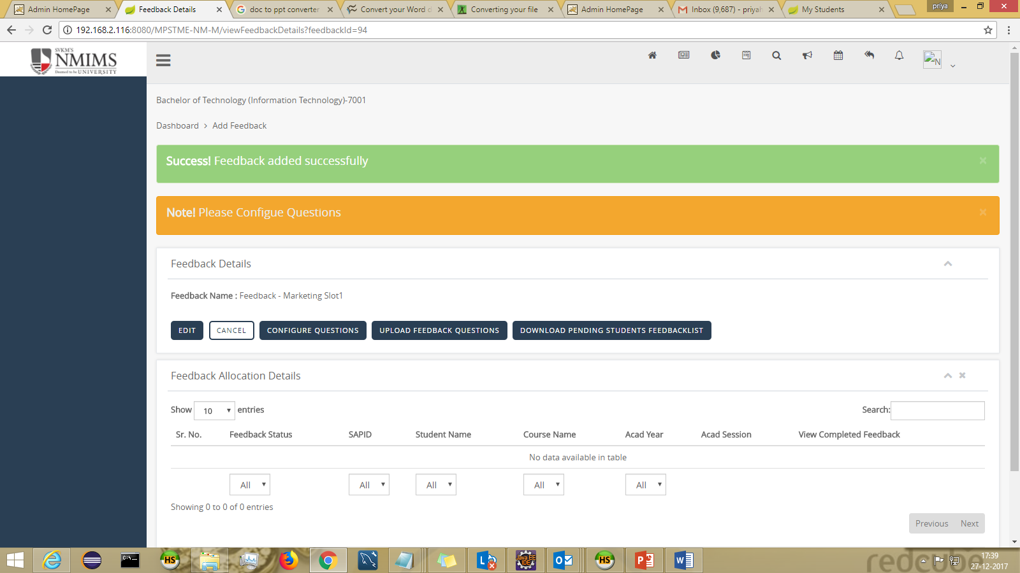

Uploading Questions for Feedback

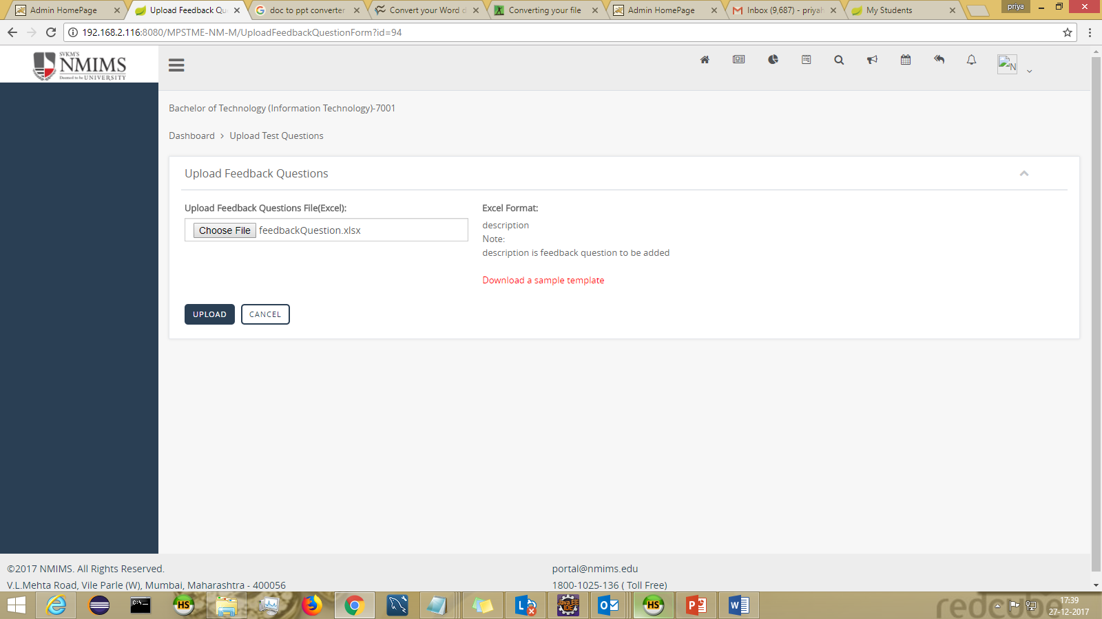

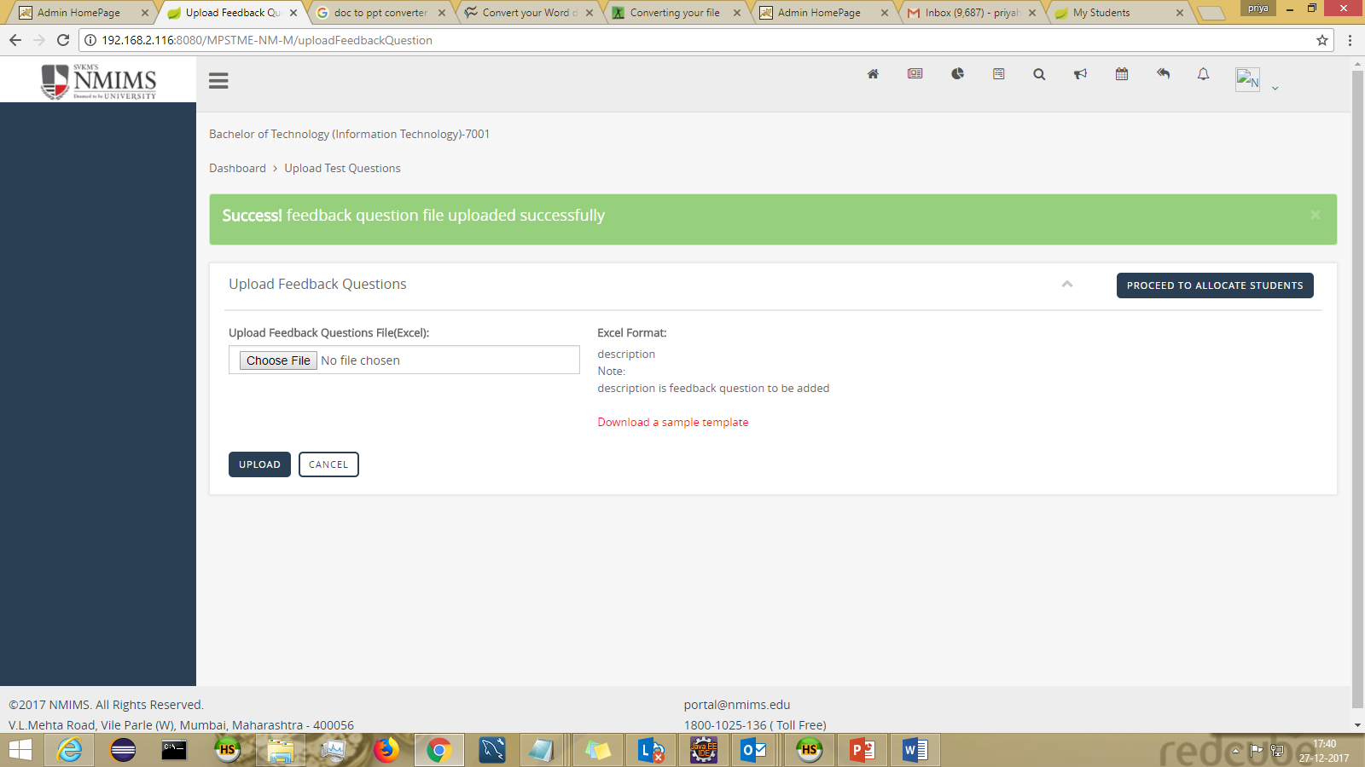

Allocation Of Feedback (Program level) :
-can be landed via header : Feedback > Allocate Feedback

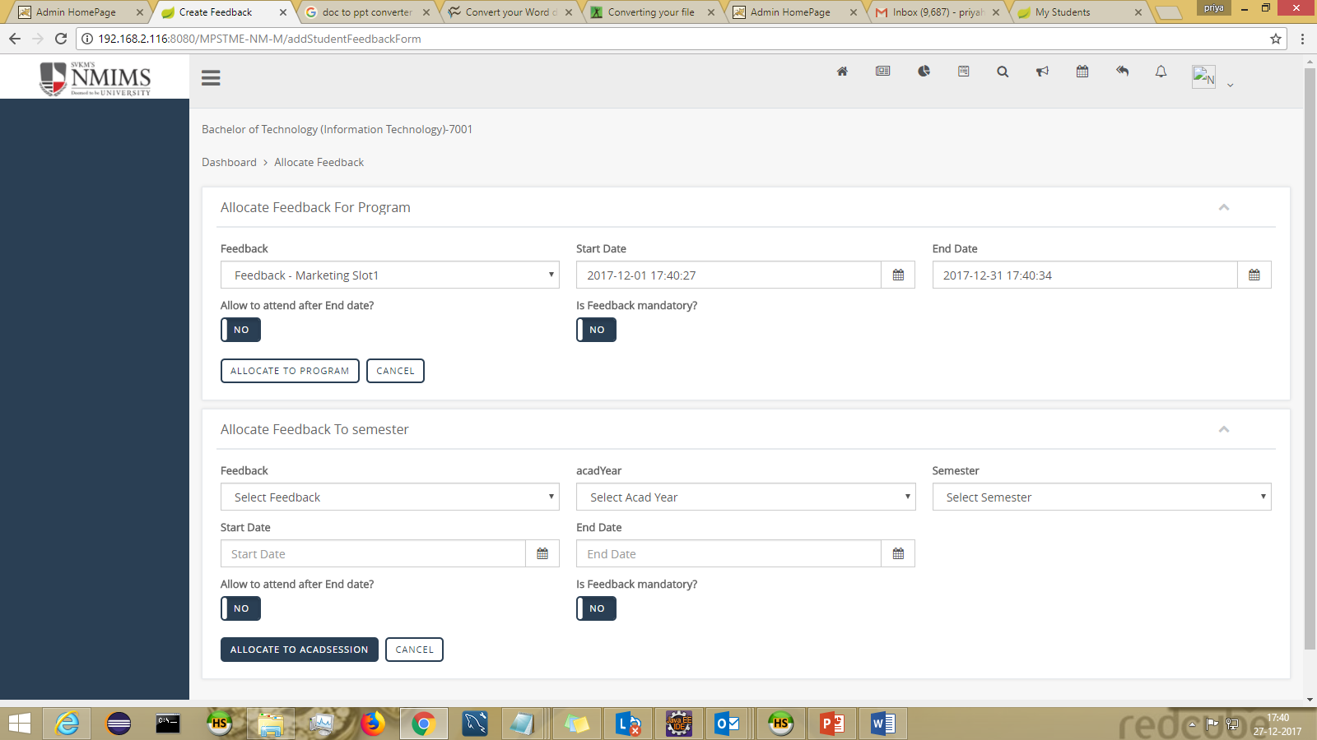

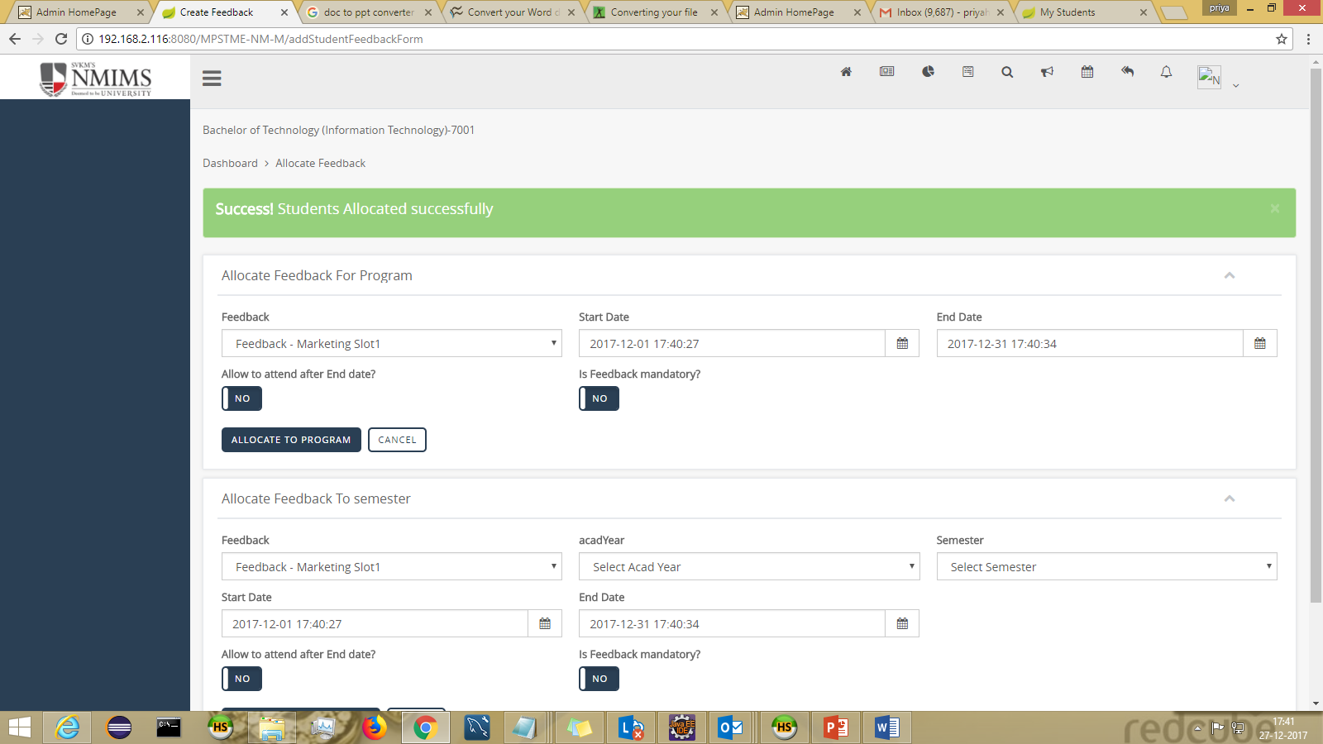

Feedback can also be allocated acad session wise:

VIEW FEEDBACK :
-can be landed via header : Feedback > View Feedback

Students to whom feedback is allocated can be viewed in View Feedback in info action

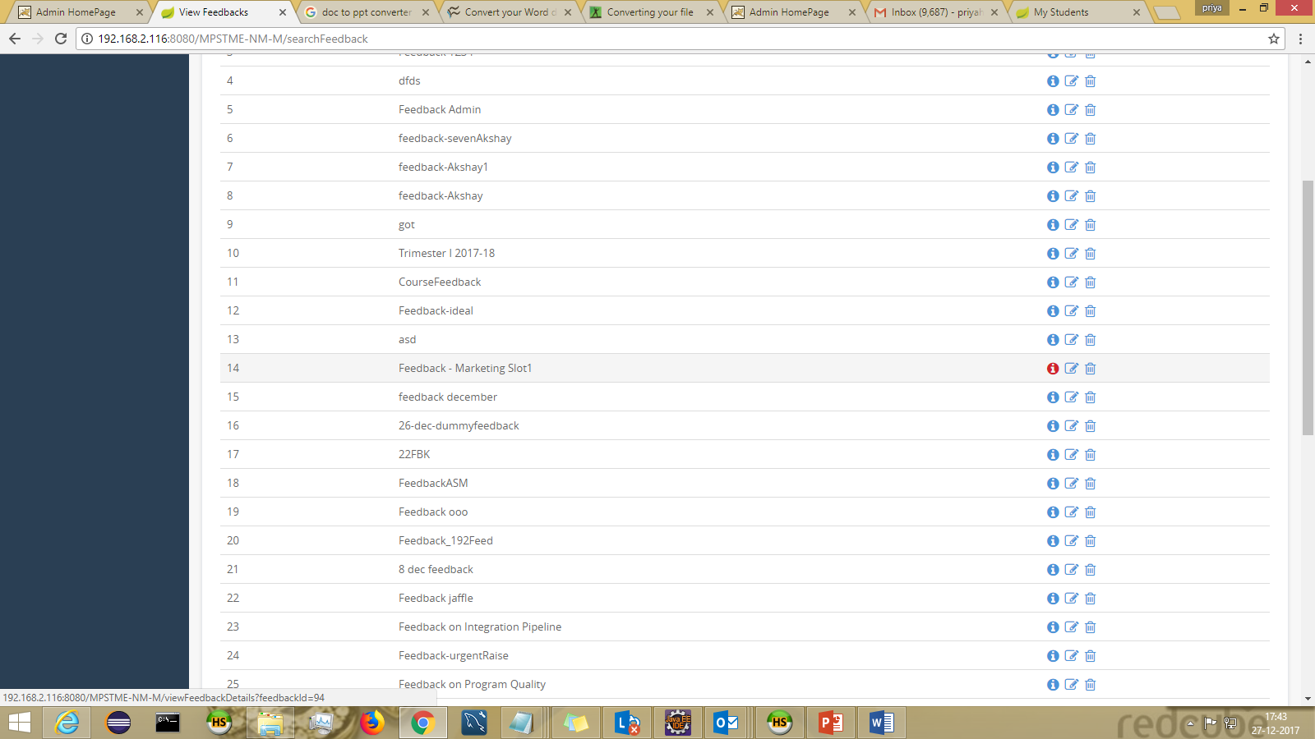

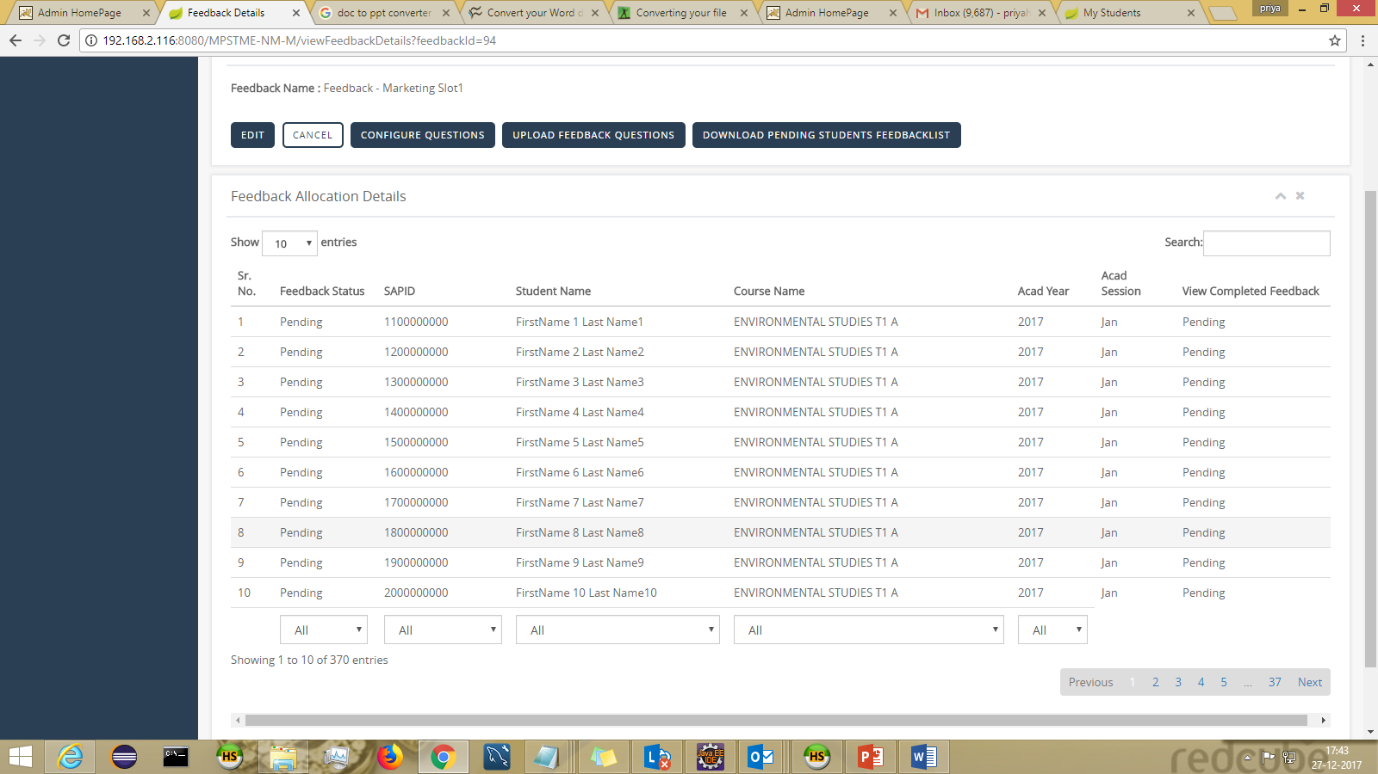

NOTIFICATION
-can be landed via header : Alert icon

Alert (rightmost icon on the header menu) - will show all announcements (Course + Institute level)

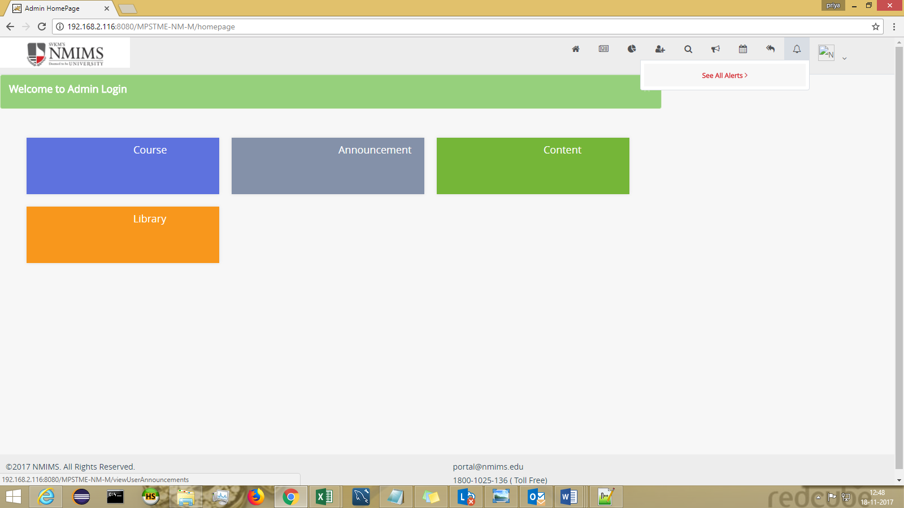

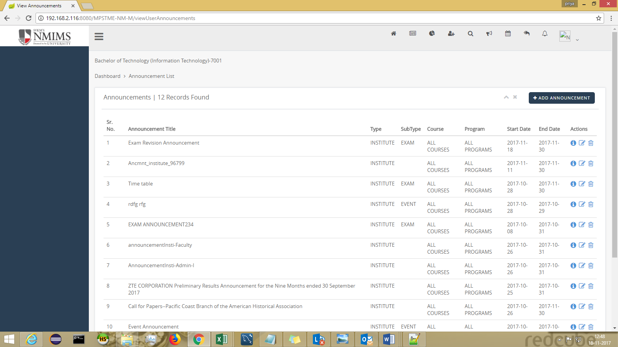

LIBRARY (Non Course Content)
-can be landed via dashboard > Library

The Non-Course content would be visible to all the members of the INSTITUTE.

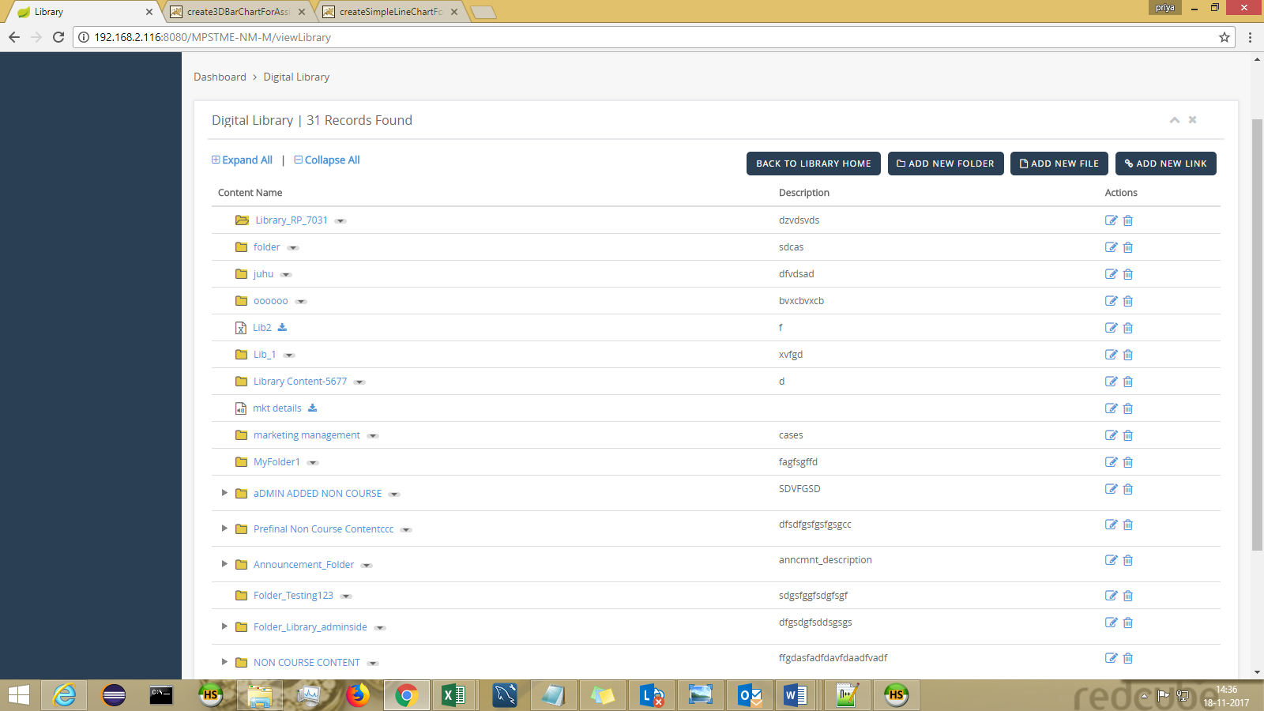

Adding Folder
Fill in all the required fields and click on “CREATE FOLDER”

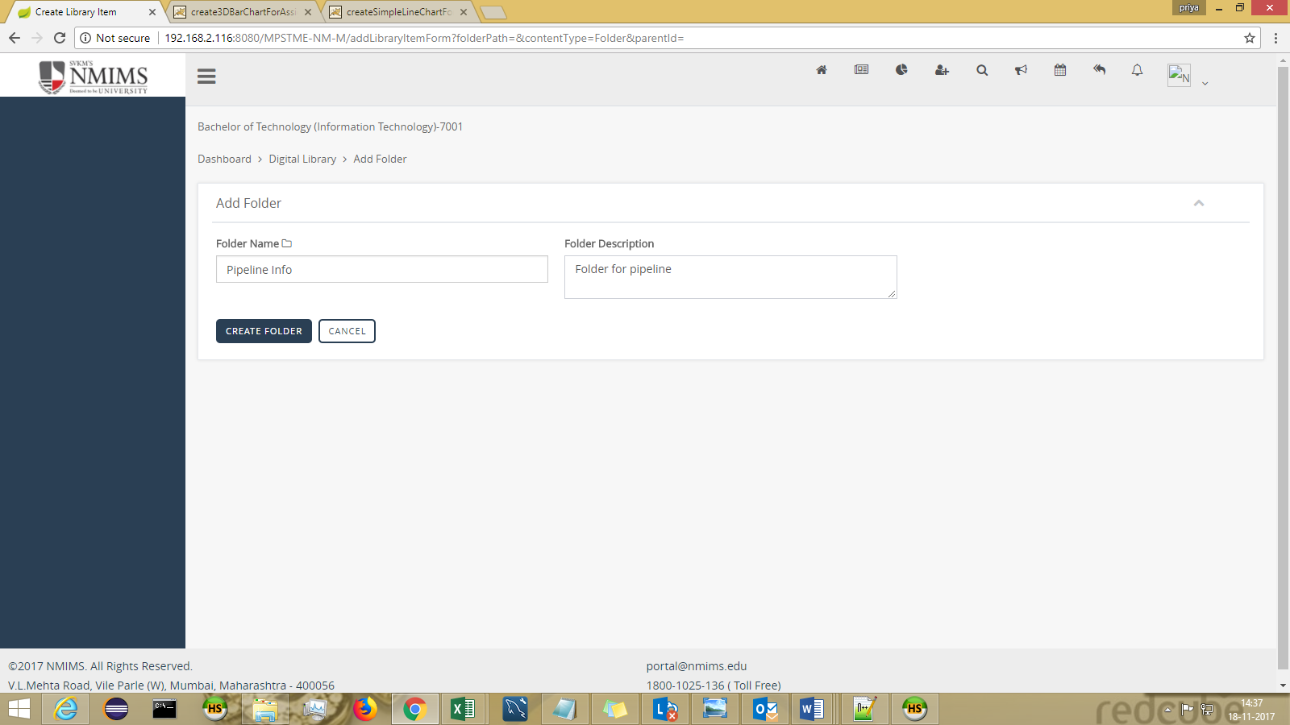
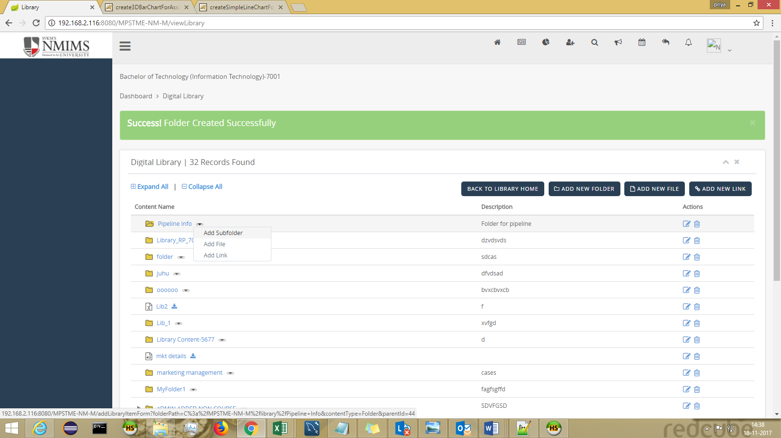

Adding Sub Folder
Fill in all the required fields and click on “CREATE FOLDER”
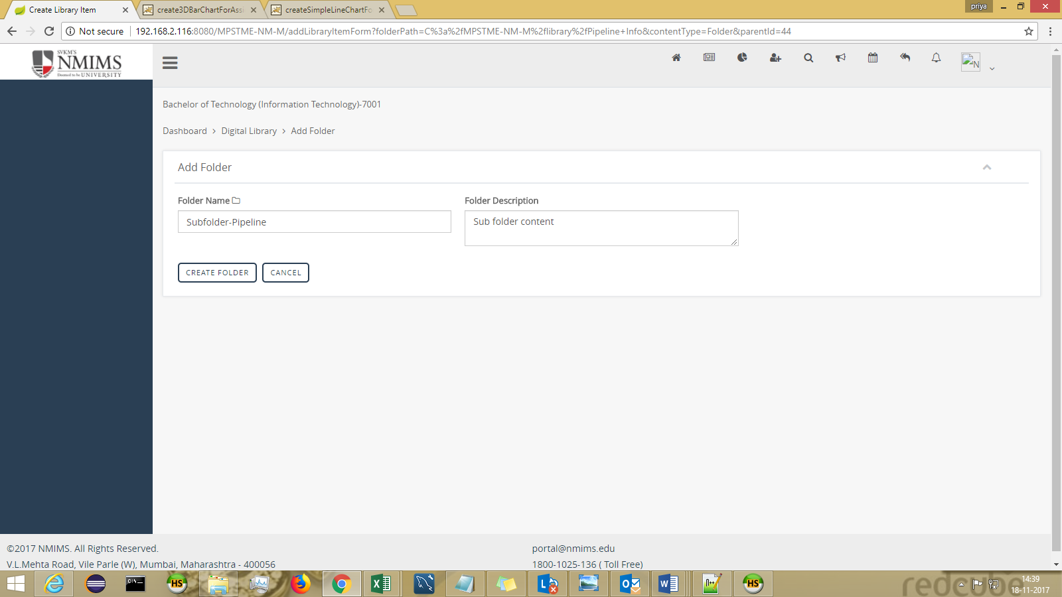
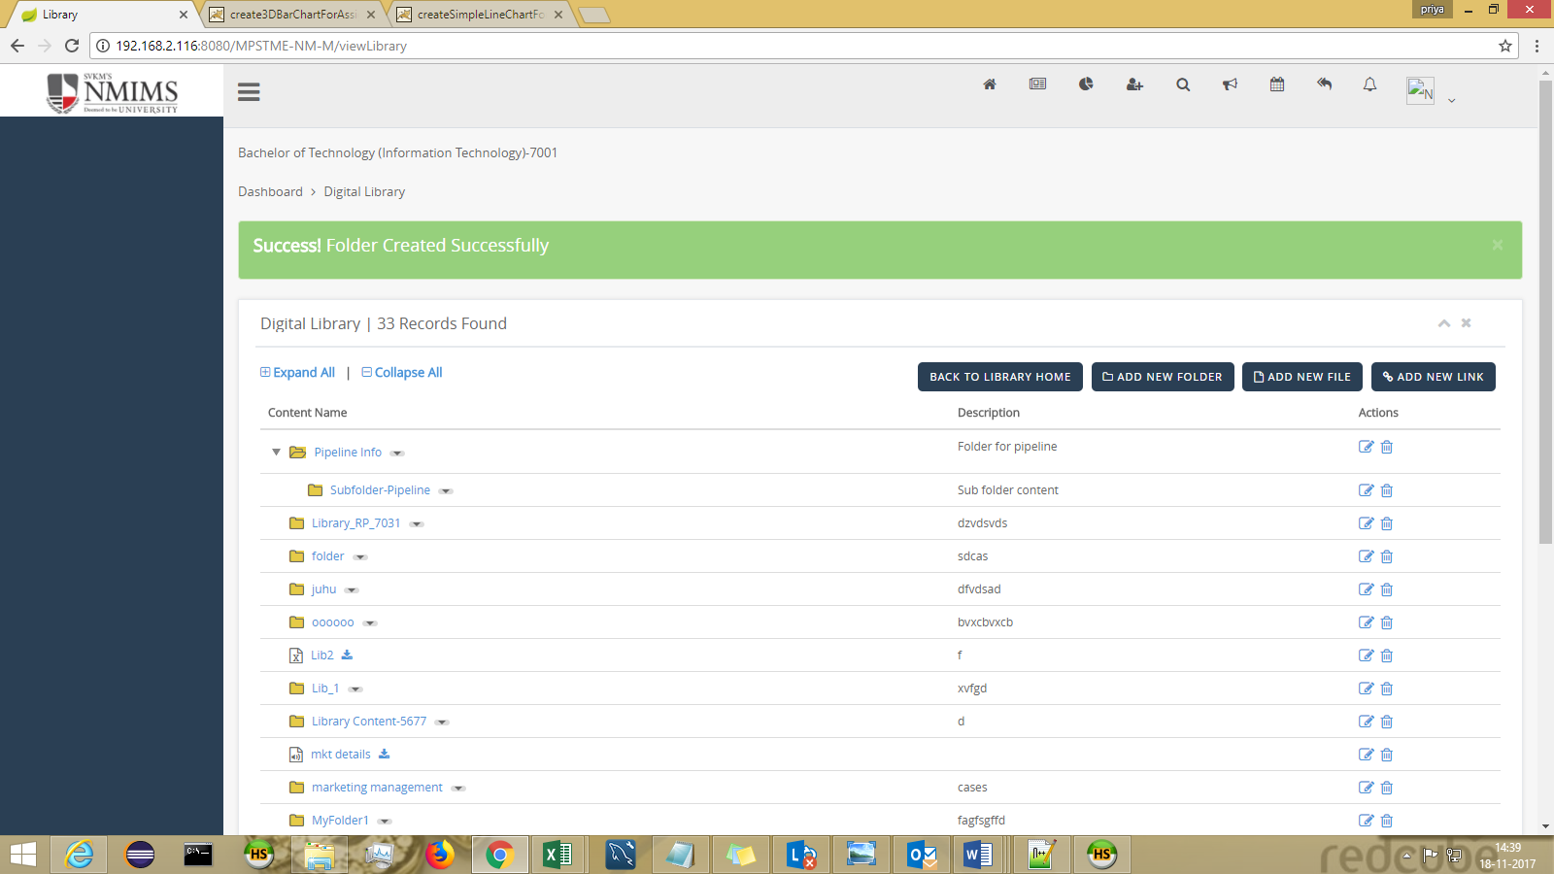

CONTENT (Course Based Content)
-can be landed via header : Dashboard > Content

All the course specific content can be added in Learning Resources.
Folders/Files/Links can be added and shared with students.

Addition of Folder:

Fill in all the required input parameters and click on “CREATE FOLDER” button at the end.
ACCESS TYPE: If you wish to share the folder with Students then Select “PUBLIC” from dropdown.
If you don’t wish to share the folder, then select “PRIVATE” from dropdown.

Notification can sent to students (Email | SMS) by keeping the toggle “ON”.

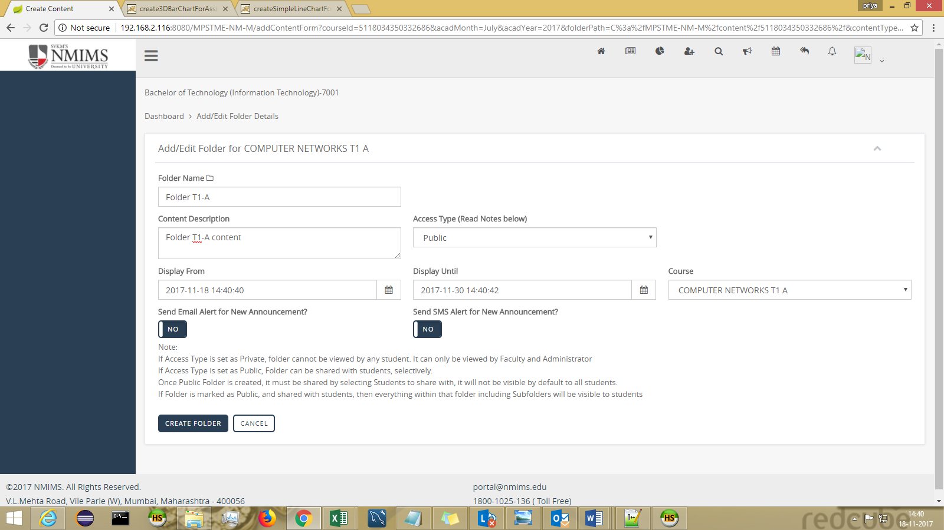

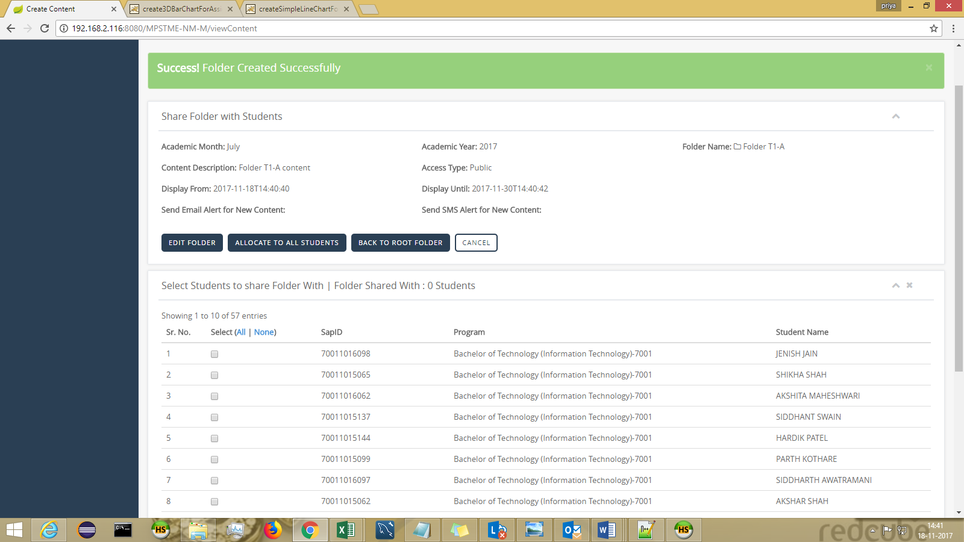

Select the student with whom the folder is to be shared and click on “SHARE FOLDER WITH SELECTED STUDENTS” at end.

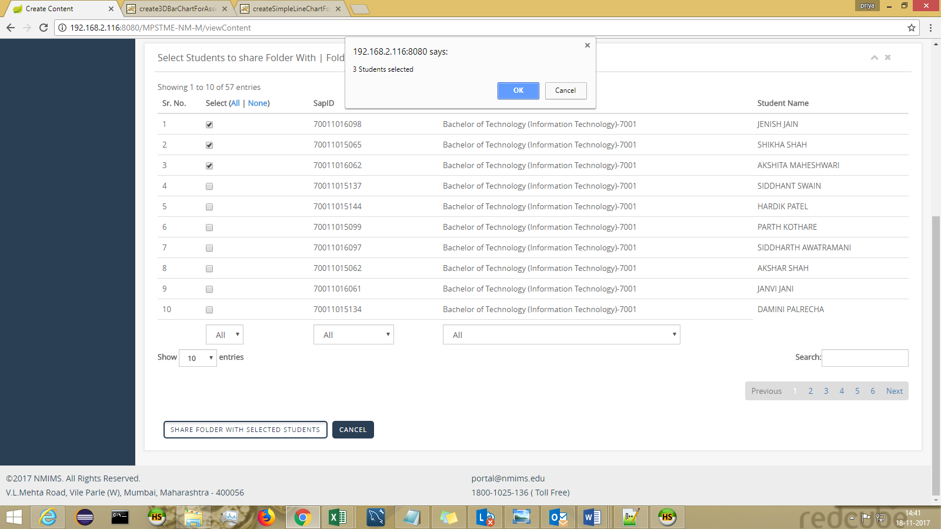
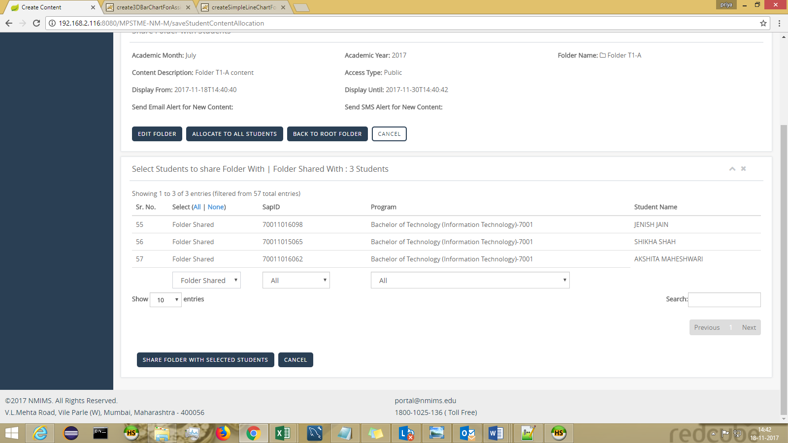

Similarly, files and links can be added.

