Contents
Module 1- ASSIGNMENT : 2
Module 2 : Test 7
Module 3 : Announcement 10
Course Level Announcement- 10
Institute Level Announcement- 11
Module 4 : Feedback 12
Module 5: Discussion Forum 15
Module 6 : Learning Resources 17
Library Link 18
Module 7 : Non Course Content 18
Module 8 : Message 20
Module 9 : Calendar 21
View Event 21
Module 10 : Grade Dashboard 22
Module 11 : My Groups 22
Module 12 : Teacher Profile : 23
Module 13 : Reports 24
Bar Chart for Assignment- 25
Bar Chart for Test 25
Module 14 : Search All Assignments/Tests 26
Module 15 : Alert icon 27
Additional Modules : 28
Raise A Query 29
View My Query Response 29
View FAQ’s 30
Overview 31

Module 1- ASSIGNMENT :

The allocated assignments can be viewed on this screen.
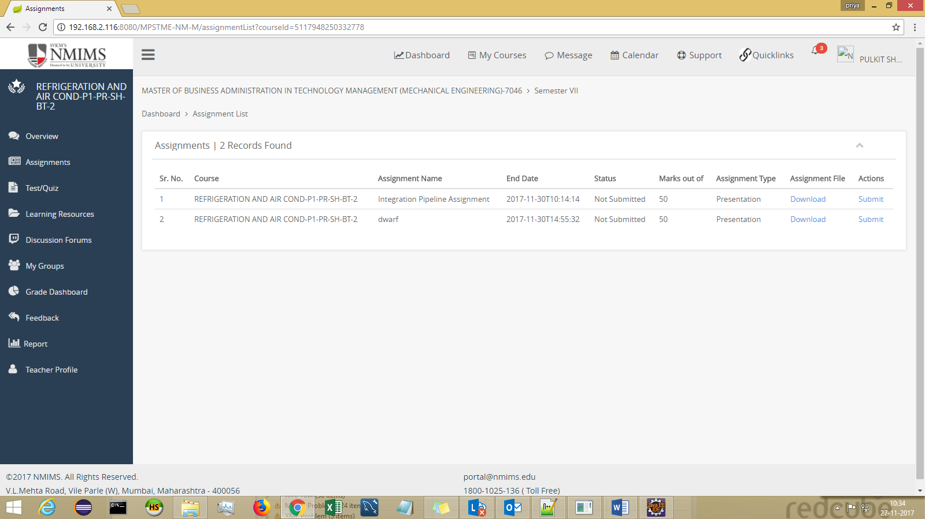

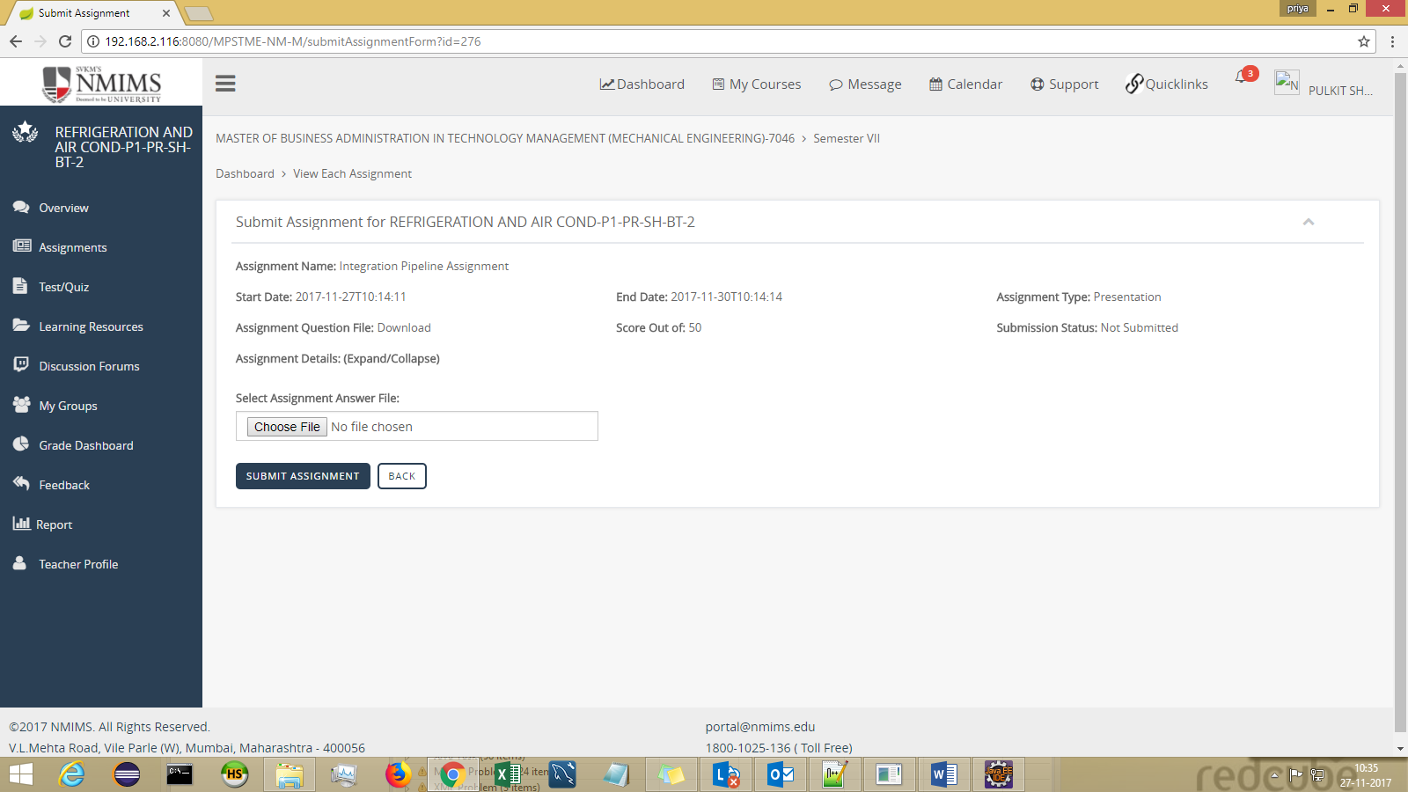

When Student clicks on Submit Assignment- popup appears :

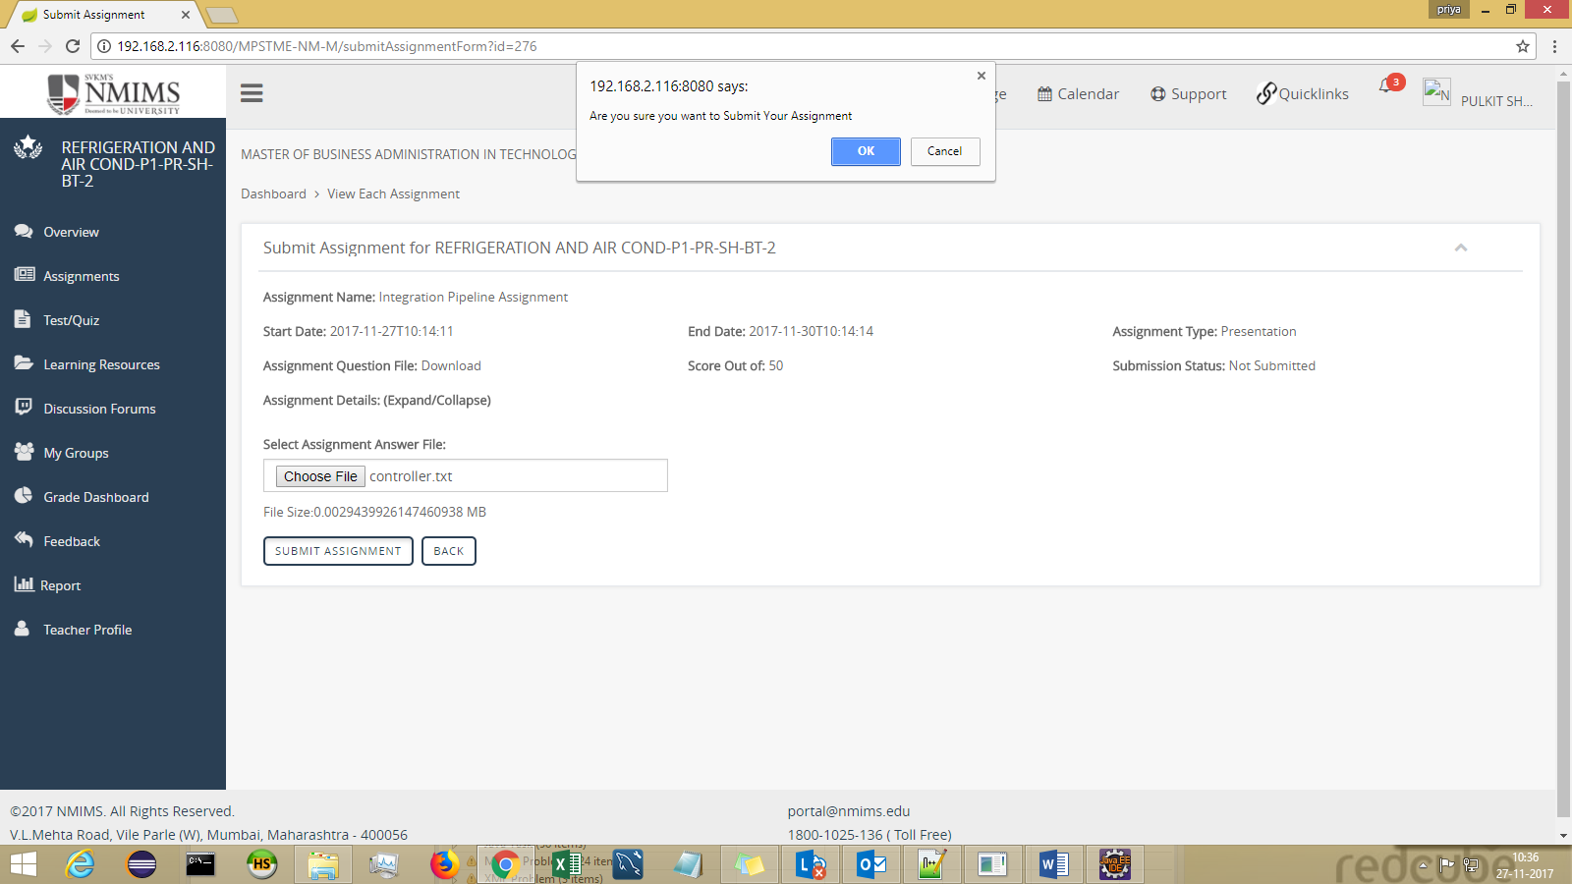

On clicking on OK from the pop-up – The Assignment is being checked for plagscan analysis in the background.

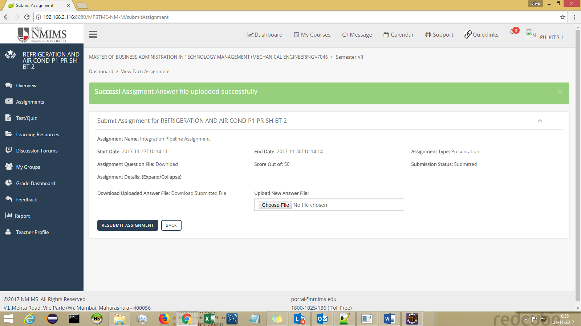

Screen after selecting course:
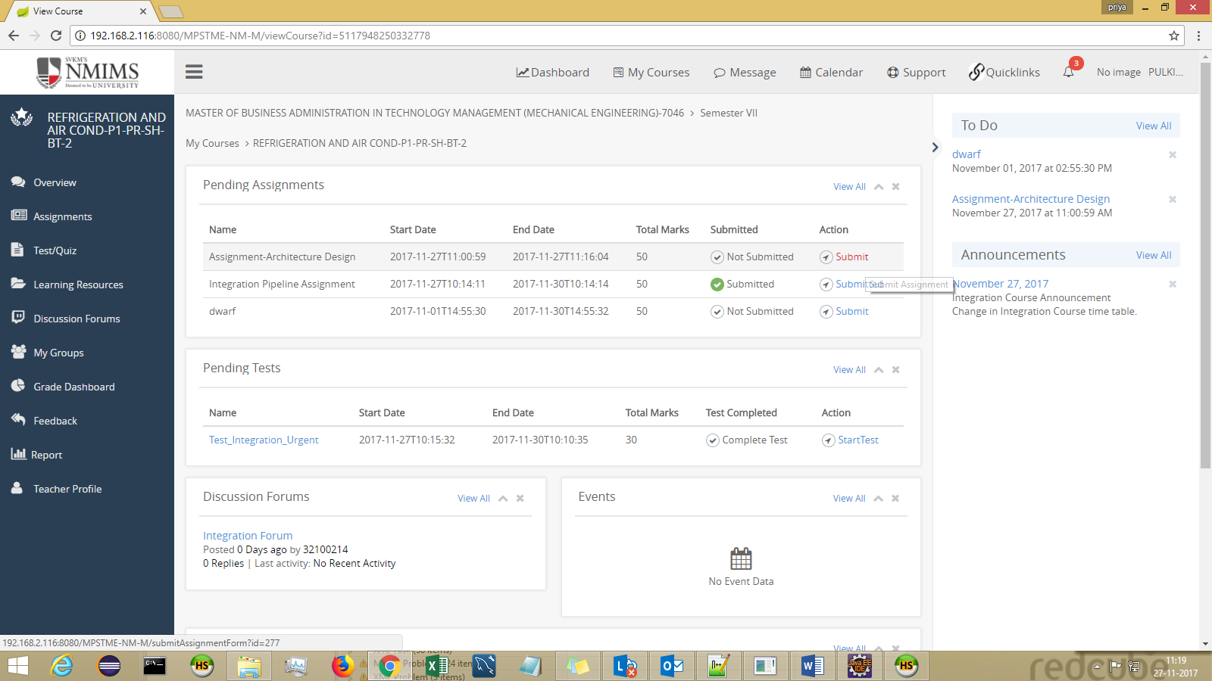

As it can be seen the End date of assignment is gone, so it will be submitted as LATE SUBMITTED ASSIGN
Status will change to Submitted once the Faculty APPROVES it while evaluation.

If the Faculty REJECTS the assignment, the student will get to see the REJECTION message in his INBOX.

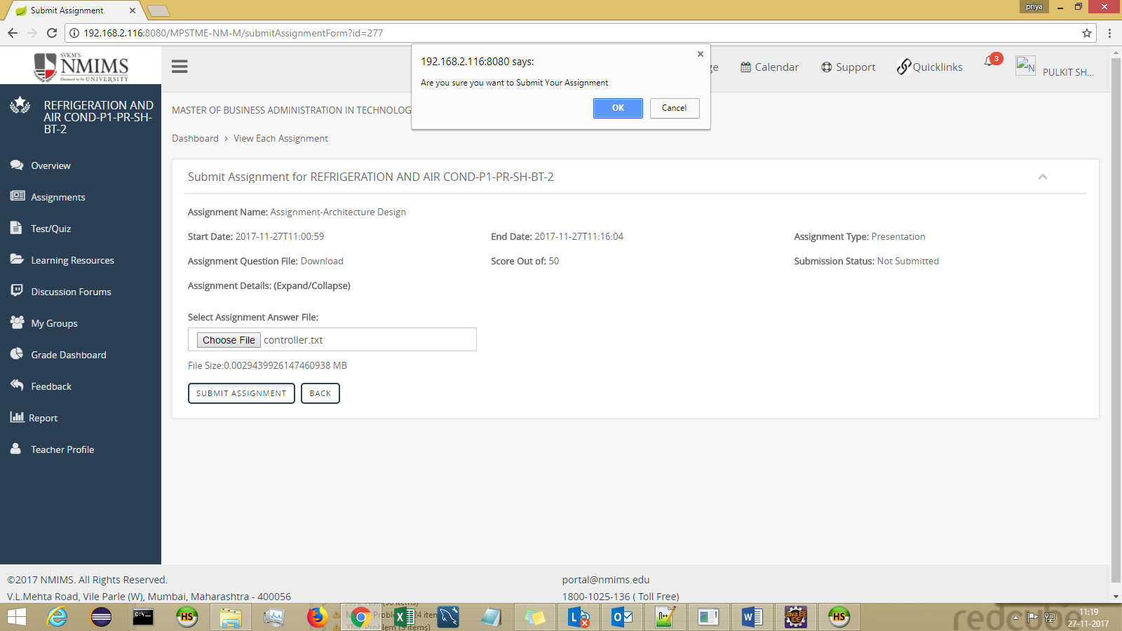

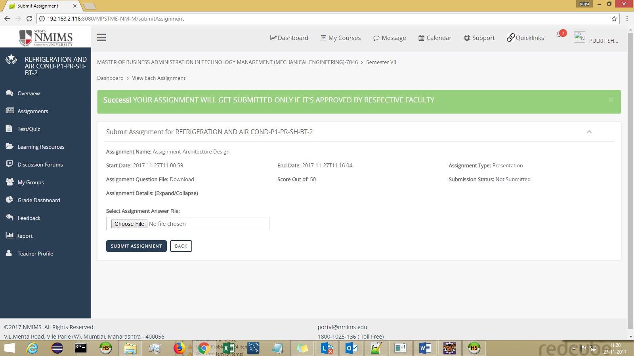

Module 2 : Test
The allocated test can be attempted through this screen.
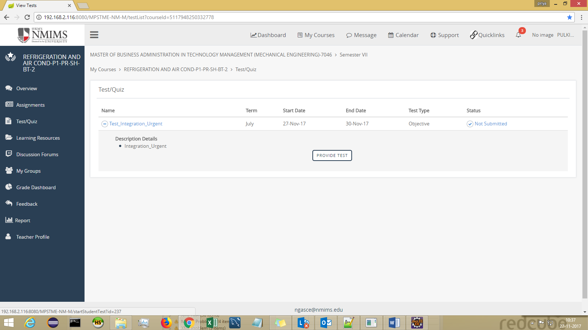

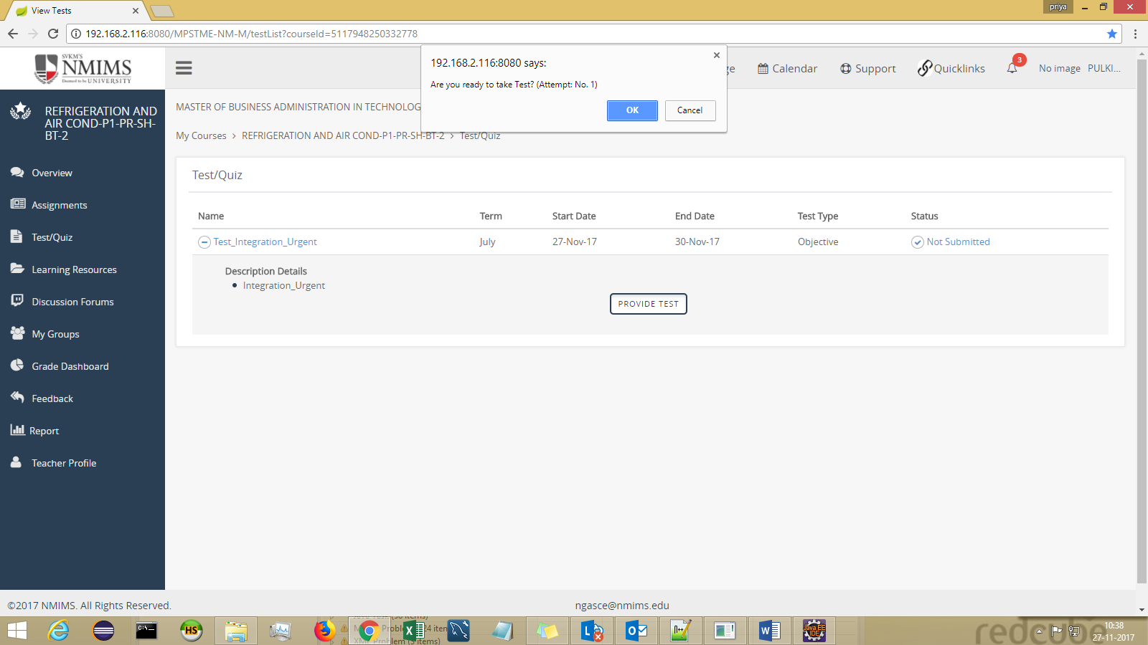

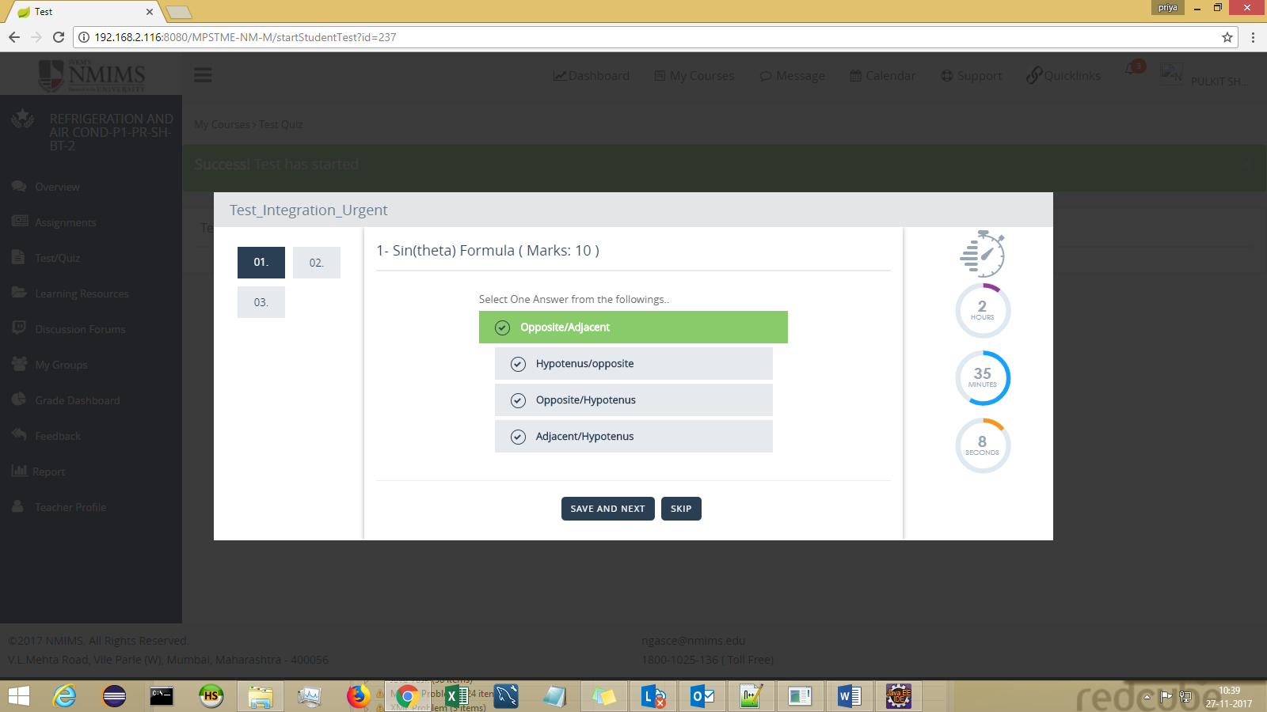
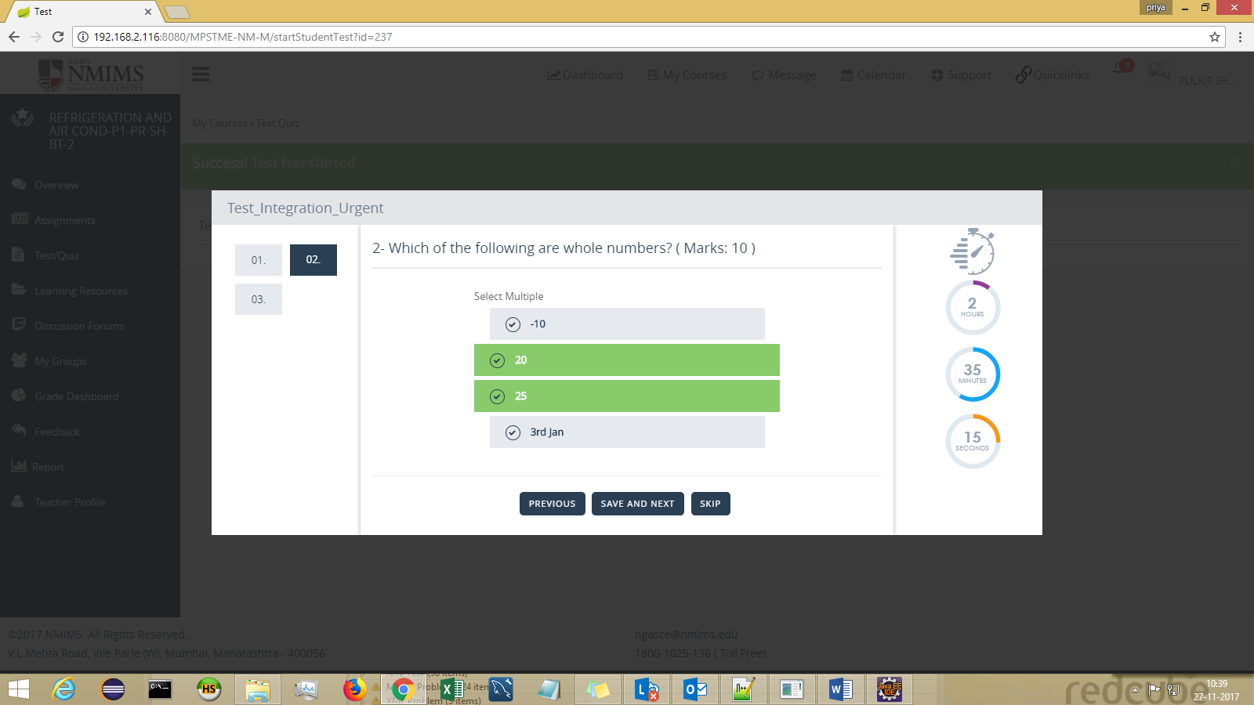
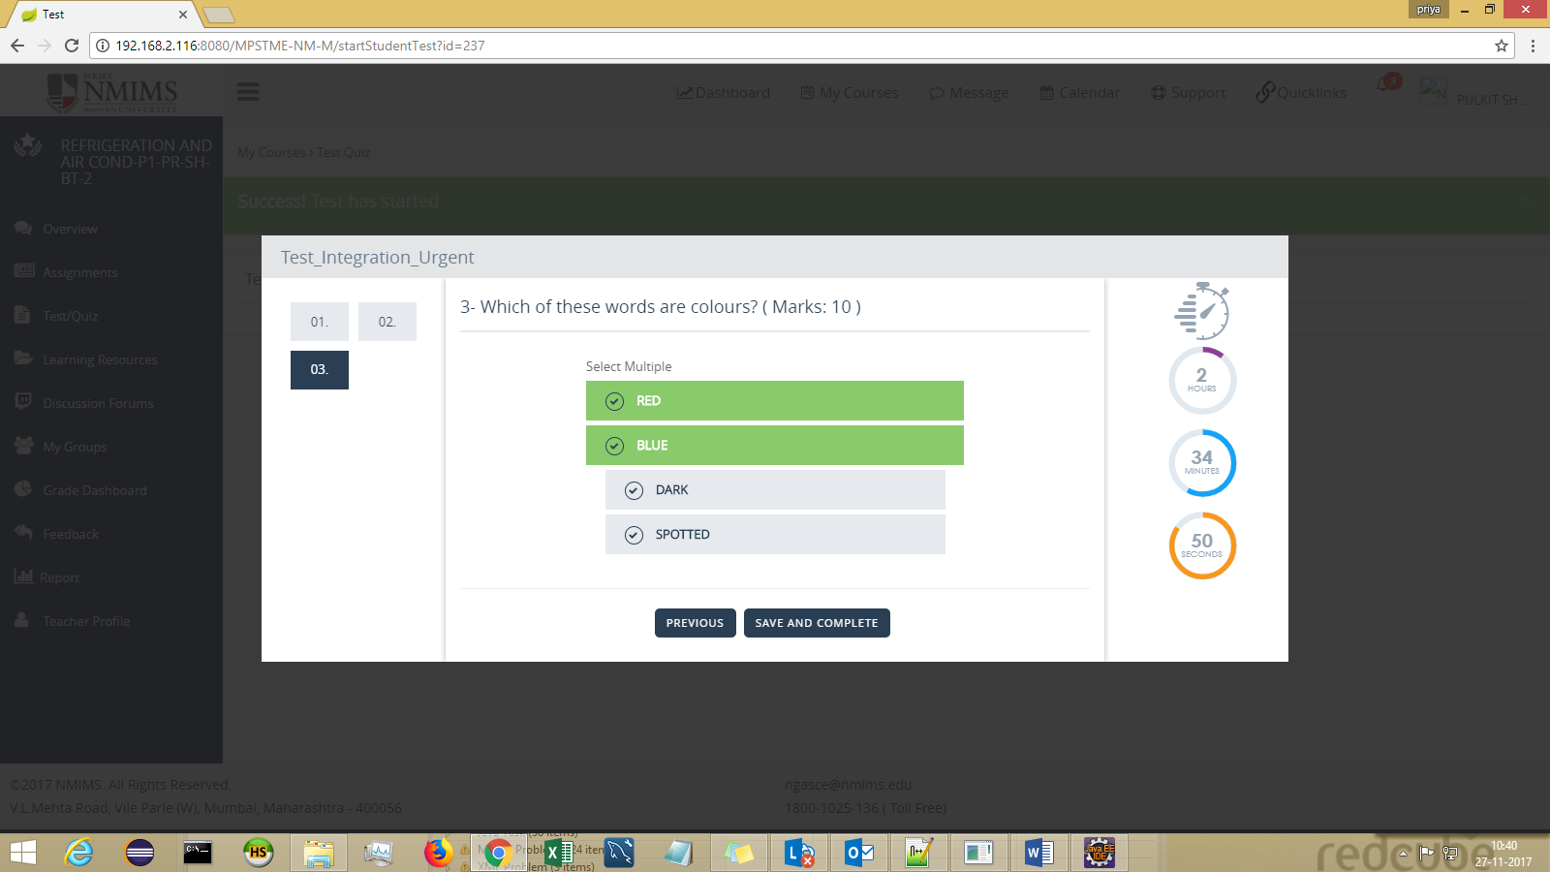
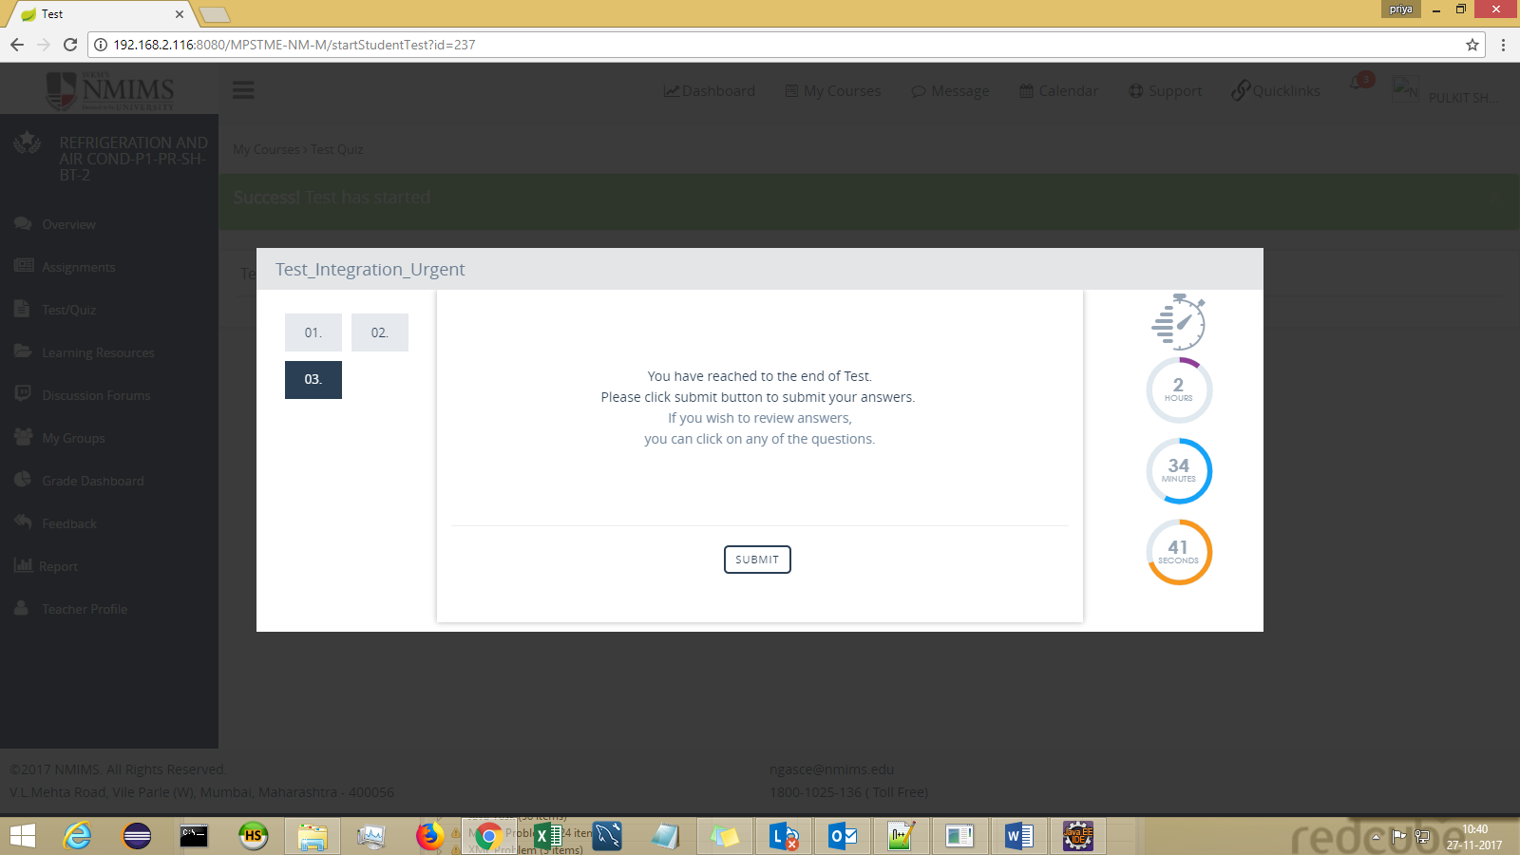

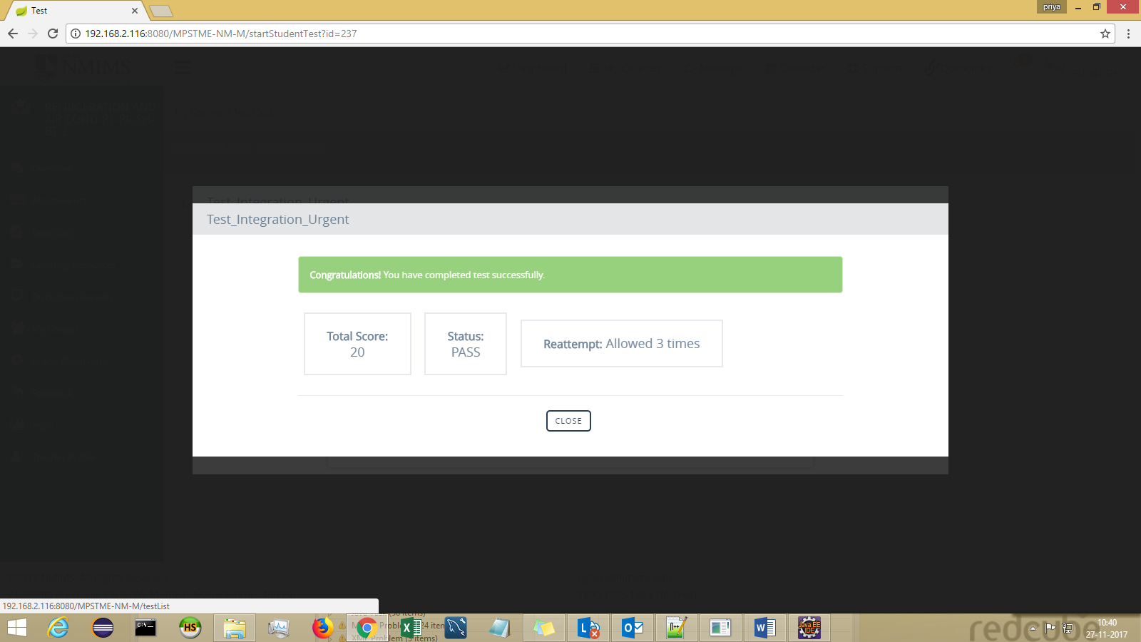

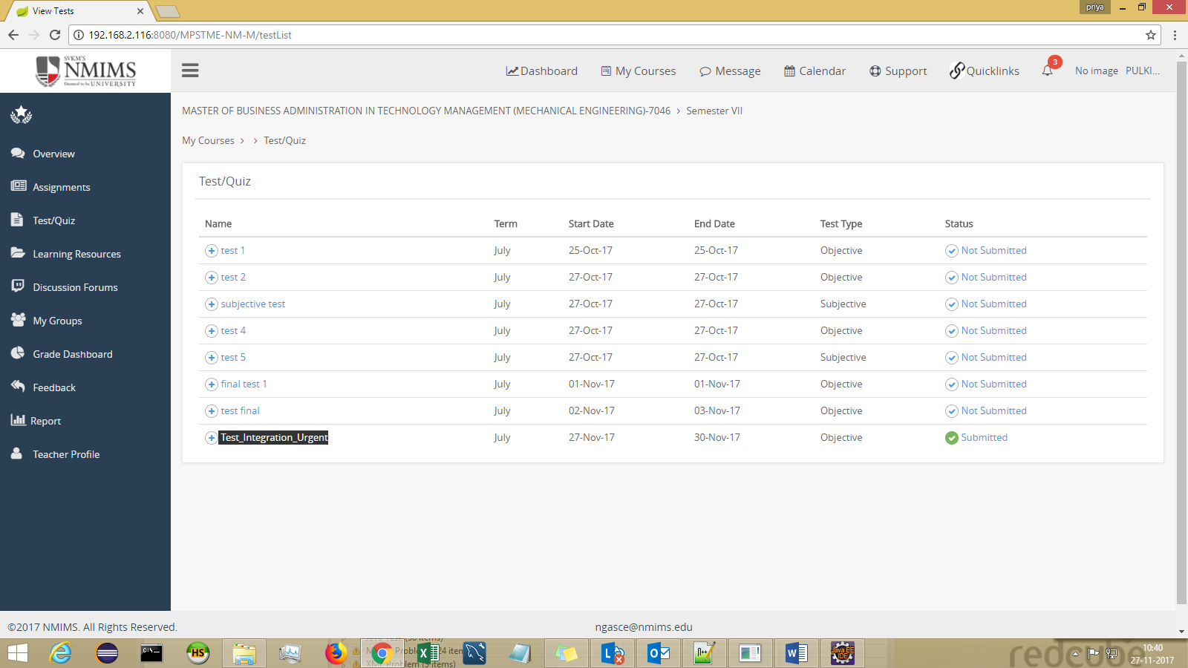

Module 3 : Announcement

Course Level Announcement-
Select AnnouncementType and AnnouncementSubType from dropdown and click on Search.
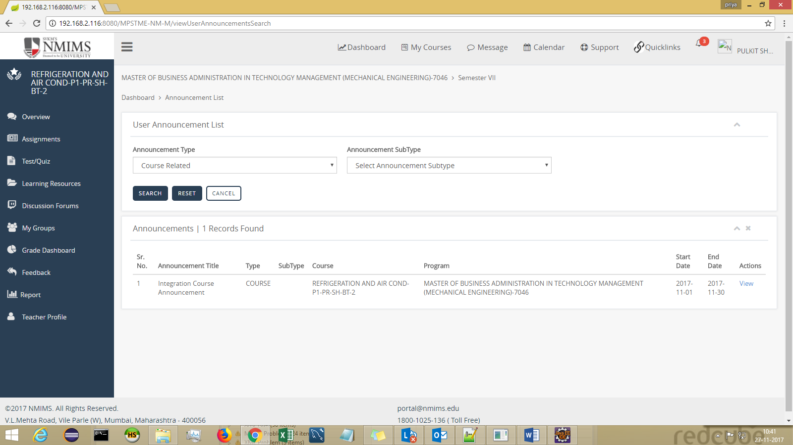

Institute Level Announcement-
Select AnnouncementType and AnnouncementSubType from dropdown and click on Search.

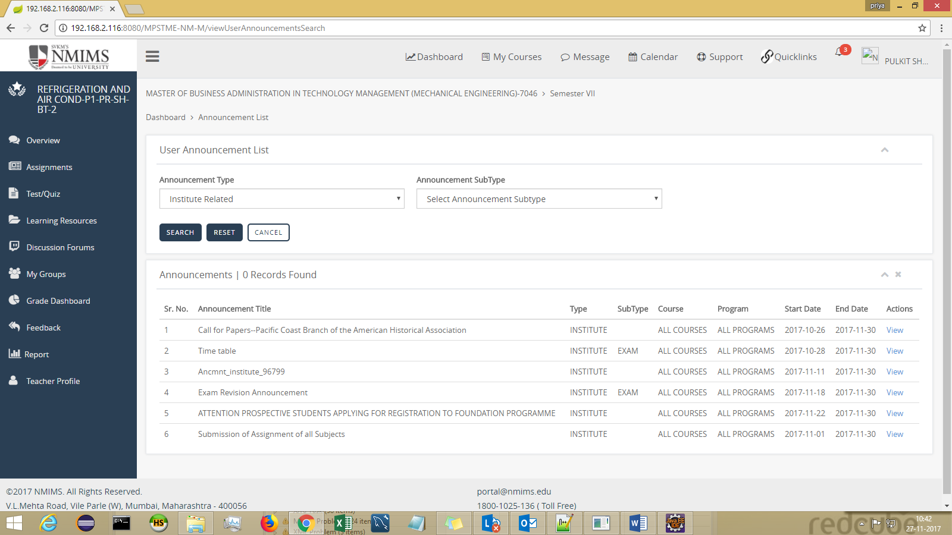

Module 4 : Feedback
All the allocated feedbacks can be given through this screen.
Click on feedback name,and click on Provide Feedback button.

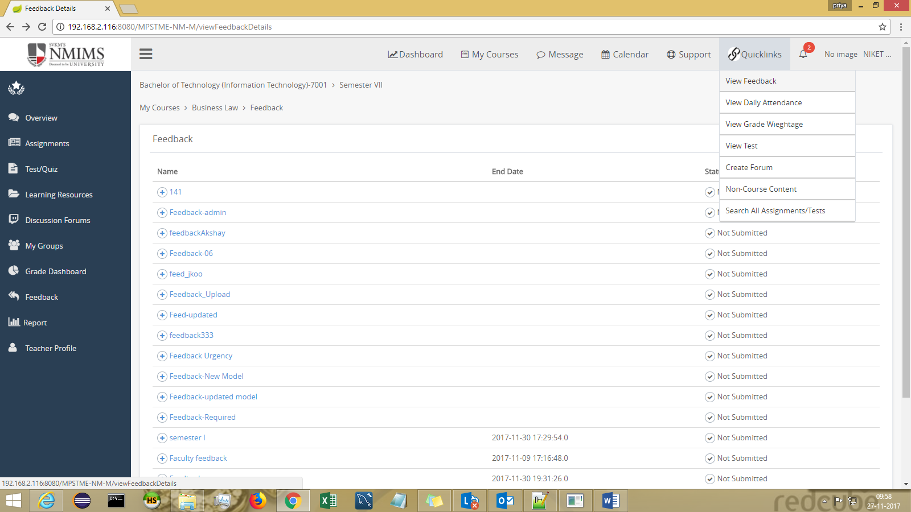

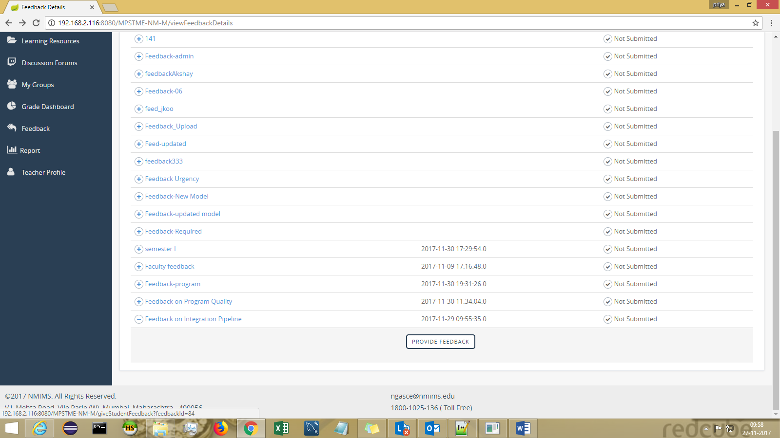

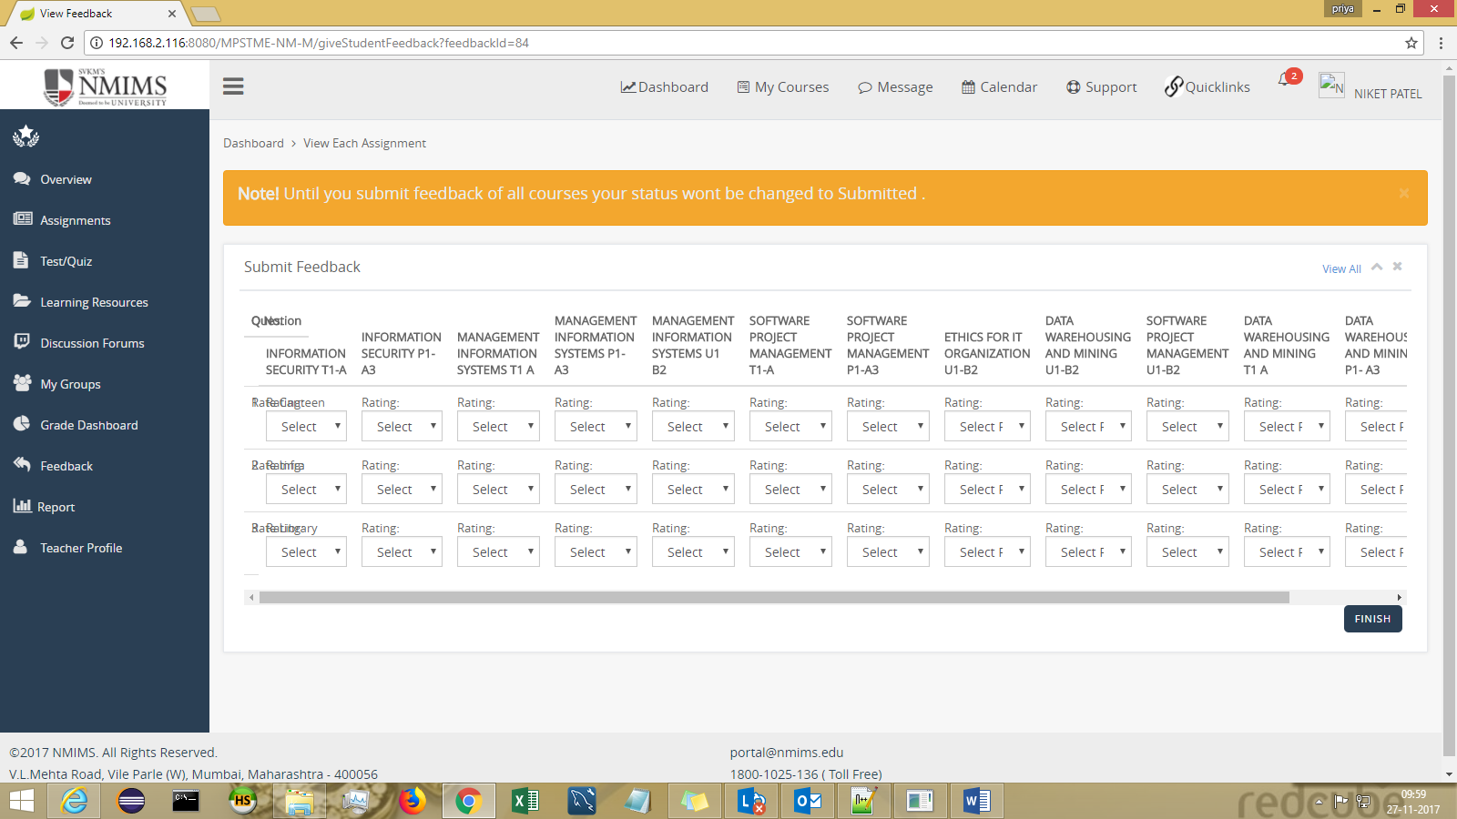

Feedback can be submitted Question wise and unless the feedback of all questions are submitted, feedback won’t get changed to Submitted.

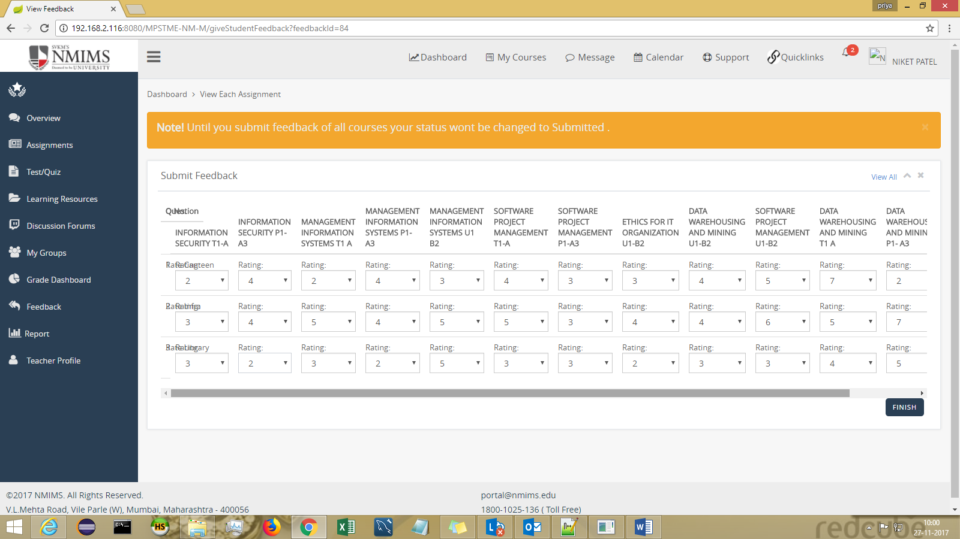

Success message can be seen on individual submission of feedback question wise.

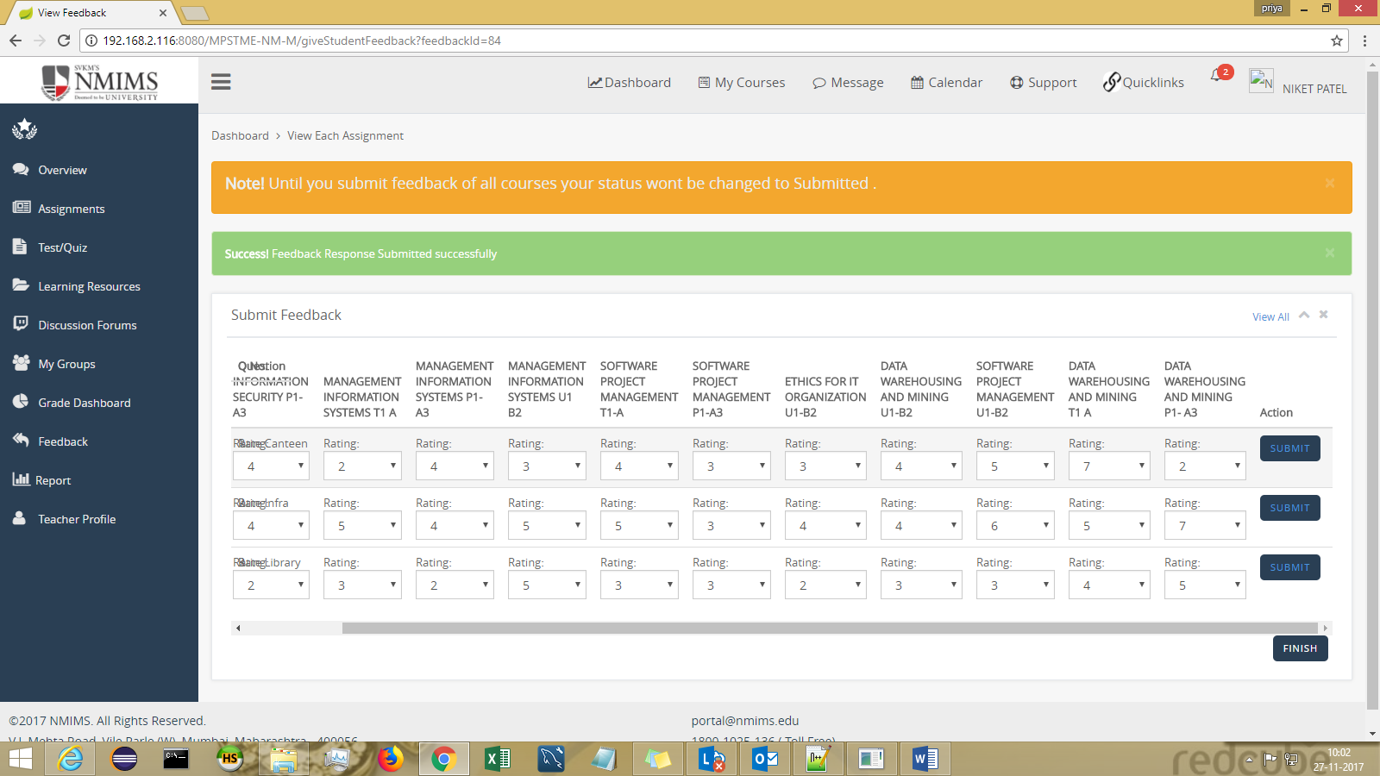

Submission status gets changed to “Submitted”.
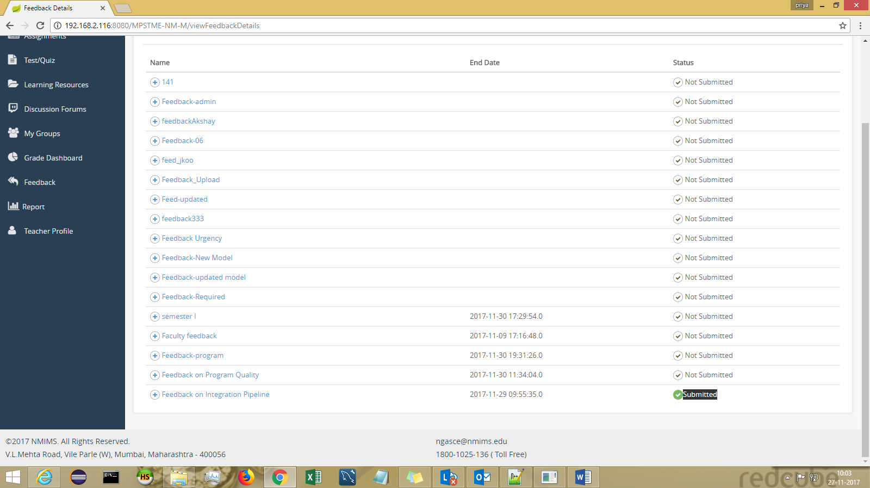

Module 5: Discussion Forum (Can be landed from left sidebar)

Students can participate in all active forums.
Select course name from dropdown.
Click on View Answers link to view all the threads pertaining to a forum topic.

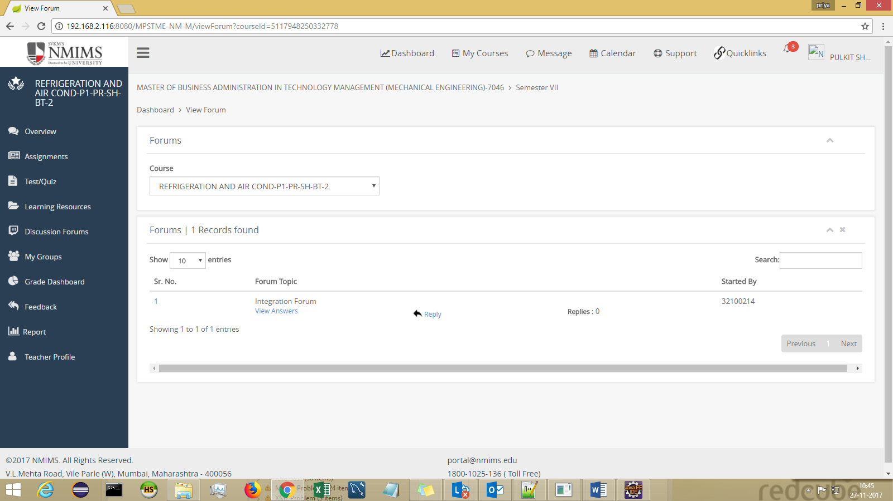

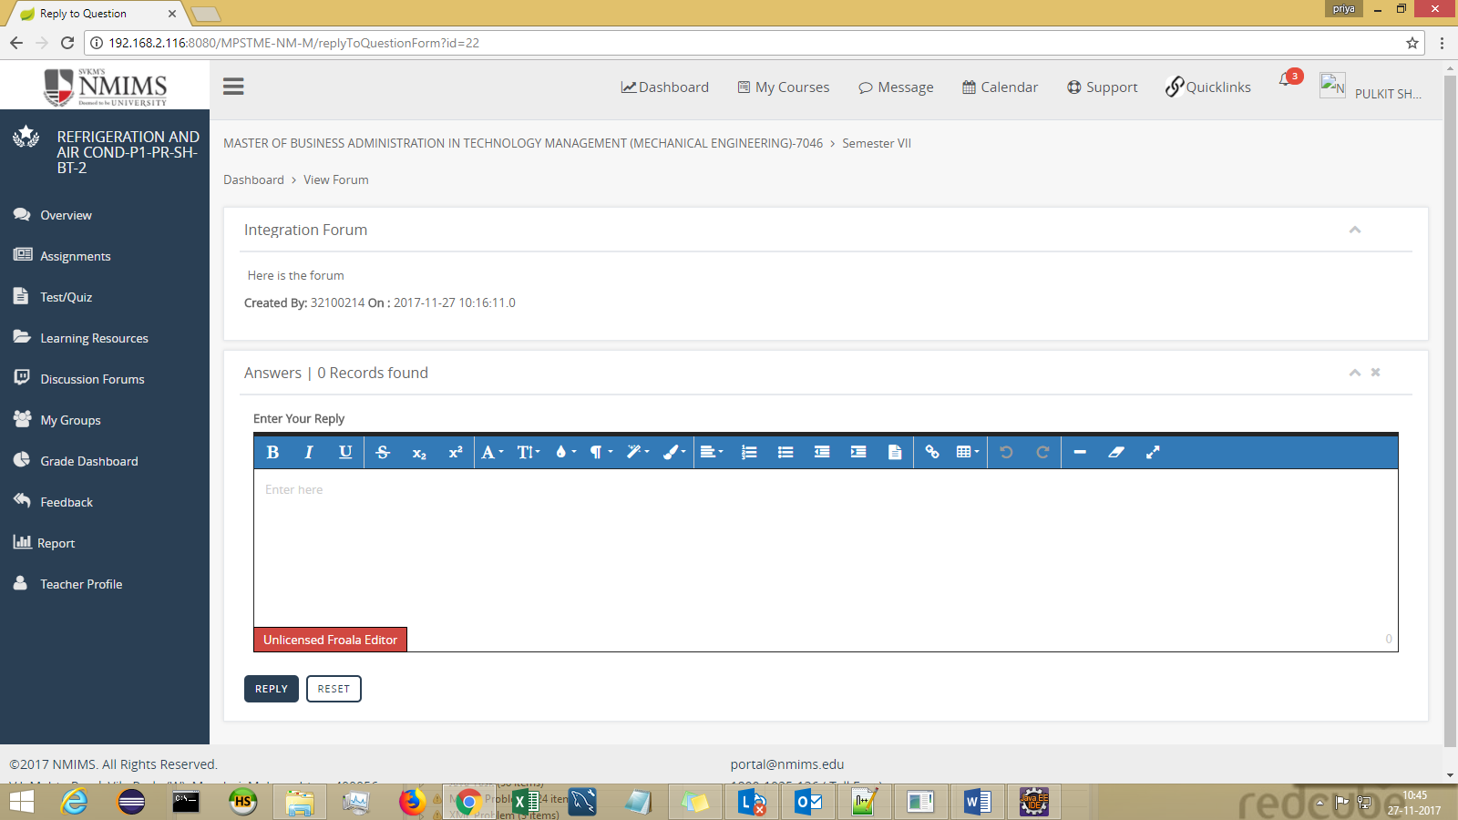

Module 6 : Learning Resources (Course Specific Content)

All the course specific content can be viewed on this screen.
Students can download all course based content which has been shared with them.
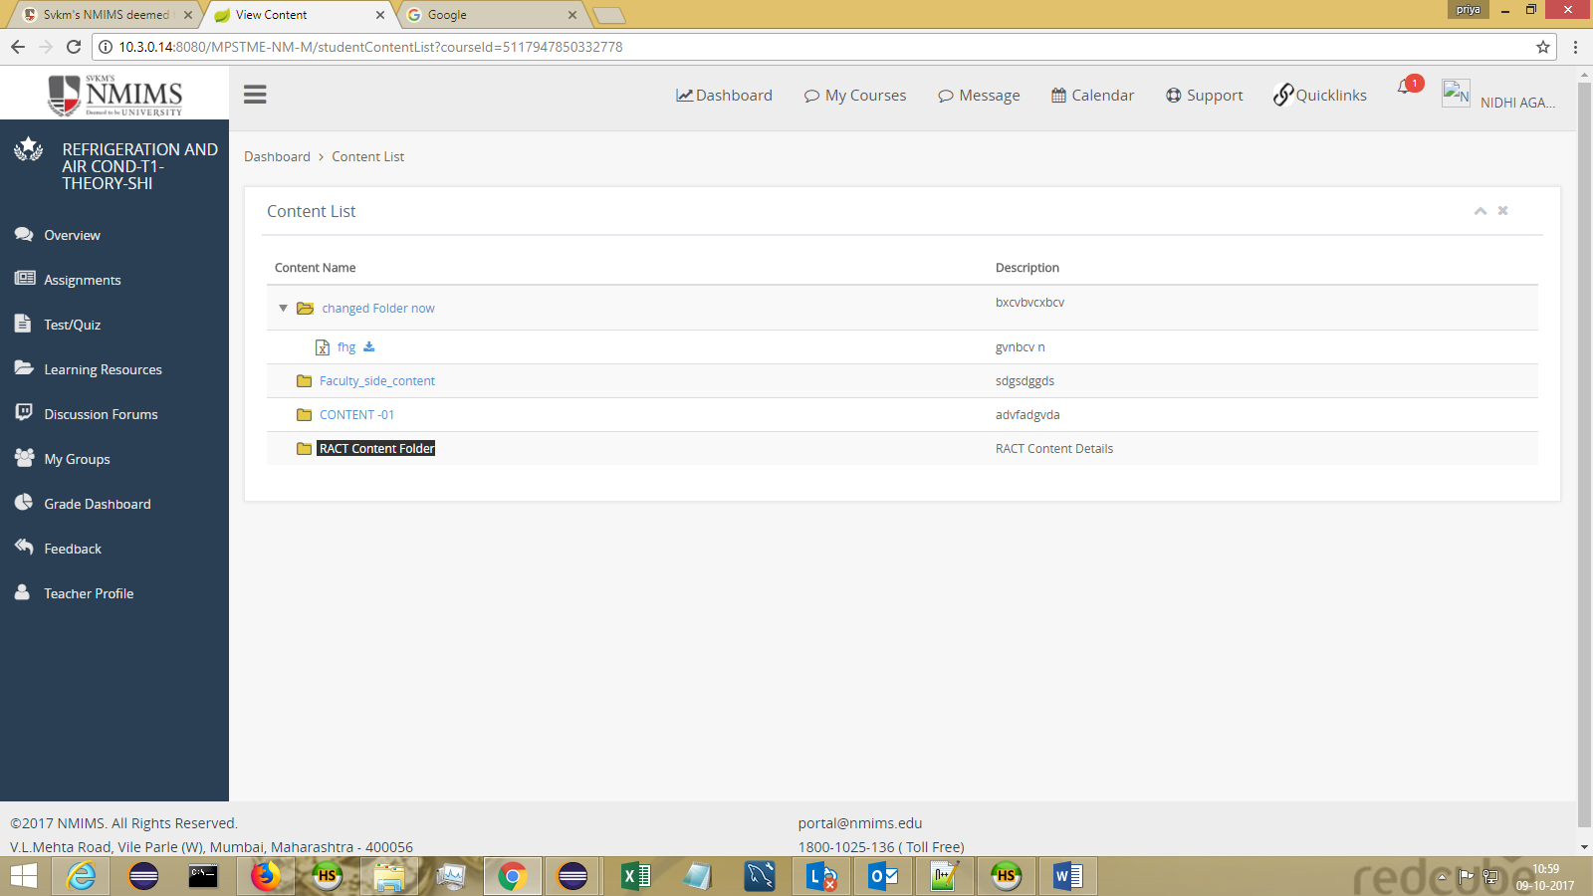

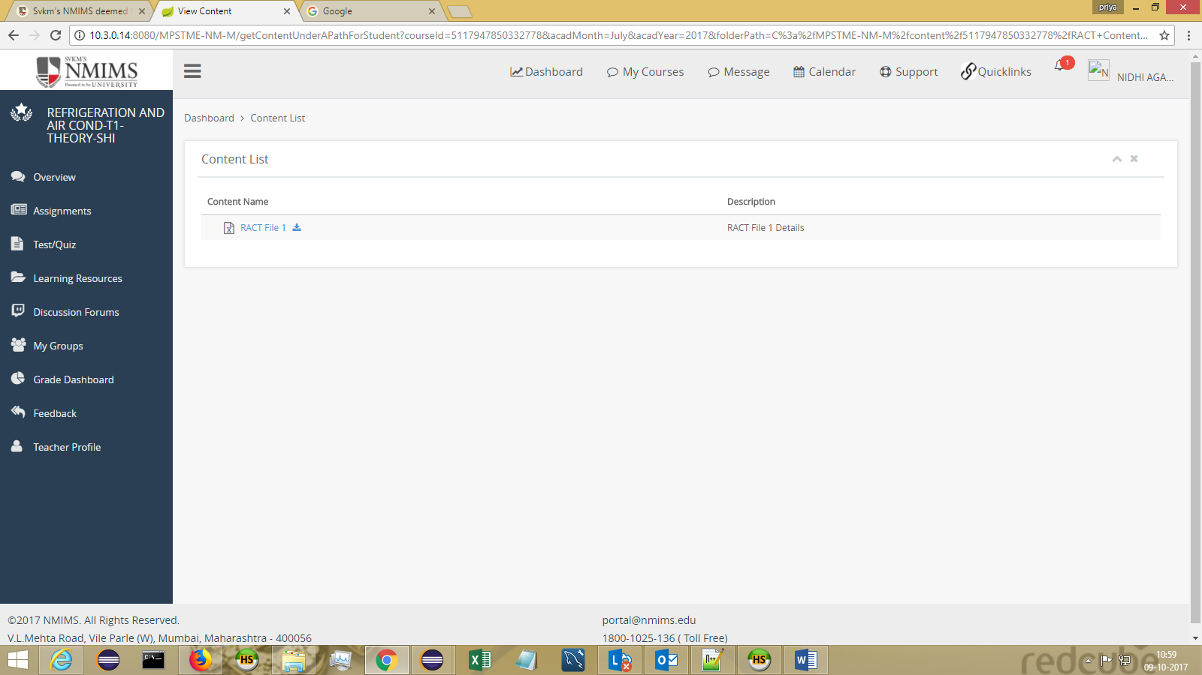

Library Link
You can access the Library by clicking on Library Link via QuickLinks >Library Link.
You can access all services by loging-in using your credentials.

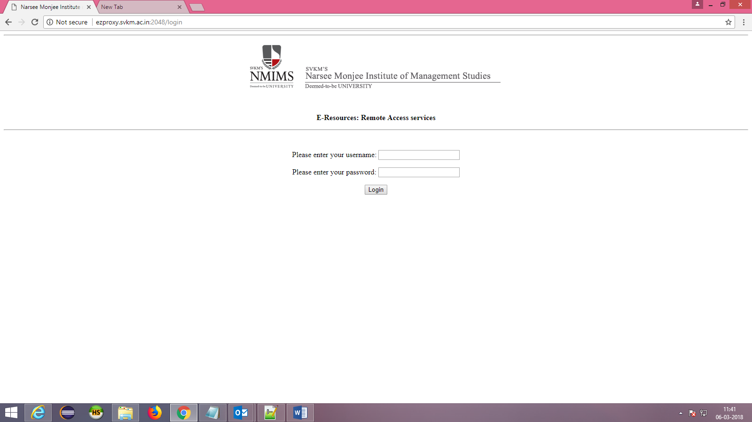

Module 7 : Non Course Content
Non course content can be seen in Quick Links > Non course Content
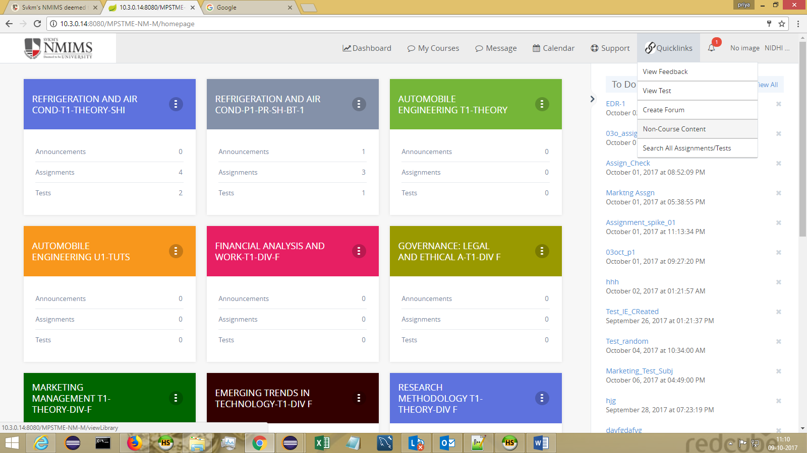

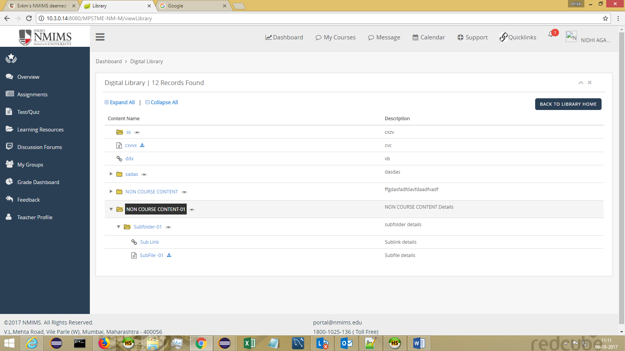

Module 8 : Message
The messages received can be seen in INBOX and the sent messages can be seen in OUTBOX.
Students can reply to a message by clicking on REPLY button.
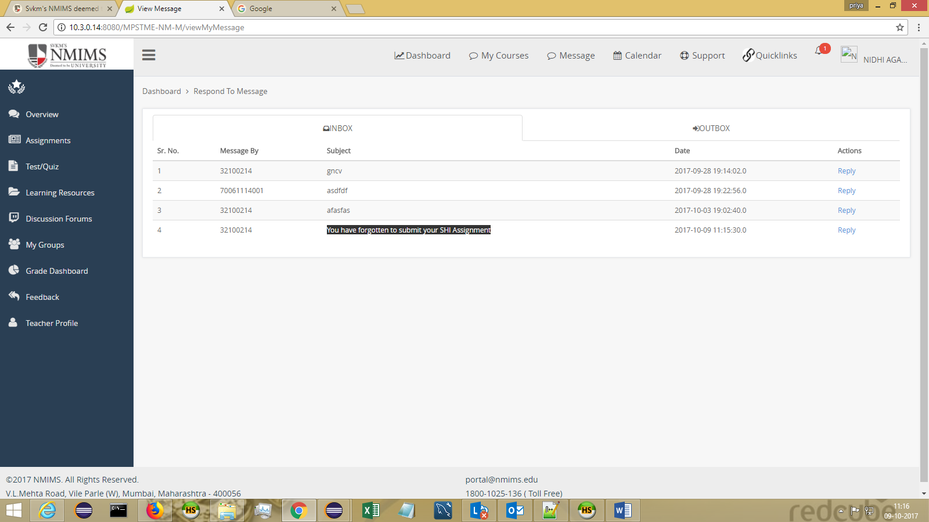

On clicking on Reply :

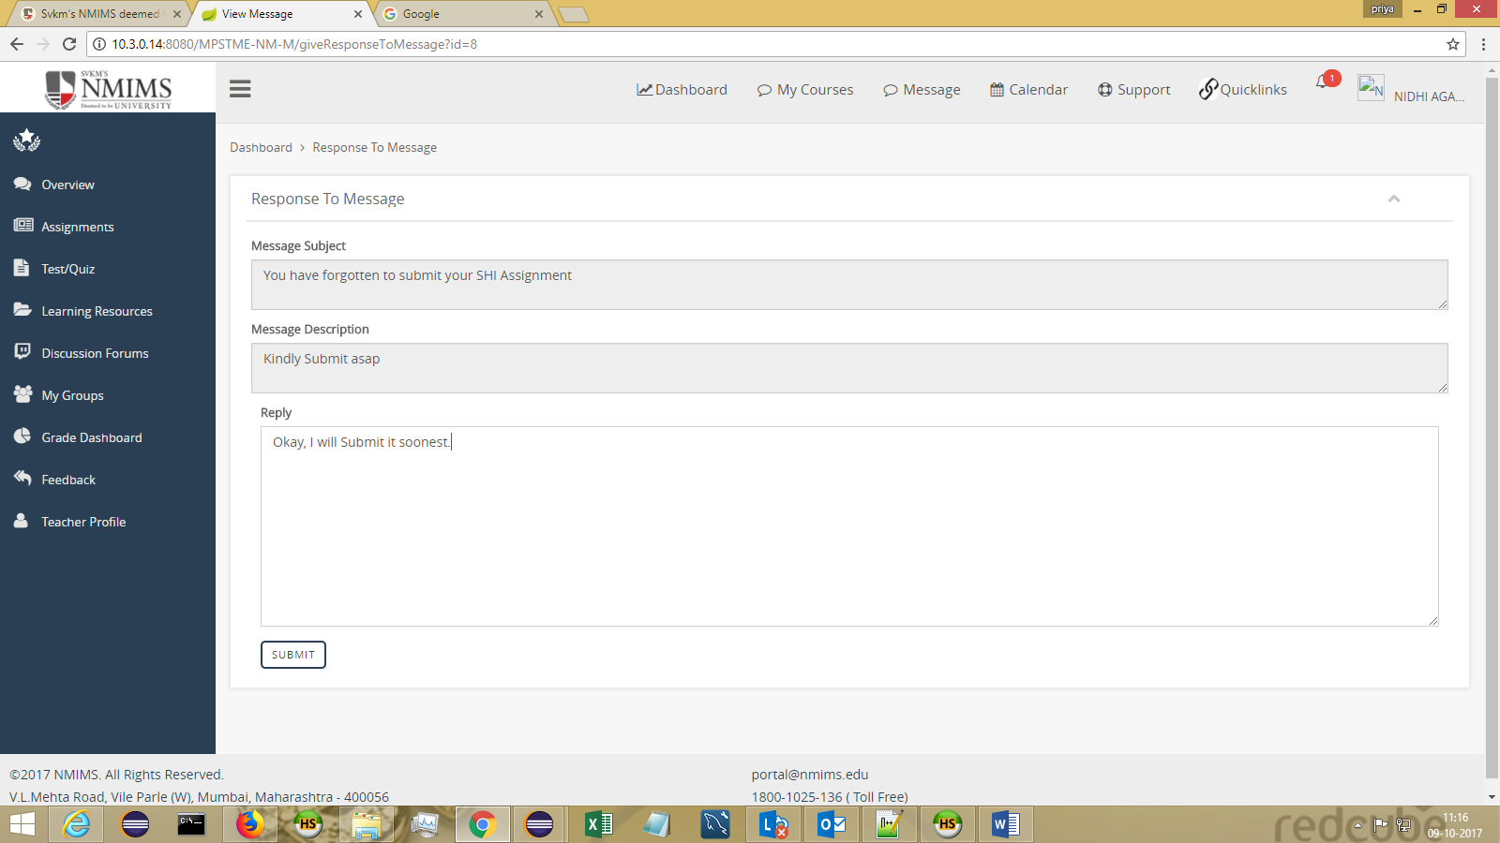

Module 9 : Calendar

View Event
Can be viewed in header Sub Menu – view Calendar
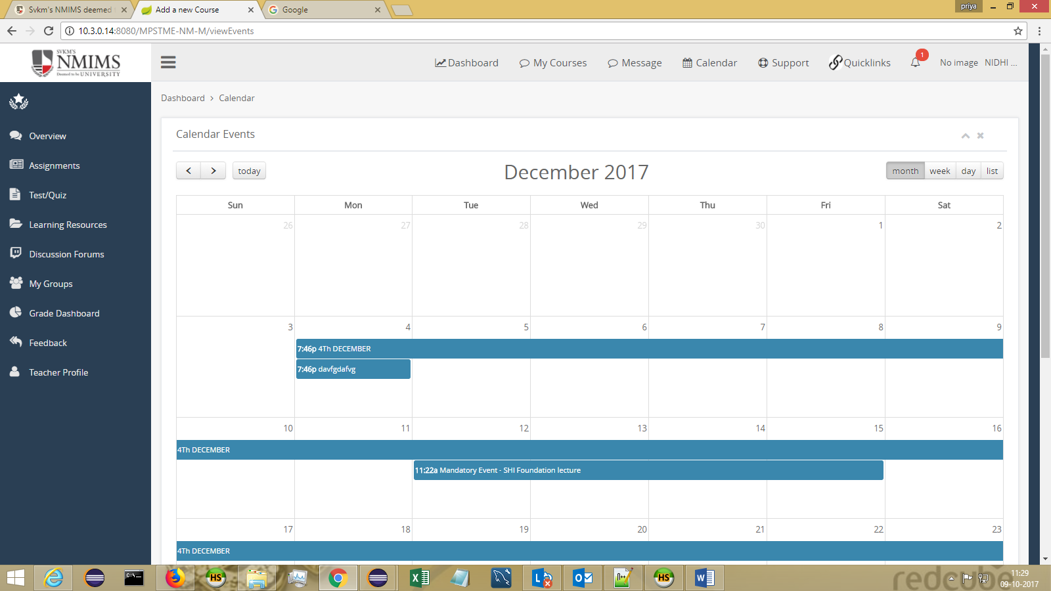
Students have the privilege of viewing the events only.
The Events whose privacy are kept “Only Me” is not visible. Only the events which are PUBLIC are visible to the students.

Module 10 : Grade Dashboard
A consolidated report of your scores in assignment/test/class participation can be seen through this screen.
Just select the course name from dropdown of which the grades are to be viewed.

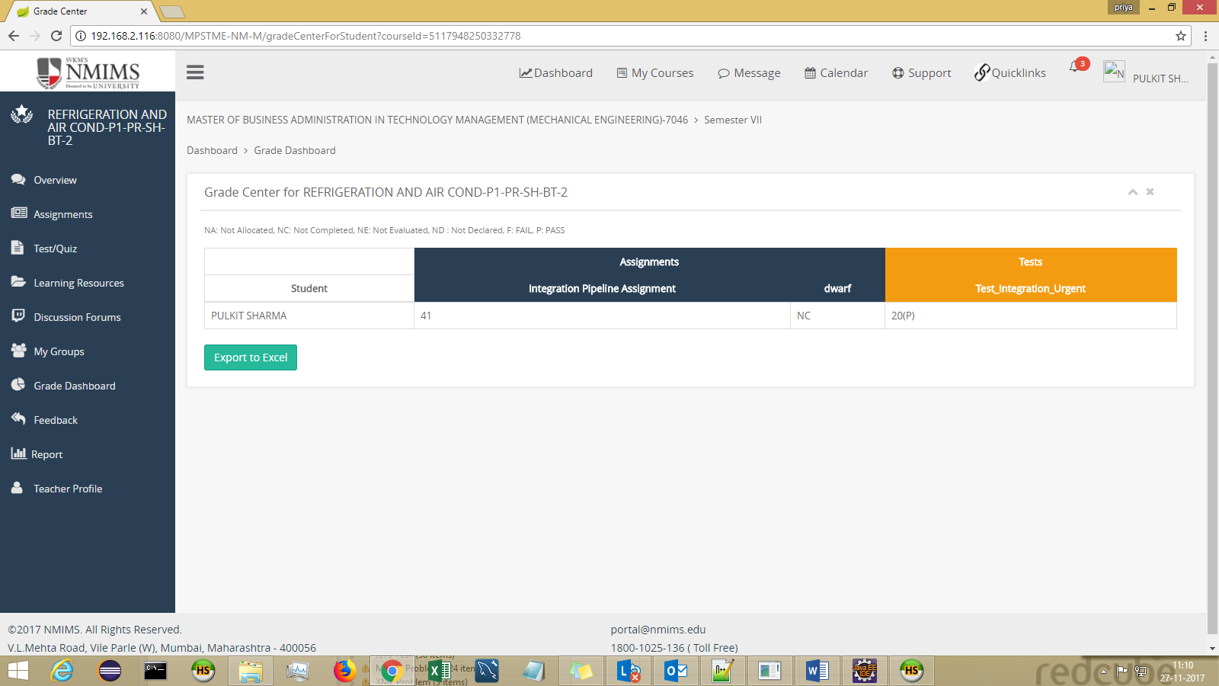

Module 11 : My Groups
Student can see his fellow group members on this screen
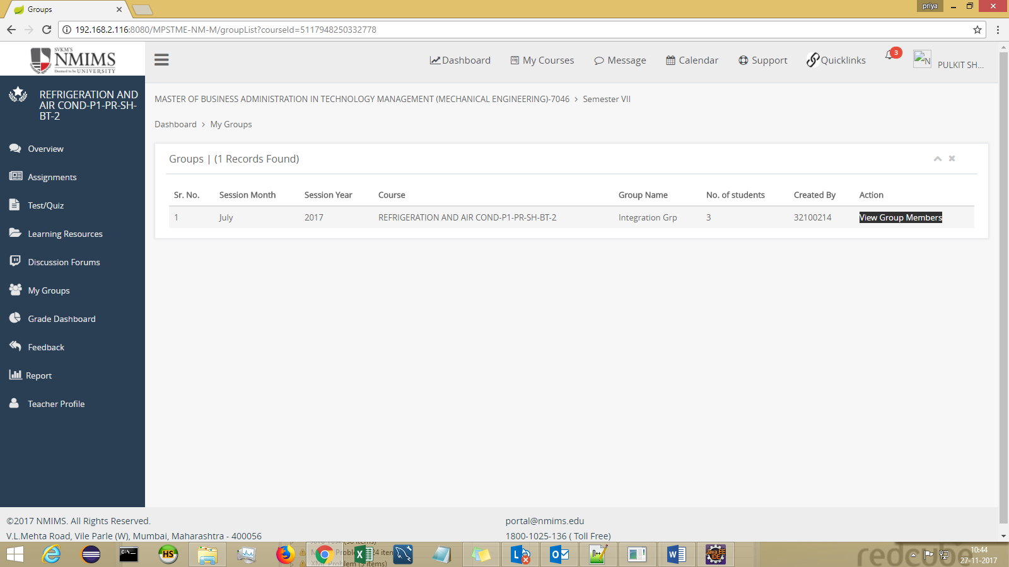

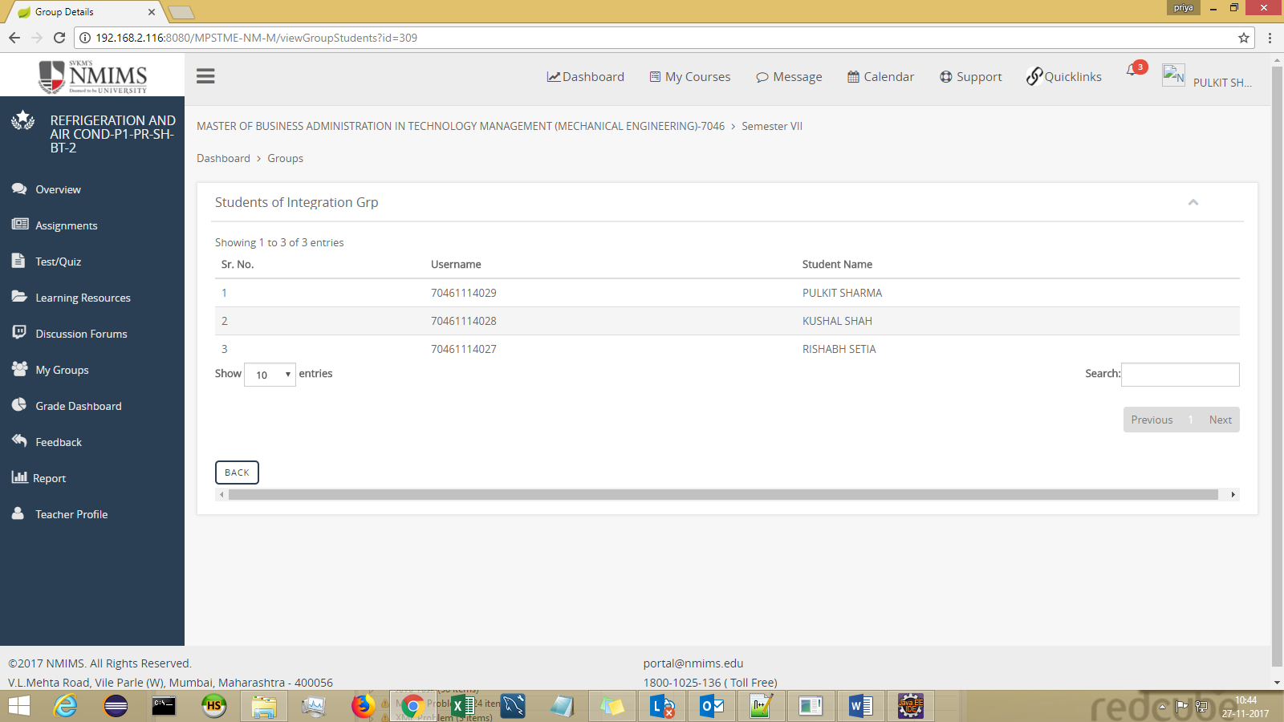

Module 12 : Teacher Profile :
Students can get Faculty details on this screen.
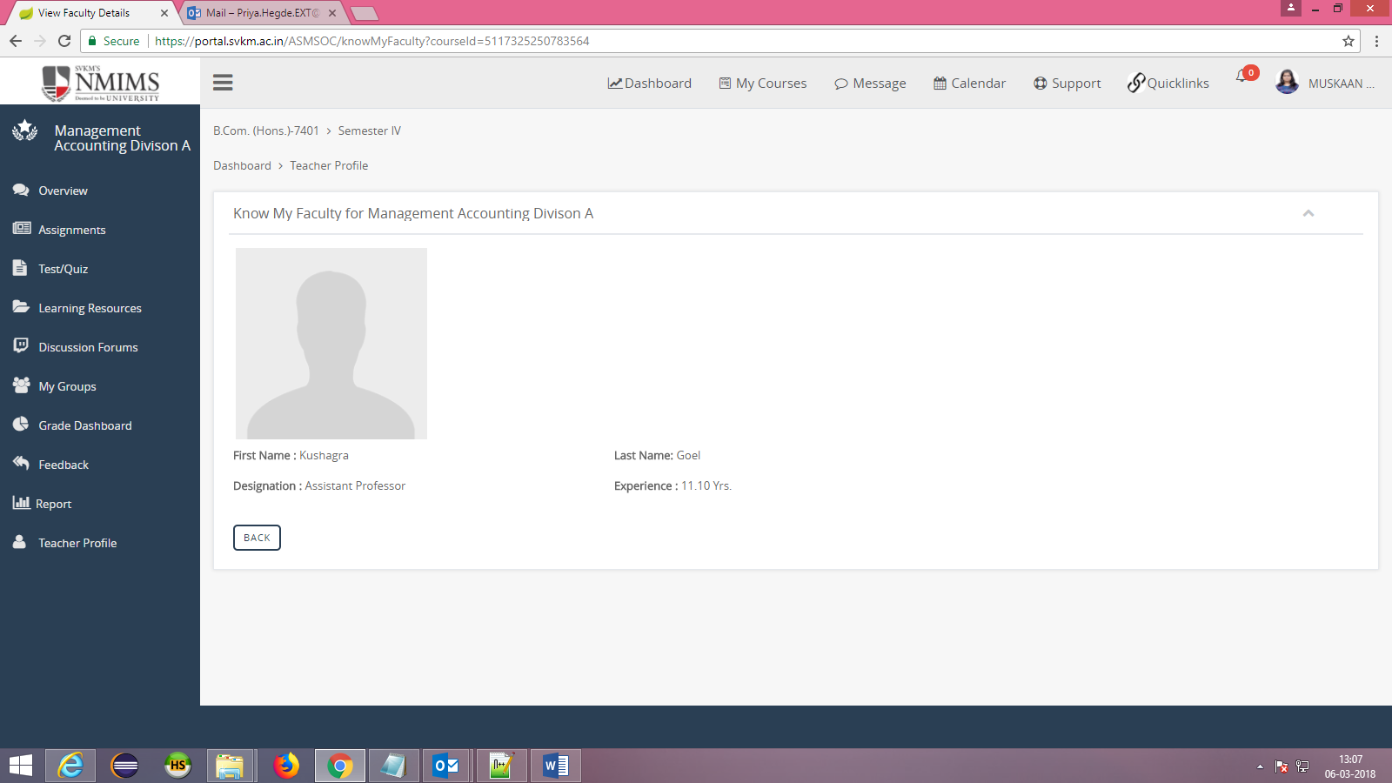

Module 13 : Reports
Students can have a graphical bar chart report of his assignment and test on this screen.
Select course name from dropdown and click on VIEW button.

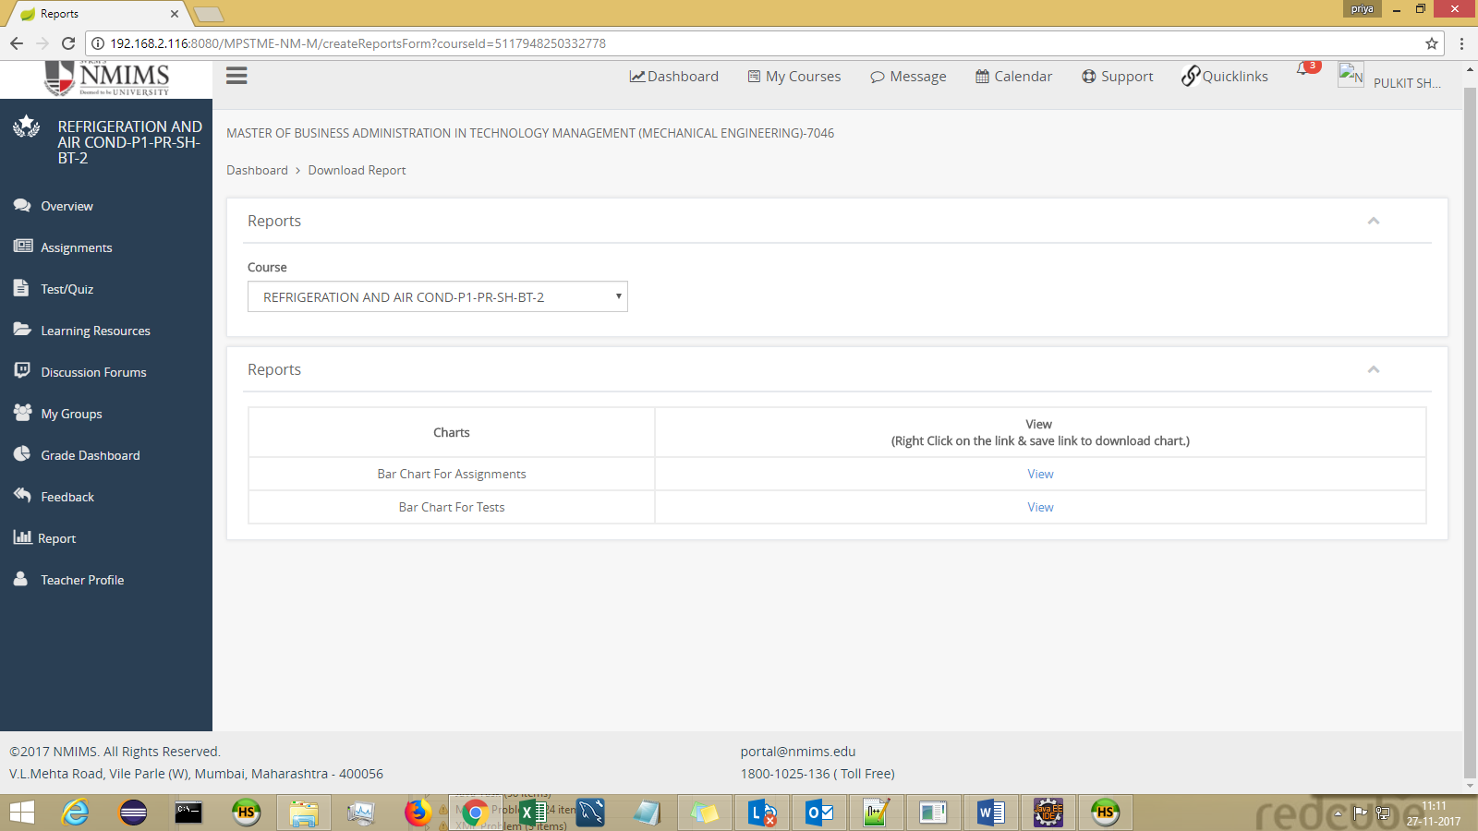

Bar Chart for Assignment-
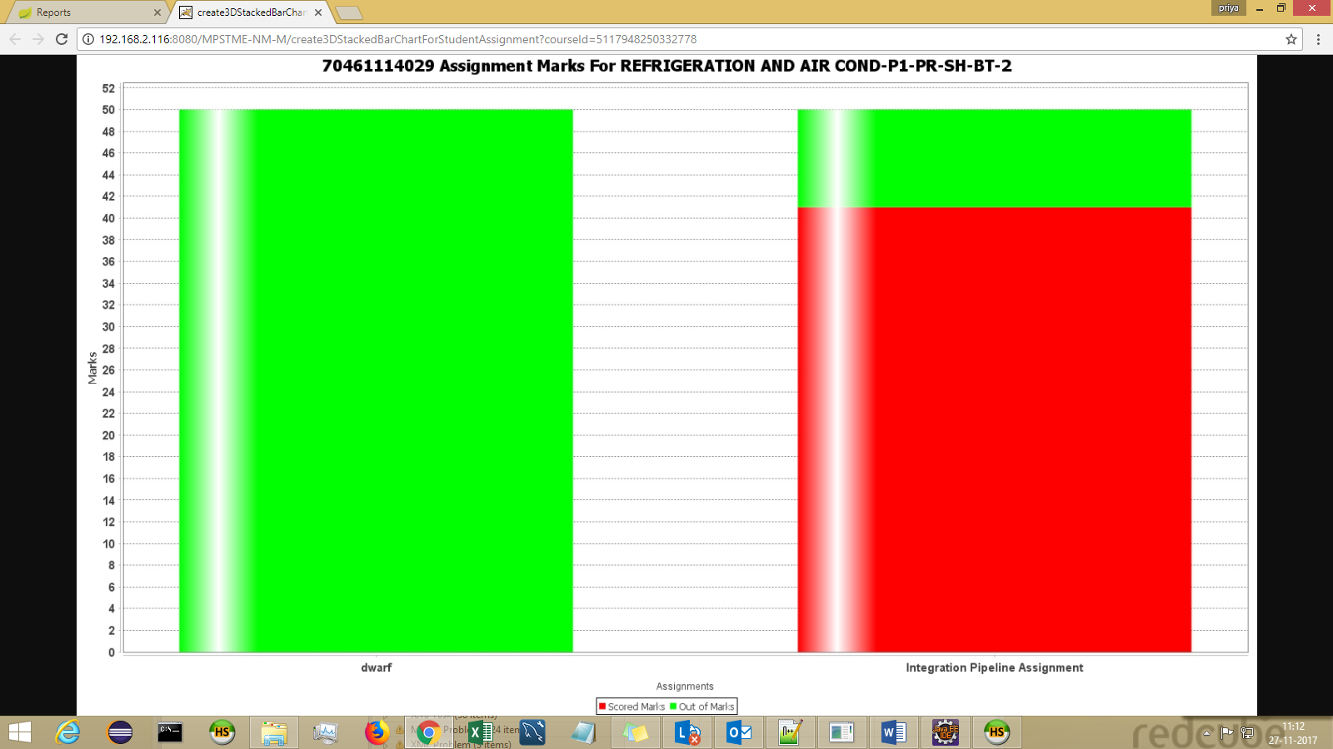

Bar Chart for Test

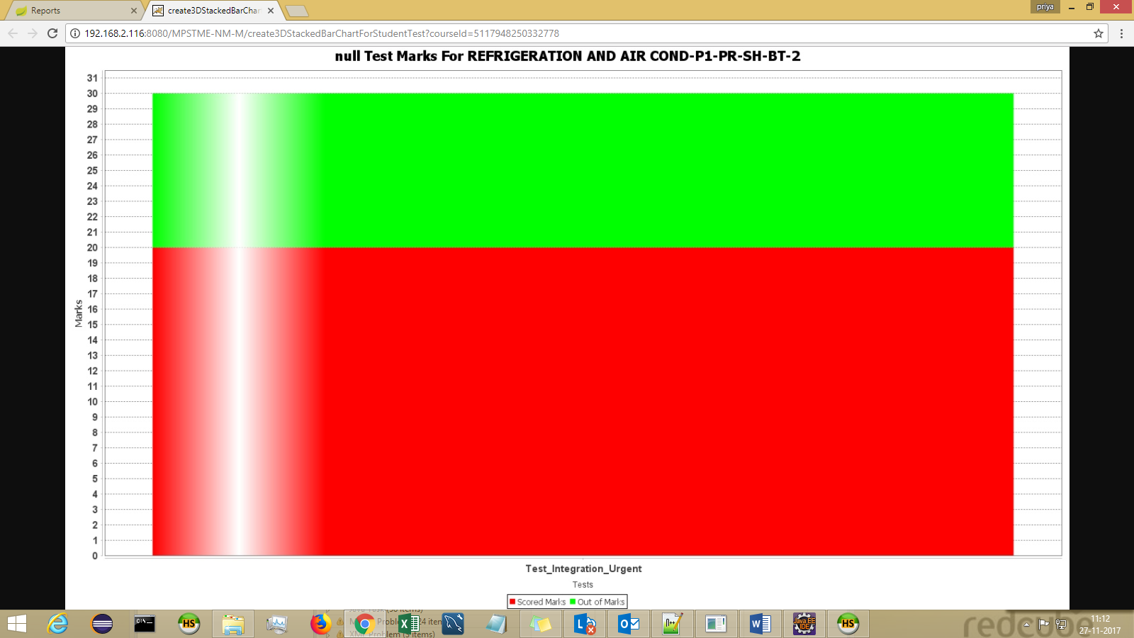

Module 14 : Search All Assignments/Tests
Select the acad month and acad year and select the component to be searched[assignment/test/Content] from dropdown and click on SEARCH button.

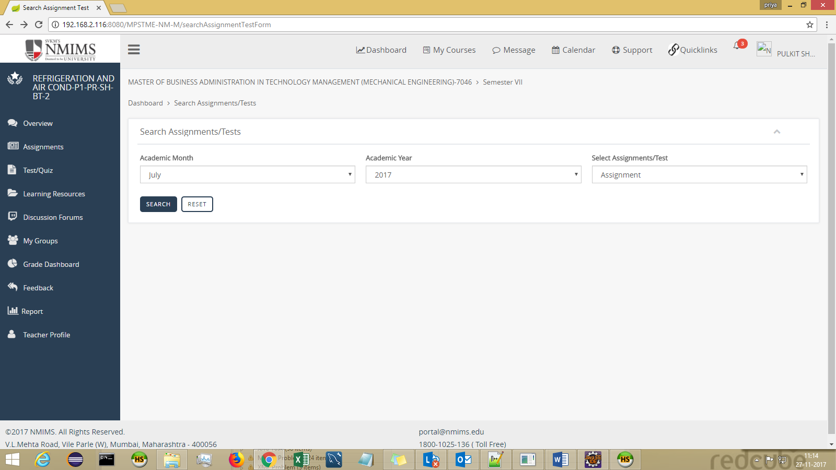

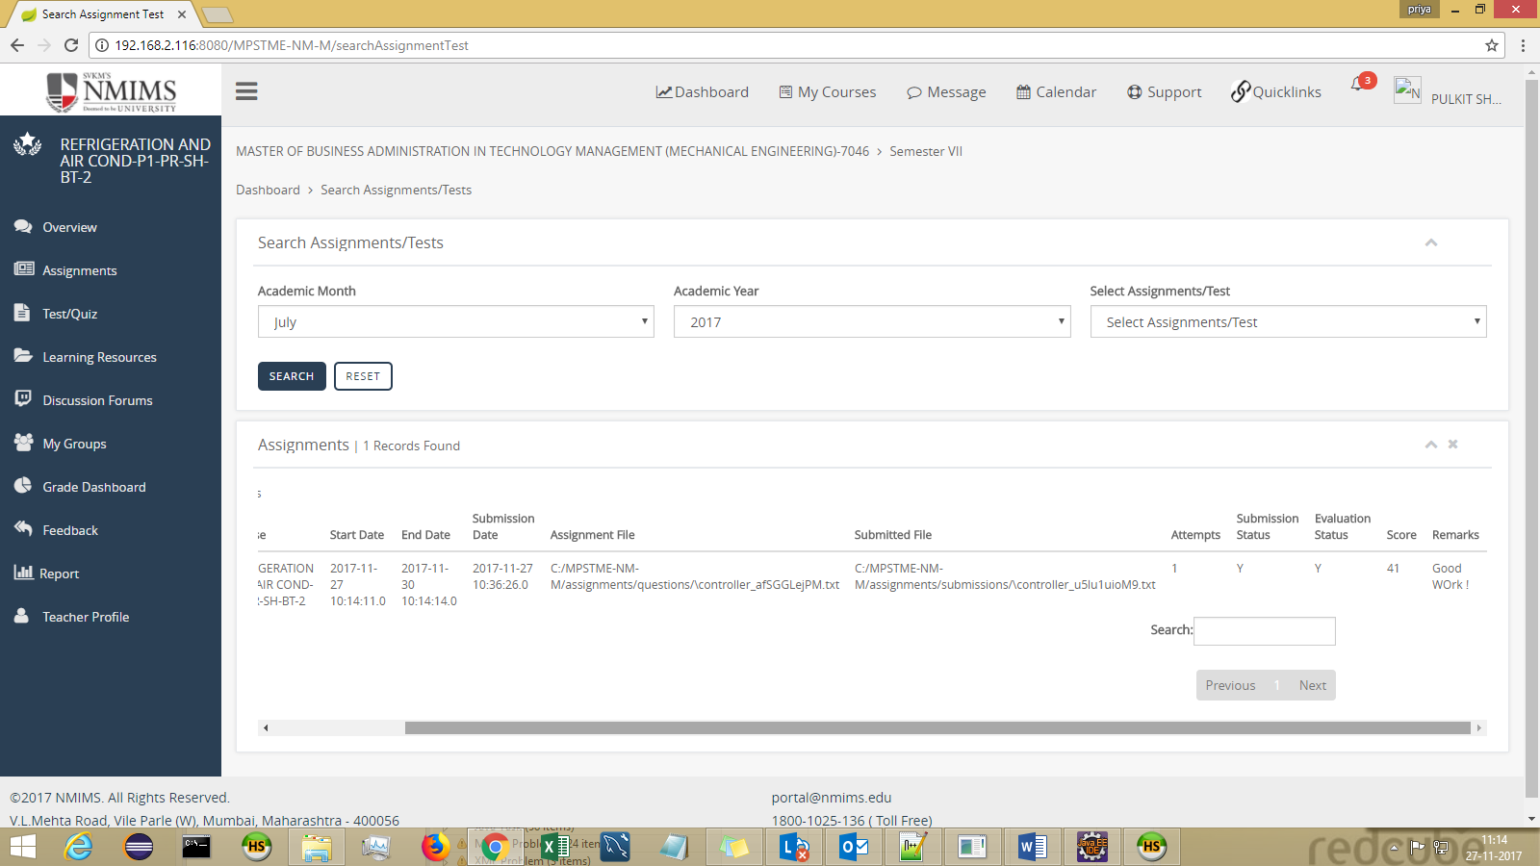

Module 15 : Alert icon

Can be found at the rightmost corner on the header menu.
It will show all announcements (Course + Institute level)
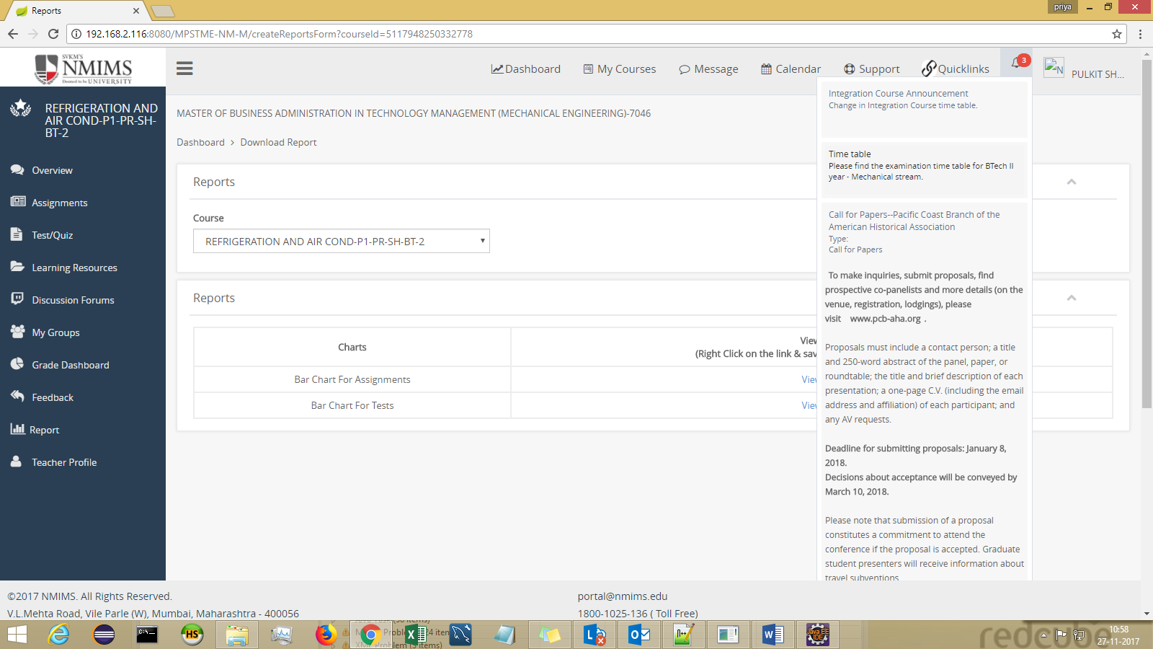

Additional Modules :

Raise A Query
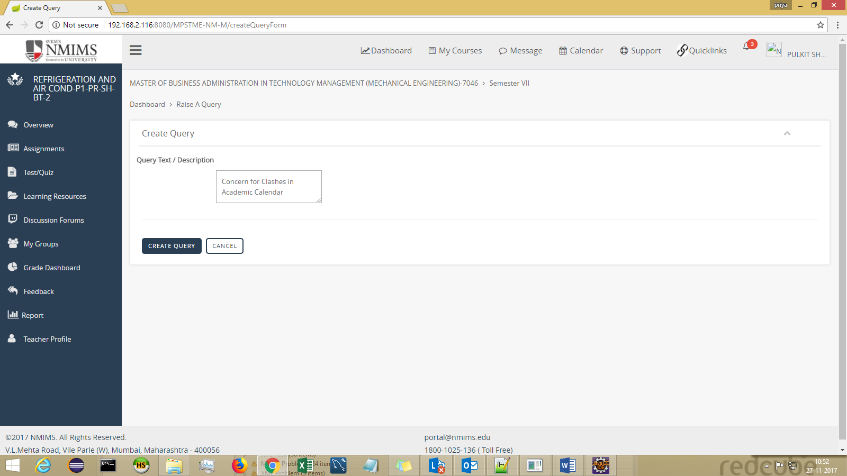
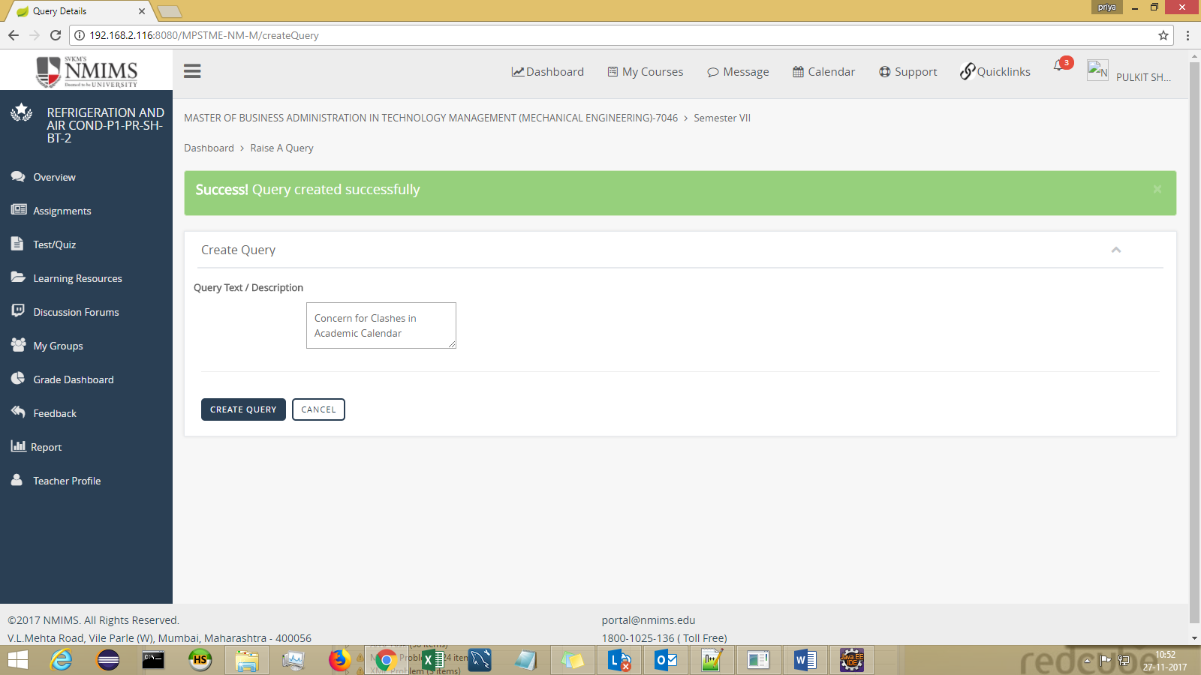

View My Query Response- The Response given by ADMIN to your query can be viewed here.

View FAQ’s
Students can have a glance on all the Frequently asked questions categorywise on this screen.
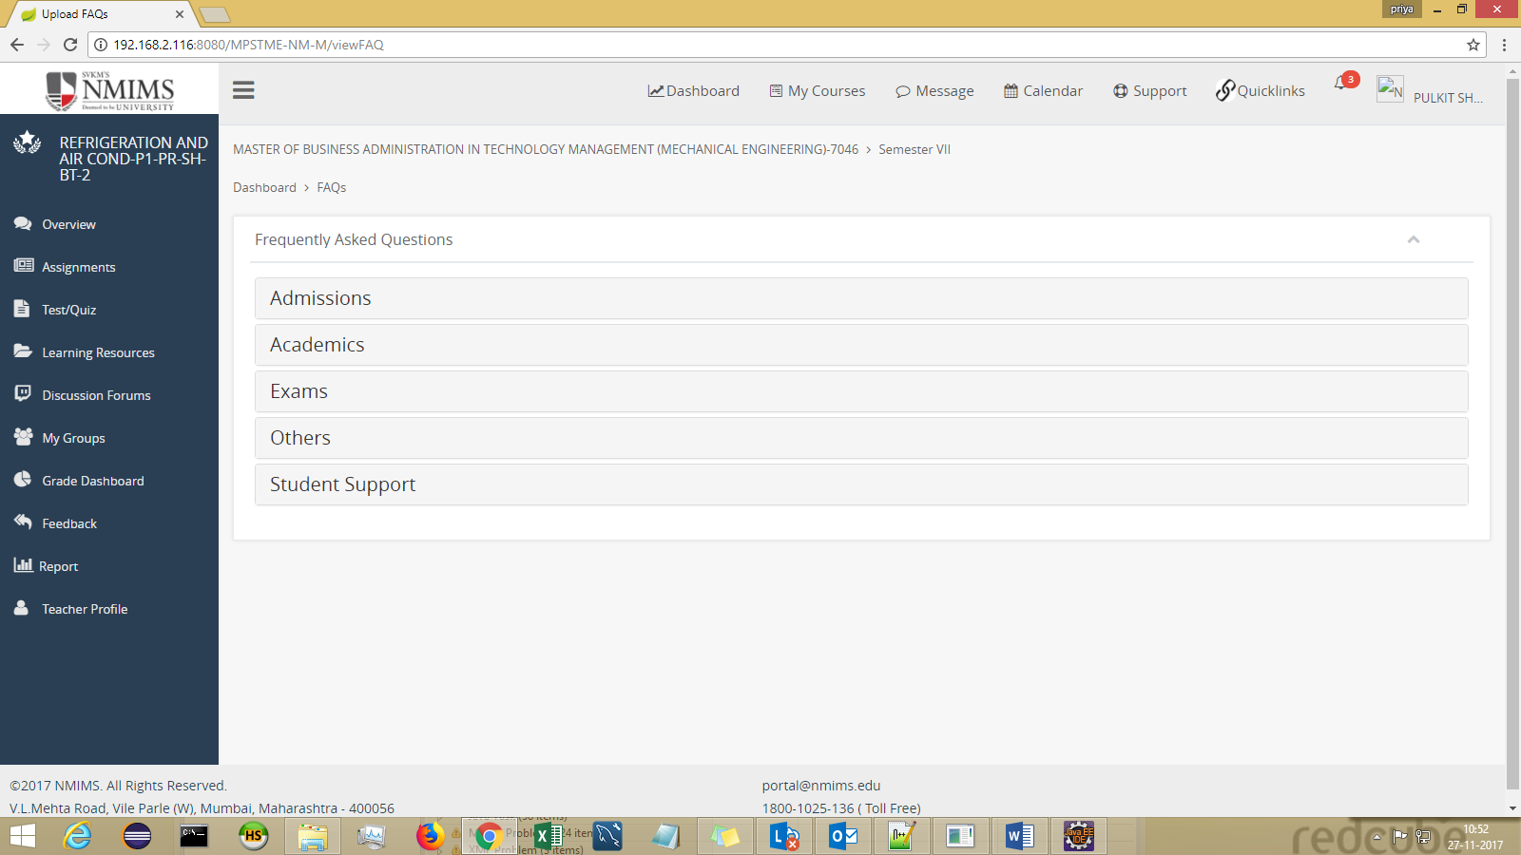

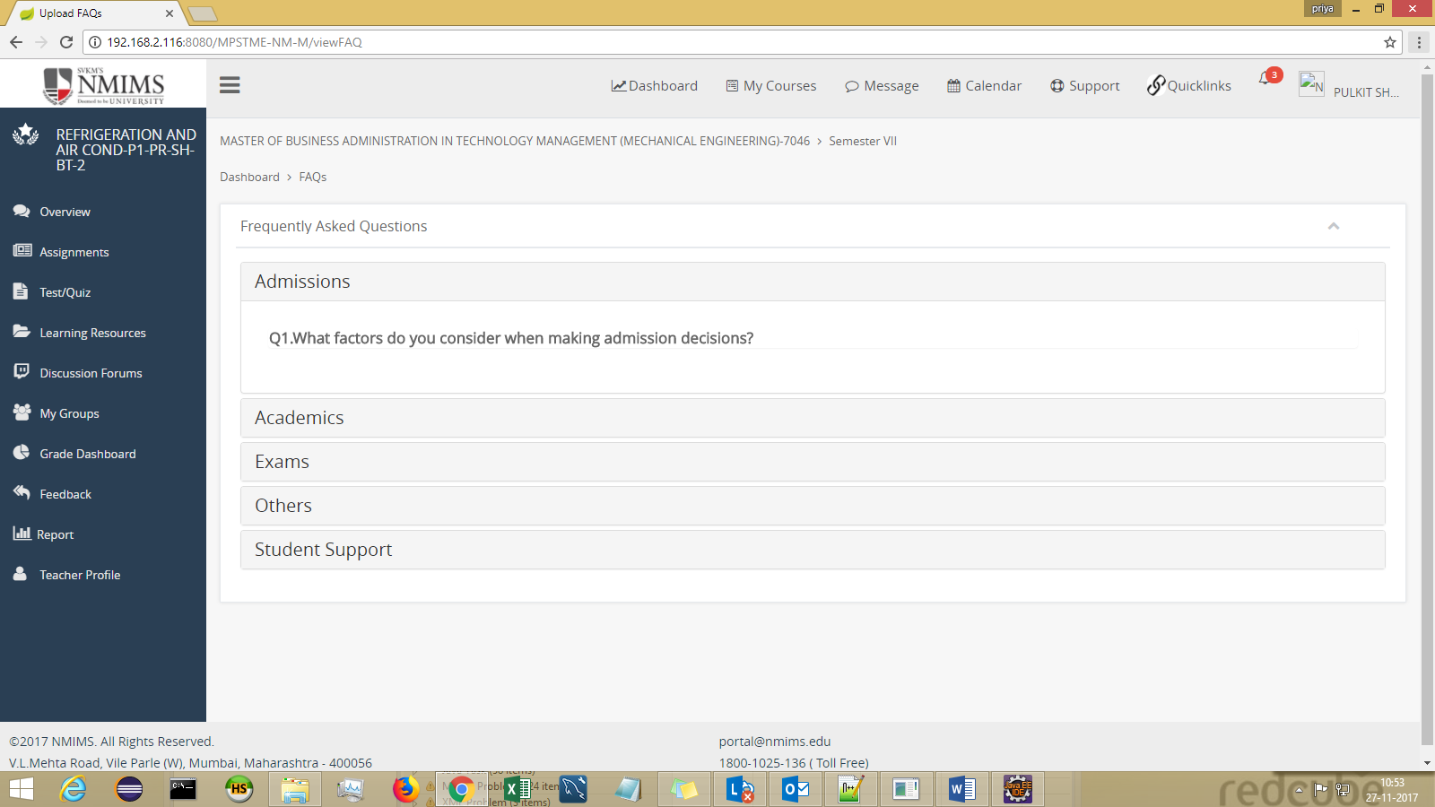

Overview
Can be landed via Support > Overview or Overview from left side bar
The SRB can be downloaded here.

